Dr. Steve Mihok  388 Church Street  Russell, Ontario, Canada K4R 1A8 | Telephone: (613) 445-8225  Email: smihok@rogers.com  June 20, 2006

Introduction 2

Performance of VF Polyester Nzi Traps 4

Glossina 4
Savannah Tsetse (morsitans group) 4
Forest Tsetse (fusca group) 6
Riverine Tsetse (palpalis group) 7

Stomoxyinae 8
Stomoxys 8

Tabanidae 9

Non-Biting Muscinae 10

Performance of Conventional Traps 11

Glossina 12
Savannah Tsetse (morsitans group) 12
Forest Tsetse (fusca group) 13
Riverine Tsetse (palpalis group) 14

Stomoxys 15

Tabanidae 16

Nzi Trap Bibliography 17

Appendices 20

Acknowledgements 20
Database Variables 21
Species Crosstabulation 23
Guide to Raw Data Files 26
Experimental Summary 29

Introduction
This document is a brief guide to an unpublished compendium of coordinated experiments on the performance of various traps for tsetse and biting flies conducted by the author and numerous colleagues during the 1990’s, mostly in association with the ICIPE tsetse research programme in Nairobi, Kenya (Acknowledgements in the Appendices). Experimental trapping results have all been summarized relative to a consistent standard - a phthalogen blue cotton Nzi trap with white polyester netting (STD or code NZI-COT in the database). Initial experiments with this trap were documented in Mihok (2002); relevant experiments are also included here.

Altogether, the database represents results from 17 published and 26 unpublished experiments in 14 countries. Entries are provided for multiple taxonomic levels to suit any analysis objectives. Typically, entries are available by species and sex for tsetse, and by family/subfamily, genus and/or species for biting flies, with some information also available by sex for Stomoxyinae. The level of detail depends on the level of reporting as all possible analyses have been performed.

A few experiments may still be added to this data set if original records can be retrieved from authors. For all but one experiment, data have been re-analyzed in a consistent fashion and results have been checked against original electronic / paper records in the author’s possession.

This database arose out of collaborative experiments designed to test the performance of matching polyester (Vestergaard Frandsen, Denmark, pure blue “pongee 2”) and cotton (Awassa Textiles, Ethiopia, phthalogen blue) Nzi traps relative to conventional “local” traps preferred by various researchers for different species. These fabrics were chosen for large-scale trials based on good performance for diverse tsetse and biting flies at Nguruman, Kenya in Experiment 23 of Mihok (2002). The project expanded from these original objectives over the past ten years, but the main theme of testing diverse traps against a standard Nzi trap was maintained.

These data are a “work in progress” and are being prepared for publication in a “meta-analysis” with numerous co-authors. It is anticipated that a manuscript will be finalized and submitted to a journal in mid-2007. In the interim, the underlying data are being made available for the benefit of researchers interested in the utility of various traps and fabrics for both tsetse and biting flies. The database is expected to be error-free but should be considered as “draft” until it comes under more intense scrutiny as the meta-analysis is performed.

The complete database is in the EXCEL file NZITRIALS RESPONSE RATIOS.XLS.

The file contains the results of ANOVAs performed on log-transformed catches [Y=log(X+1)] with each row representing an a priori paired comparison of an “experimental” trap to a STD phthalogen blue cotton Nzi trap. Hence, there are multiple entries for each experiment by trap type and by taxonomic group. Nearly all experiments represent daily catches; most experiments were replicated Latin square designs.

Numerous summary statistics are provided for interpretation, with the key statistic of interest being the RESPONSE RATIO [R] and its 95% confidence intervals. This statistic is one of the many options for summarizing relative results from an ANOVA; it has a rigorous statistical basis in the literature on meta-analysis. In the most basic of terms, it represents the ratio of the catch in an experimental trap relative to the STD trap.

The reference information required to use these data is provided in a several Appendices.

The rest of this document is a straightforward overview of the information available using examples of the performance of Vestergaard Frandsen polyester versus STD cotton Nzi traps, and the performance of other conventional tsetse or biting fly traps relative to STD cotton Nzi traps. Only a minimum of interpretation has been provided.

The database currently contains 1,791 records representing 112 taxonomic entries for 50 trap types. All data have been entered, and hence caution must be used in selecting only useful information. One objective of the meta-analysis will be to explore how these data can best be used to obtain repeatable estimates of relative trap performance.

Given the diverse information available by trap, species and locality, the best way to explore the database is to simply cross-tabulate and filter the EXCEL file for any data of interest. Subsets of data can then be sorted and graphed using the templates provided in the EXCEL file to interpret specific trends.

Performance of VF Polyester Nzi Traps
As part of a coordinated effort to test standardized Nzi traps, most experiments included a Nzi trap made from Vestergaard Frandsen's original "pongee 2" pure blue 100% polyester from the mid-1990s (coded as NZI-POL). This is Fabric #24 in Appendix 1 of Mihok (2002). This special fabric was replaced by a similar bright “phthalogen blue” polyester fabric that was introduced by Vestergaard Frandsen at ISCTRC in 2003.

Glossina

Savannah Tsetse (morsitans group)
Fabric comparisons were performed for Glossina pallidipes in Kenya, Ethiopia and Zimbabwe with several robust experiments at high density, with replicates in wet and dry seasons, and with replicates in contrasting habitats (savannah, woodland, forest).

Catches were nearly always lower with VF polyester, with large and significant reductions in catch in several experiments conducted at different locations in Ethiopia (e.g. about ½ the catch of phthalogen blue cotton).

Here and in other graphs, some experimental bars are coded in grey to draw attention to “low” catches in the STD trap; low catches also typically correspond to high coefficients of variation (CV), reducing statistical power. In the graph below, experiments are sorted from top to bottom by the geometric mean catch (Geo X) in the STD trap (383 at the top in TrNguWet versus 3.5 in TrChanka1). The importance of data transformation, ANOVA design, sample sizes and statistical power in cross-comparisons among experiments will be examined as part of the meta-analysis. At present, there are no simple guidelines for interpreting the combined results of experiments.

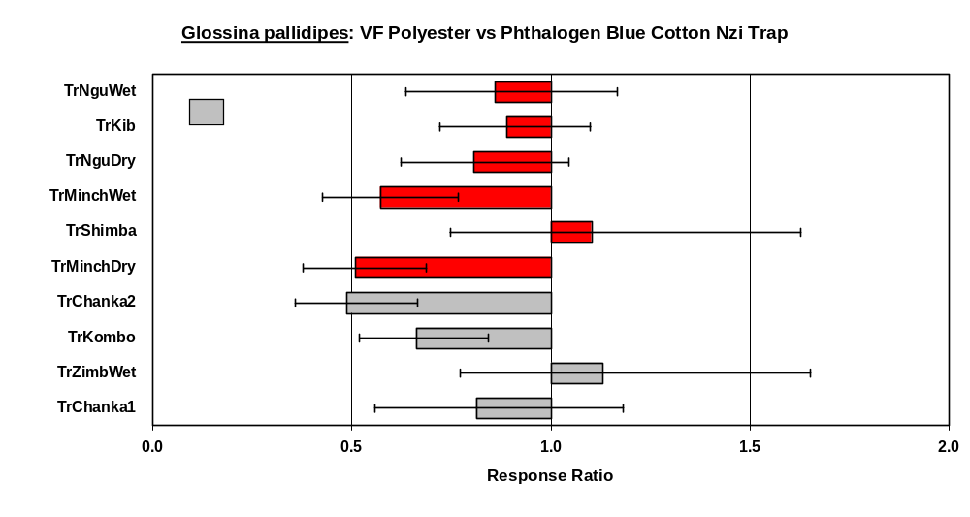
Fabric comparisons were performed for other savannah tsetse (G. austeni, G. swynnertoni, G. morsitans morsitans, G. morsitans centralis,G. morsitans submorsitans) in Kenya, Ethiopia, Tanzania, Zambia, Zimbabwe, Mali and The Gambia, mostly in woodland or savannah habitats. Only a few of these experiments were done at high densities with good statistical power.

As with G. pallidipes, catches were typically lower with VF polyester, with a significant reduction in catch in several experiments.

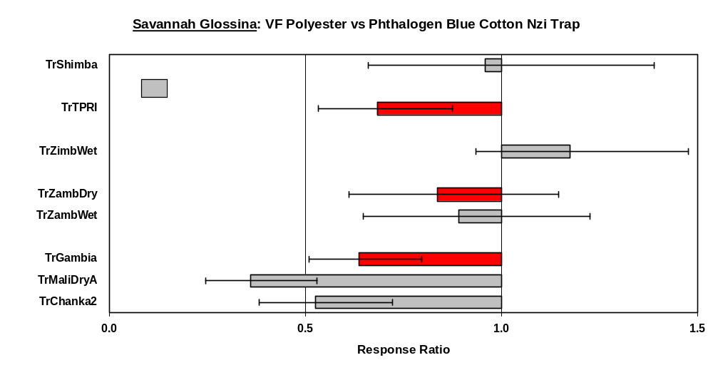

Forest Tsetse (fusca group)
Fabric comparisons were performed for two forest tsetse species (G. brevipalpis, G. longipennis) in woodland and forest in Kenya only. These experiments were done at high densities with good statistical power.

Catches were similar in polyester and cotton Nzi traps.

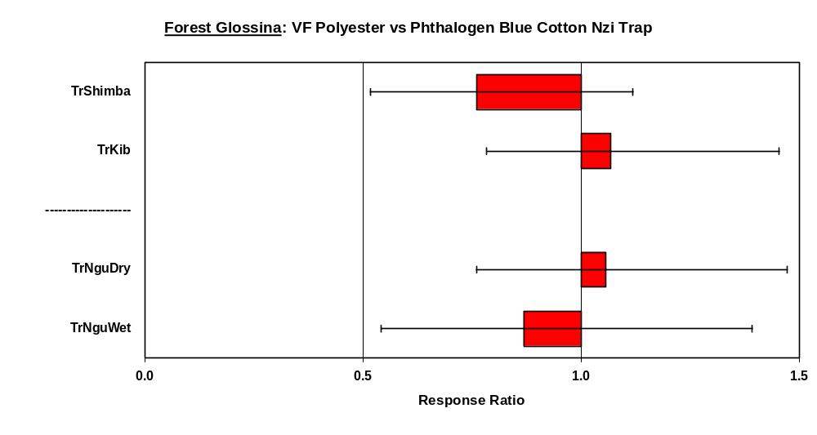

Riverine Tsetse (palpalis group)
Fabric comparisons were performed for riverine tsetse (G. tachinoides, G. palpalis gambiensis, G. fuscipes) in Kenya, Ethiopia, Mali, The Gambia, and Uganda, near rivers or lakes in both natural and peridomestic habitats. All of these experiments were conducted at low density with high coefficients of variation for catches.

Catches were similar in polyester and cotton Nzi traps.

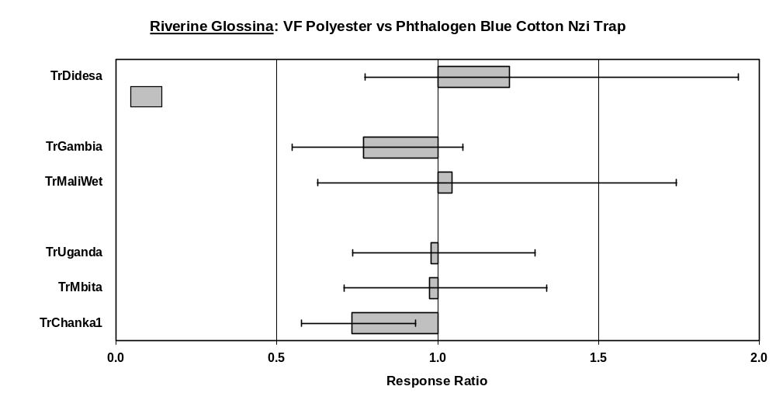

Stomoxyinae

The database contains extensive information on numerous Stomoxys spp. with many entries coded by species and by sex. There is particularly good replication for S. niger sspp. and S. calcitrans. These species often account for the bulk of the catch of stable flies in Africa, even if researchers did not identify specimens to species.

Limited information is also available for Haematobosca, typically H. latifrons. Very little information was generated for other genera of Stomoxyinae, e.g. Rhinomusca, Prostomoxys, etc.

Stomoxys
Fabric comparisons were performed for stable flies in nine countries in diverse settings with numerous experiments conducted at high numbers. Catches were nearly always lower with VF polyester, with large reductions in catch some experiments (e.g. ¼ the catch of cotton).

There were a few exceptions to general trends by species or locality, e.g. note the equivalent catches of polyester and cotton in a robust experiment at high density conducted in the USA for S. calcitrans (TrIowa), the only experiment conducted at a farm.

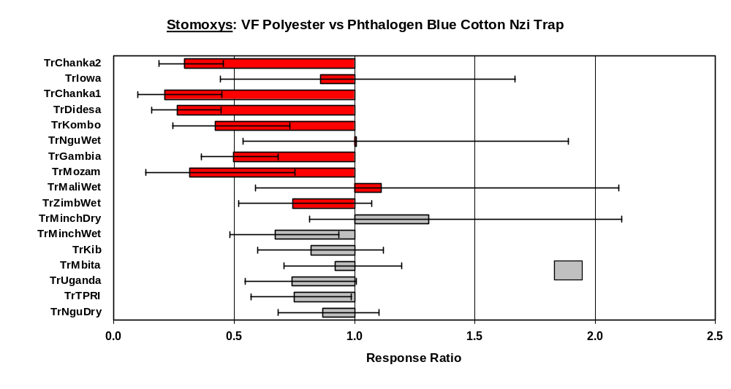

Tabanidae
The database contains extensive information on numerous genera and species of tabanids with fabric comparisons conducted in twelve countries. As for stable flies, catches were nearly always lower with polyester (e.g. ½ the catch of cotton), but with a few exceptions by species or locality.

All researchers identified tabanids to genus, and most researchers identified tabanids to species. Hence the database can be filtered and explored for considerable detailed information on the responses of species in different countries, habitats, seasons, etc.

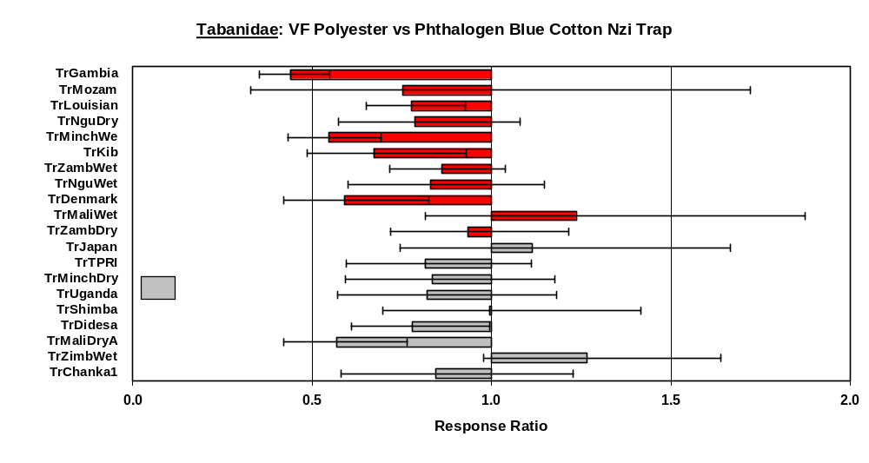

Non-Biting Muscinae
Some researchers recorded catches of non-biting Muscinae, which are typically ignored during counting, along with occasional catches of other non-target insects.

Results of fabric comparisons for non-biting Muscinae were similar to those for Stomoxyinae with uniformly lower catches with polyester versus cotton in all experiments.

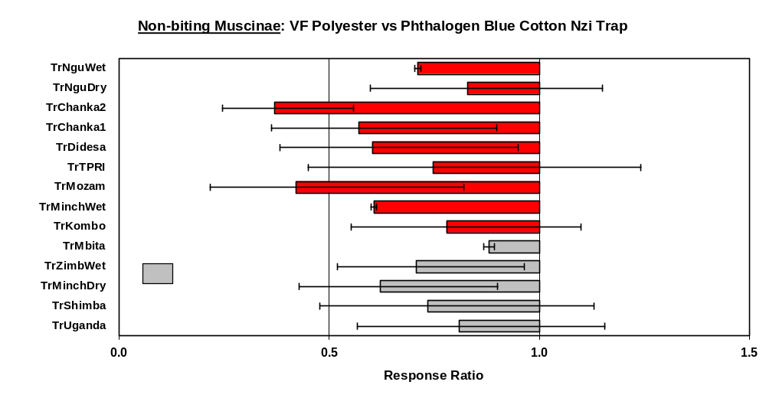

Performance of Conventional Traps
Coordinated experiments were designed to test standard cotton and polyester Nzi traps relative to conventional “local” traps made from various fabrics, typically conducted as 3x3 Latin squares in triplicate. Various researchers also conducted experiments comparing only cotton Nzi traps to conventional traps. Altogether, the database contains a diverse collection of trap performance information that can be sorted and filtered to analyze for any specific patterns of interest.

Presently, there are entries for 50 “traps”, 18 of which are straightforward published designs that can be identified by their code names (nearly all cloth traps with just a few sticky traps). The remaining traps are minor variations on Nzi traps, mostly with NZI-*** codes or abbreviations that can be associated with detailed descriptions in publications. For example, the database contains several interesting tests of NZI-BLK / NZI-RED traps. These are “all-black” Nzi traps in terms of insect vision (the blue panels were replaced with either black or red cloth).

An annotated bibliography of papers that have used the Nzi trap is provided at the end of this document. Several of these publications include further comparisons of traps that have not yet been included in this database.

Glossina

Savannah Tsetse (morsitans group)
Box-style or triangular cloth traps are often used to sample savannah tsetse, e.g. the “NGU” series from Kenya, the Epsilon from Zimbabwe, the F3, M3, S3, etc. Below is an example for G. pallidipes of the data available for Epsilon and NG2G traps. This is the largest subset of data for one species of tsetse for similar trap styles. All of the traps were made out of “phthalogen blue” cotton (various suppliers). In other comparisons, interpretation of trap performance is sometimes confounded by traps being made out of different fabrics, or blues other than phthalogen blue.

In most experiments, differences in catch relative to a STD Nzi trap are minor and without any consistent pattern in deviations from equal catches. The one notable exception is in the superior performance of the Epsilon trap in two experiments conducted in Zimbabwe. These experiments were the only experiments performed in the late afternoon instead of over a 24-h period. Hence, they may not reflect the integrated relative performance of traps throughout the day (e.g. electric net trap efficiency experiments for the NG2G show some major differences in efficiency during the course of the day).

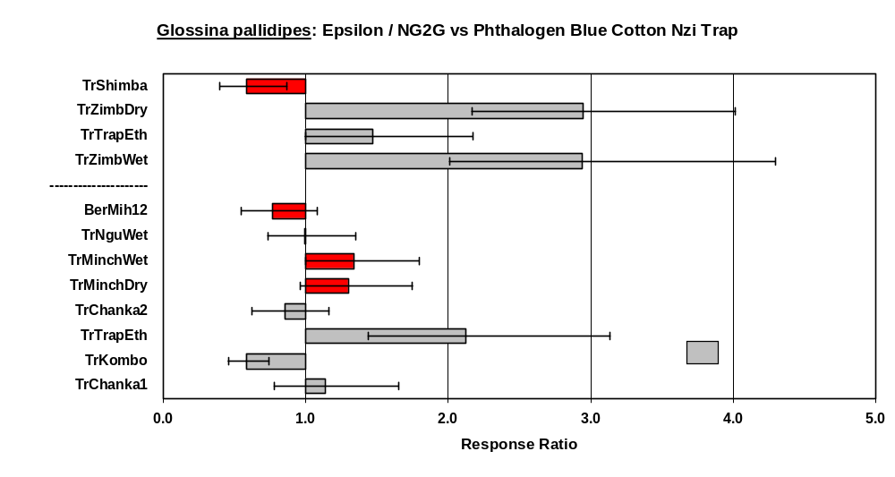

Forest Tsetse (fusca group)
Relatively few experiments were conducted on fusca tsetse, and hence there is no large series of replicated conventional trap comparisons for this interesting group. An example of one early experiment is shown below for G. brevipalpis. This was experiment #20 in Mihok (2002) at the Shimba Hills Reserve in Kenya.

Note the good performance of the Siamese trap, which was designed for coastal tsetse species in this area, relative to other traps. Note also the poor performance of Nzi traps made out of several partially-texturized (somewhat shiny) Vestergaard Frandsen experimental polyesters.

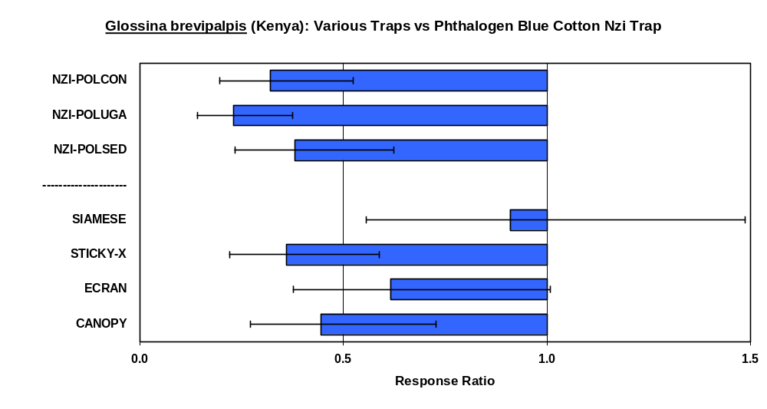

Riverine Tsetse (palpalis group)
The biconical trap, or various open-bottom, canopy-style traps such as the pyramidal, Vavoua, monoscreen, etc. are typically used to sample riverine tsetse. There are many examples in the database and in the published literature comparing the STD Nzi trap to these more open trap styles. A few examples for G. palpalis gambiensis, G. fuscipes and G. tachinoides are shown below from Kenya, Ethiopia, Uganda and Burkina Faso.

Catches in all of these experiments were low and coefficients of variation were high.

Results agree with the few other published studies on riverine tsetse (e.g. in Mali in IAEA, 2003) which indicate that the Nzi trap is not optimal for riverine tsetse relative to “open-style” traps.

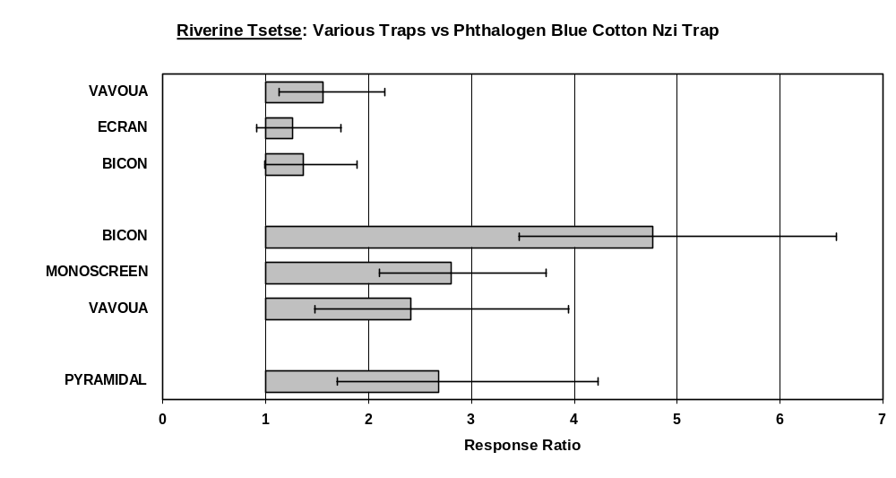

Stomoxys
The database contains a wealth of information on the performance of Nzi traps for diverse Stomoxyinae to supplement the information in Mihok (2002). A well-replicated experiment conducted in Ethiopia (TrTrapEth) at very high densities of many species of Stomoxys is shown below. All of the traps were made from the same phthalogen blue cotton fabric to original design specifications.

With some locality and species differences, these results are typical of relative trap performance for key species in Africa such as S. niger and S. calcitrans. Generally, Nzi traps catch more Stomoxys than other basic cloth traps, with some particularly striking differences in catches for certain species.

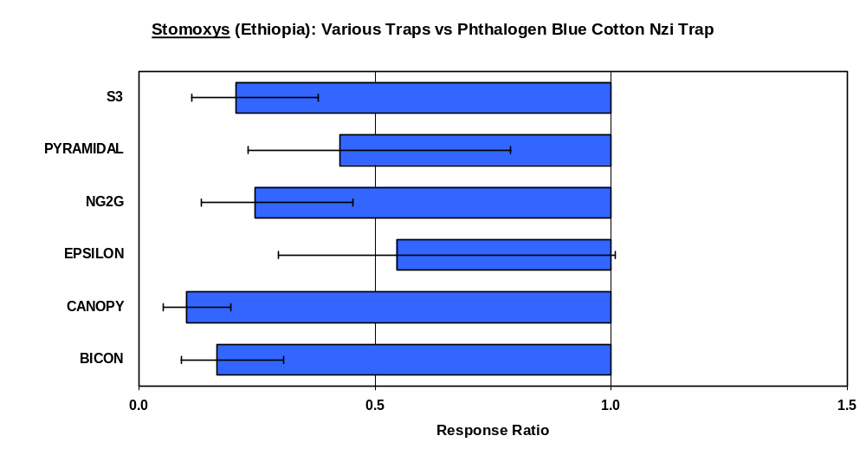

Tabanidae
The database contains a wealth of information on the performance of Nzi traps for many genera and species of tabanids with considerable additional information available in recent publications. The graph below is an example of the data available for experiments conducted at high numbers (Geo X for the STD Nzi trap > 20 and CV < 20%).

As with Stomoxys, there are occasional locality and species differences in trap performance relative to the Nzi, e.g. note the excellent performance of a canopy trap (with a beach ball decoy) in the experiment conducted in the USA (mainly Tabanus fuscicostatus).

Otherwise, Nzi traps invariably catch larger numbers of tabanids than other conventional cloth traps. Differences by locality or species can occasionally be striking. For example, in a trial conducted at very high tabanid numbers and diversity in The Gambia (TrGambia, Geo X = 131), the STD Nzi trap caught 11.7 times as many tabanids as the F3 trap in terms of the response ratio for log-transformed data, or 8.8 times as many tabanids in terms of the raw catches.

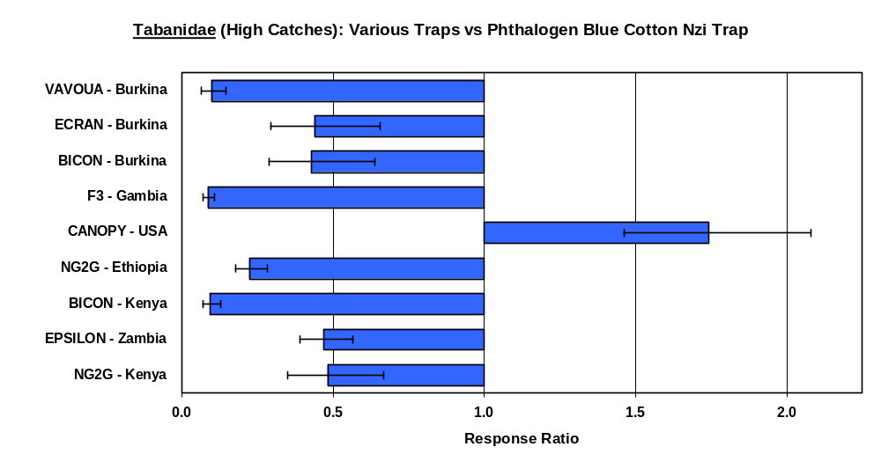

Nzi Trap Bibliography
The publication below is the original reference to the design of the Nzi trap with extensive comparisons against other trap designs.
Mihok, S. (2002) The development of a multipurpose trap (the Nzi) for tsetse and other biting flies. Bulletin of Entomological Research 92, 385-403. Medline
Current information is maintained at http://www.nzitrap.com

Next Issue | Mihok, S., Carlson, D.A., Krafsur, E.S. & Foil, L.D. (2006) Performance of the Nzi and other traps for biting flies in North America. Bulletin of Entomological Research, (in press).
Request Directly from Author | Desquesnes, M., Dia, M.L., Acapovi, G. & Yoni, W. (2005) Les vecteurs mécaniques des trypanosomoses animales; Généralités, morphologie, biologie, impacts et contrôle. Identification des espèces les plus abondantes en Afrique de l’Ouest, Bobo-Dioulasso, Burkina Faso: Centre International de Recherche-Développement sur l'Elevage en zone Subhumide, 70 pages.
  Comparisons of Nzi and Tetra traps in Burkina Faso in a major review of the biology of tabanids in West Africa; contains excellent photographs of many species
Journal Table of Contents | Dia, M.L., Desquesnes, M., Elsen, P., Lancelot, R. & Acapovi, G. (2004) Evaluation of a new trap for tabanids and stomoxyines. Bulletin de la Societe Royale Belge d'Entomologie, 140, 72-81.
  Comparisons of Nzi and Tetra traps in Burkina Faso
Medline | Desquesnes, M. & , Dia, M.L. (2004) Mechanical transmission of Trypanosoma vivax in cattle by the African tabanid Atylotus fuscipes. Veterinary Parasitology 119, 9-19.
  Catching Tabanidae for experiments in Burkina Faso
Word  94 k | Koller, W.W., Barros, A.T.M., Madruga, C.R., Ismael, A.P.K., Martins, C.F., Soares, C.O., Araújo, F.R., Gorayeb, I.S., Mihok, S. & Araújo, C.P. (2003) Tabanids of an area infected by Trypanosoma vivax in the Pantanal of Mato Grosso do Sul State, Brazil. pp. 3, CD-ROM 831.pdf in ISVEE/FCVPUC. (Ed) International Symposium for Veterinary Epidemiology and Economics X, Viña del Mar, Chile.
  Surveys of Tabanidae in Brazil
Medline | Desquesnes, M. & Dia, M.L. (2003) Mechanical transmission of Trypanosoma congolense in cattle by the African tabanid Atylotus agrestis. Experimental Parasitology 105, 226-231.
  Catching Tabanidae for experiments in Burkina Faso
PDF  963k | IAEA. (2003) Improved attractants for enhancing tsetse fly suppression. Final report of the co-ordinated research project 1996-2002. IAEA-TECDOC-1373. Vienna, Austria International Atomic Energy Agency, 121 pp.
  Nzi trap included in various trials with tsetse in Africa
Medline | Desquesnes, M. & Dia, M.L. (2003) Trypanosoma vivax mechanical transmission in cattle by one of the most common African tabanids, Atylotus agrestis. Experimental Parasitology 103, 35-43.
  Catching Tabanidae for experiments in Burkina Faso
Abstract | Ndegwa, P.N. & Ogodo, J.A. (2002) Community structure and diel activity patterns of Stomoxyinae from odour-baited Nzi trap collections. Insect Science and its Application 22, 281-287.
  Survey of Stomoxyinae in peridomestic settings in Kenya
English Abstract | Doutoum, A.A., Delafosse, A., Elsen, P. & Amsler-Delafosse, S. (2002) Vecteur potentiels de Trypanosoma evansi chez les dromadaires au Tchad oriental. Revue d'Élevage et de Médecine Vétérinaire des pays tropicaux 55, 21-30.
  Survey of biting flies in Chad
English Abstract | Acapovi, G.L., Yao, Y., N'goran, E., Dia, M.L. & Desquesnes, M. (2002) Abondance relative des tabanidés dans la région des savanes de Côte d'Ivoire. Revue d'Élevage et de Médecine Vétérinaire des pays tropicaux 54, 109-114.
  Survey of biting flies in the Ivory Coast
PDF  242k | Abeeluck, D., Ghoorbin, H.B. & Rawanansha, T. (2001) Potential of olfactory and visual baits for the control of Stomoxys nigra Macq. (Diptera Muscidae) in Mauritius. pp. 91-97 in FARC. (Ed) Annual Meeting of Agricultural Scientists, Proceedings. Réduit, Mauritius, Food and Agricultural Research Council.
  Nzi trap and attractant tests at deer farms in Mauritius
Medline | Kappmeier, K. & Nevill, E.M. (2000) A newly developed odour-baited "H-trap" for the live collection of Glossina brevipalpis and Glossina austeni (Diptera Glossinidae) in South Africa. Onderstepoort Journal of Veterinary Research 67, 15-16.
  Trap comparisons for Glossina brevipalpis and Glossina austeni in South Africa
Abstract  PDF  153k | Ndegwa, P.N. & Mihok, S. (1999) Development of odour-baited traps for Glossina swynnertoni Austen (Diptera Glossindae). Bulletin of Entomological Research 89, 255-261.
  Trap comparisons for Glossina swynnertoni in Tanzania

Medline | Sumba, A.L., Mihok, S. & Oyieke, F.A. (1998) Mechanical transmission of Trypanosoma evansi and T. congolense by Stomoxys niger niger and S. taeniatus in a laboratory mouse model. Medical and Veterinary Entomology 12, 417-422.
  Use of the trap to collect Stomoxys spp. for studying the mechanical transmission of trypanosomes
French  Abstract | Seignot, J. (1997) Enquête séro-épidémiologique à propos des trypanosomoses equines et asines dans la région de Dakar, Sénégal. These Vétérinaire, Université Claude Bernard de Lyon, France, 145 pp.
  Survey of biting flies during an outbreak of trypanosomosis
Swahili  Image  74k | Muzuma, S.T. (1997) Mtego wa Inzi. Mfugaji wa Kagera 3, 10.
  Extension article in farmer's magazine describing the use of the Nzi trap on dairy farms in Tanzania

Appendices

Acknowledgements

This work represents the efforts of about 100 scientists, technicians and students
The key researchers involved are listed below, in alphabetical order by institution
Researcher | Affiliation
Marc Desquesnes | Centre de coopération internationale en recherche agronomique pour le développement – Département d'élevage et médecine vétérinaire, France
Sandrine Amsler | Centre International de Recherche-Développement sur l'Elevage en zone Subhumide, Burkina Faso
Jean-Baptiste Rayaisse | Centre International de Recherche-Développement sur l'Elevage en zone Subhumide, Burkina Faso
Josue Okoth | Community-Based Vector Control Organization, Uganda
John Hargrove | Department of Veterinary Services, Zimbabwe
Sheila Trumper | Farm Africa, Kenya
Nigel Pollard | Grupo Madal, Quelimane, Mozambique
Paul Ndegwa | International Centre of Insect Physiology and Ecology, Kenya
Getachew Tikubet | International Centre of Insect Physiology and Ecology, Kenya
Adedapo Odulaja | International Centre of Insect Physiology and Ecology, Kenya
M. Mohamed-Ahmed | International Centre of Insect Physiology and Ecology, Kenya
Reardon Olubayo | International Centre of Insect Physiology and Ecology, Kenya
Momodou Ceesay | International Trypanotolerance Centre, Gambia
Elliot Krafsur | Iowa State University, USA
Japhet Kiragu | Kenya Trypanosomiasis Research Institute, Kenya
Aligue Djiteye | Laboratoire Central Vétérinaire, Mali
Lane Foil | Louisiana State University, USA
Miressa Keno | National Tsetse and Trypanosomiasis Info. and Control Centre, Ethiopia
Hitoshi Sasaki | Rakuno Gakuen University, Japan
Bergenie Bancha | Southern Region Nations, Nationalities and Peoples Agricultural Bureau, Ethiopia
Terzu Daya | Southern Region Nations, Nationalities and Peoples Agricultural Bureau, Ethiopia
Christian Sommer | The Royal Veterinary and Agricultural University, Denmark
Peter Kristensen | The Royal Veterinary and Agricultural University, Denmark
Charles Muangirwa | Tropical Pesticides Research Institute, Tanzania
Elisabeth Kimaro | Tropical Pesticides Research Institute, Tanzania
David Carlson | United States Department of Agriculture Research Service, USA
Floyd Dowell | United States Department of Agriculture Research Service, USA
Francis Oloo | Veterinary Department, Kenya
Mwangelwa Mwangelwa | Zambezi Livestock and Lands, Zambia

Database Variables

Error terms were calculated from ANOVAs for transformed data [Y=log(X+1) where X is the original raw catch].

Many entries are still being updated to include Error term degrees of freedom, critical t-values for the LSD test, arithmetic rather than log-transformed average catches for each trap type, etc. so that a complete suite of useful statistics can be calculated for different approaches in meta-analysis.

Species$ | Unit of analysis for ANOVA, e.g. family or subfamily, genus, species, sex
Experiment$ | Unique Identifier for each experiment
StdTrap$ | Code for the Standard trap (here all NZI-COT)
StdOdour$ | Abbreviation for baits (U=cow urine, A=acetone, O=Octenol, Sachet = phenols, etc.)
Stdlog | Mean transformed catch in the Standard trap [mean of Y or mean of log (X+1)]
MSQErr | Mean Square Error of the ANOVA (used to calculate the pooled standard error for each trap)
LSD | Least Significant Difference (transformed catch) for an a priori comparison of the trap to the standard
Explog | Mean transformed catch in the experimental trap [mean of Y or mean of log (X+1)]
ExpN | Sample size for the experimental trap
Prob$ | SIG if LSD test is P < 0.05, NOT otherwise
 | Actual probability can be re-calculated from data provided in other entries
ExpTrap$ | Code for the Experimental Trap
RespRatio | Response Ratio as defined in the statistical notes below
LowDelta | Lower 95% Confidence Interval for the Response Ratio
UpDelta | Upper 95% Confidence Interval for the Response Ratio
DF | Denominator or Error Degrees of Freedom in the ANOVA
t | Critical t-value for the LSD test
StdMean | Mean untransformed or raw catch in the Standard trap [mean of X]
ExpMean | Mean untransformed or raw catch in the Experimental trap [mean of X]
ExpMax | Maximum untransformed or raw catch in the Experimental trap
Useful Calculations
StdGeo | Standard Trap Detransformed Mean Catch [Geometric Mean or mean of log(X+1)]
StdBack | Standard Trap Backtransformed Mean Catch (Detransformed Mean Catch LESS One)
ExpGeo | Experimental Trap Detransformed Mean Catch [Geometric Mean or mean of log(X+1)]
ExpBack | Experimental Trap Backtransformed Mean Catch (Detransformed Mean Catch LESS One)
Index | Index of Increase (Ratio of the Backtransformed Mean Catches, Expt vs Standard)
CatchRatio | Ratio of RAW mean catch in Experimental Trap to Standard
PoolSD | Pooled Standard Deviation for log-transformed catches [SQRT(MSQErr)]
PoolSE | Pooled Standard Error for log-transformed mean catches [PoolSD / SQRT(ExpN)]
StdCV | Standard Trap Coefficient of Variation for log-transformed catches [100 * PoolSD / (10^Stdlog)]

Some Statistical Notes

The BACKTRANSFORMED Mean is the antilog of the log-transformed mean LESS ONE.

The INDEX OF INCREASE is the ratio of the treatment backtransformed mean to the standard backtransformed mean. This is one of several ways that entomologists often interpret their results; see FAO Training Manual below:
Dransfield, R.D. & Brightwell, R. (1992) Use of attractive devices for tsetse survey and control. pp. 1-196 in Hursey, B.S. & Slingenbergh, J.H.W. (Eds.) Training manual for tsetse control personnel, Volume 4. Rome, Italy, Food and Agriculture Organisation of the United Nations.

The DETRANSFORMED Mean is the GEOMETRIC Mean, i.e. without subtracting one. This is the basis of the ANOVA used for statistical interpretation of transformed data. Most ecologists do not use the "Index of Increase", they use the RESPONSE RATIO. This number and its confidence intervals are explicitly defined through the properties of logarithms and ratios.

The RESPONSE RATIO is the ratio of the treatment geometric mean to the standard geometric mean. The statistical properties of response ratios are discussed in the paper below:

Hedges, L.V., Gurevith, J . & P.l.S. Curtis (1999) The meta-analysis of response ratios in experimental ecology, Ecology 80(4) 1150-1156 [the entire issue is devoted to this topic]

A PRIORI or PLANNED COMPARISONS are explained in statistical textbooks, e.g. on Page 243 in Sokal, R.R. & F.J. Rohlf (1981) Biometry, 2nd Edition, W.H. Freeman and Company, San Francisco. Comparisons in the database are based on a two-tailed test at P=0.05.

Conversion of mean log catches to a Response Ratio for geometric means is simply a mathematical manipulation.

log(a) - log(b) = log(a / b), see the statistical paper below:
http://bmj.bmjjournals.com/cgi/content/full/312/7039/1153

Bland, J.M. & Altman, D.G. (1996) Statistics Notes: The use of transformation when comparing two means. British Medical Journal, 312, 1153.

The response ratio is simply a visual representation of the ANOVA & LSD tests. When 95% confidence intervals of response ratios do not overlap, the two traps are significantly different. For most situations with large N, the Index of Increase and the Response Ratio are nearly identical. In contrast, the ratio of untransformed raw catches may not accurately represent the results of a Latin Square experiment. This is explained with a hypothetical example in the FAO Training Manual.

Species Crosstabulation

The database contains entries by family/subfamily, genus, species and sex with ANOVAs repeated at each level of detail. Each entry provides statistics for catches in an experimental trap (both standard biting fly and tsetse traps, and experimental Nzi traps in various fabrics or formats) relative to a standard trap (here always a phthalogen blue cotton or NZI-COT trap).
Care must be taken in filtering and summarizing raw information as ALL DATA have been included in the database regardless of sample sizes or coefficients of variation.

Ancala | 8
Ancala africana | 3
Ancala necopina | 3
Atylotus | 48
Atylotus agrestis | 39
Atylotus albipalpus | 3
Atylotus fuscipes | 7
Chrysops | 21
Chrysops aberrans | 1
Chrysops distinctipennis | 9
Chrysops univittatus | 1
Glossina austeni | 14
Glossina austeni female | 14
Glossina austeni male | 7
Glossina brevipalpis | 16
Glossina brevipalpis female | 16
Glossina brevipalpis male | 16
Glossina fuscipes | 16
Glossina fuscipes female | 16
Glossina fuscipes male | 16
Glossina longipennis | 26
Glossina longipennis female | 26
Glossina longipennis male | 26
Glossina morsitans centralis | 4
Glossina morsitans centralis female | 4
Glossina morsitans centralis male | 4
Glossina morsitans morsitans | 4
Glossina morsitans morsitans female | 4
Glossina morsitans morsitans male | 4
Glossina morsitans submorsitans | 18
Glossina morsitans submorsitans female | 18
Glossina morsitans submorsitans male | 18
Glossina pallidipes | 76
Glossina pallidipes female | 71
Glossina pallidipes male | 71
Glossina palpalis gambiensis | 11
Glossina palpalis gambiensis female | 5
Glossina palpalis gambiensis male | 5
Glossina swynnertoni | 9
Glossina swynnertoni female | 7
Glossina swynnertoni male | 7
Glossina tachinoides | 2
Glossina tachinoides female | 2
Glossina tachinoides male | 2
Haematobia | 2
Haematobia stimulans | 2
Haematobosca | 42
Haematobosca latifrons | 38
Haematobosca latifrons female | 12
Haematobosca latifrons male | 12
Haematopota | 27
Haematopota pluvialis | 2
Hybomitra | 2
Hybomitra expullicata | 2
Leucotabanus | 2
Leucotabanus annulatus | 2
Mosquitoes | 10
Muscinae | 98
Philoliche | 4
Philoliche makueni | 4
Prostomoxys | 2
Prostomoxys saegerae | 2
Rhinomusca | 2
Rhinomusca dutoiti | 2
Stomoxyinae | 111
Stomoxys | 105
Stomoxys boueti | 9
Stomoxys boueti female | 9
Stomoxys boueti male | 9
Stomoxys calcitrans | 46
Stomoxys calcitrans female | 41
Stomoxys calcitrans male | 42
Stomoxys inornatus | 6
Stomoxys inornatus female | 6
Stomoxys inornatus male | 6
Stomoxys niger bilineatus | 26
Stomoxys niger bilineatus female | 19
Stomoxys niger bilineatus male | 19
Stomoxys niger niger | 52
Stomoxys niger niger female | 44
Stomoxys niger niger male | 44
Stomoxys pallidus | 4
Stomoxys pallidus female | 2
Stomoxys pallidus male | 2
Stomoxys taeniatus | 30
Stomoxys taeniatus brunnipes | 7
Stomoxys taeniatus brunnipes female | 7
Stomoxys taeniatus brunnipes male | 7
Stomoxys taeniatus female | 28
Stomoxys taeniatus male | 28
Stomoxys varipes | 2
Stomoxys varipes female | 2
Stomoxys varipes male | 2
Tabanidae | 108
Tabanus | 73
Tabanus coniformis | 4
Tabanus copemani | 2
Tabanus fraternus | 2
Tabanus fuscicostatus | 2
Tabanus gratus | 13
Tabanus insignis | 2
Tabanus laverani | 3
Tabanus leucostomus | 2
Tabanus limbatinervis | 2
Tabanus lineola | 2
Tabanus par | 6
Tabanus pullulus | 2
Tabanus quinquevittatus | 1
Tabanus similis | 1
Tabanus sufis | 6
Tabanus taeniola | 49
Tabanus thoracinus | 5

Guide to Raw Data Files

All key trials include a NZI-COT standard trap (phthalogen blue cotton, Ethiopian or Kenyan fabric), and most also include a NZI-POL standard trap (Vestergaard Frandsen's original "pongee 2" pure blue 100% polyester from the mid-1990's). The original goal of this research was to test Nzi traps made from blue fabrics #105 and #101 in 3-times replicated 3 x 3 Latin squares relative to a "local" standard trap. Fabrics #105 and #101 are simply large lots of the equivalent fabrics #60 and #65 that did well when tested in Expt 23 of Mihok (2002).
Experiments where arithmetic means have not yet been collated
in the Response Ratio database are highlighted in BLUE
Fabric codes refer to the original codes in the ACCESS Database FABRICS.MDB
Cross references to the codes in Mihok (2002) are in SPECTRA REFERENCE.XLS

Country | Area | Season | Summary | Data File | Commands | Catches | Fabrics
 |  |  | WORD | SYSTAT | TEXT | EXCEL | EXCEL
3 x 3 Latin Squares - Ethiopian Phthalogen Blue Cotton #105 & Vestergaard Frandsen Polyester #101
Kenya | Nguruman | Wet | TrNguWet | NguWet | 6k | 3,265k | 310k
Kenya | Kibwezi | Wet | TrKib | Kib | 5k | 2,900k | 308k
Kenya | Mbita Point | Wet | TrMbita | Mbita | 3k | 2,113k | 308k
Ethiopia | Didesa | Wet | TrDidesa | Didesa | 6k | 3,626k | 308k
Ethiopia | Arba Minch | Wet | TrMinchWet | MinchWet | 6k | 3,254k | 308k
Tanzania | Naitolya | Dry | TrTPRI | TPRI | 2k | 2,151k | 240k
Uganda | Busoga | Dry | TrUganda | Uganda | 3k | 2,145k | 274k
Zambia | Kafue | Wet | TrZambWet | ZambWet | 3k | 2,167k | 308k
Zambia | Kafue | Dry | TrZambDry | ZambDry | 3k | 2,167k | 308k
Gambia | Niamina East | Wet | TrGambia | Gambia | 4k | 2,476k | 340k
Denmark | Copenhagen | Wet | TrDenmark | Denmark | 2k | 2,006k | 206k
USA* | Iowa | Dry | TrIowa | Iowa | 3k | 1,894k | 307k
USA* | Louisiana | Dry | TrLouisiana | Louisiana | 2k | 2,075k | 275k
Japan | Hokkaido | Dry | TrJapan | Japan | 1k | 1,811k | 173k
* Brief results published in: Mihok, S., Carlson, D.A., Krafsur, E.S. & Foil, L.D. (2006) Performance of the Nzi and other traps for biting flies in North America. Bulletin of Entomological Research, (in press).

Minor Methodological Variations - Cotton and polyester both tested
Phthalogen Blue Cotton from Mountex, Kenya #184 & Opaque VF Polyester #161
Ethiopia | Kombo | Wet | TrKombo | Kombo | 5k | 2,807k | 274k
Mozambique | Quelimane | Dry | TrMozam | Mozam | 2k | 2,182k | 308k
Phthalogen Blue Cotton from Bonar Industries, Zimbabwe #171
Cotton trap with geometric frame, Standard VF Polyester #101
Zimbabwe | Zambezi | Wet | TrZimbWet | ZimbWet | 2k | 2,301k | 240k
ROYAL BLUE Cotton from Awassa Textiles, Ethiopia #127, Standard VF Polyester #101
Mali | Tienfala-Baguineda | Wet | TrMaliWet | MaliWet | 3k | 2,511k | 239k
Mali | Madina-Diassa  (Savanna) | Dry | TrMaliDryA | MaliDryA | 2k | 2,264k | As Above
Complex Fabric Trials - Large Latin Squares with many special fabrics
Experiment 23 from Mihok (2002) in Bulletin of Entomological Research
Ethiopian #60, Kenyan #62 Phthalogen Blue & VF Polyesters #64, 65 and some size/netting variations
Kenya | Nguruman | Dry | TrNguDry | NguDry | 5k | 4,794k | 343k
Initial fabric trial to scope causes of polyester/cotton catch differences - various cotton/polyester fabrics
ROYAL BLUE Cotton from Awassa Textiles, Ethiopia #127 tested
Ethiopia | Arba Minch | Dry | TrMinchDry | MinchDry | 3k | 3,046k | 587k
Three sequential experiments using the same set of traps in minor variations on cotton/polyester fabrics
Comparing many possible sources of catch differences in fabric features
Ethiopia | Chanka1 | Wet | TrChanka1 | Chanka1 | 4k | 3,630k | 773k
Ethiopia | Chanka2 | Wet | TrChanka2 | Chanka2 | 6K | 4,681k | As Above
Kenya | Shimba | Wet | TrShimba | Shimba | 4k | 3,731k | 773k

Various Experiments - ONLY Cotton Nzi traps being compared to other traps
Mihok et al. (in preparation MVE) - 7 x 7 Latin Squares - Phthalogen Blue Cotton from Mountex, Kenya #184
Ethiopia | Chanka | Wet | TrTrapEth | TrapEth | 6k | 3,986k | 137k
Phthalogen Blue Cotton from Bonar Industries, Zimbabwe #171
Tested dark versus light netting - traps made with geometric frames
Zimbabwe | Zambezi | Dry | TrZimDry | ZimDry | 3k | 2,324k | 240k
Standard Phthalogen Blue Cotton from Awassa Textiles, Ethiopia #105
Burkina Faso | Lahirasso | Dry | TrBFLah | BFLah | 3k | 2,437k | 171k
Burkina Faso | Kimini | Dry | TRBFKimini | BFKimini | 2k | 2,488k | As Above
Burkina Faso | Banwali | Dry | TrBFBanwali | BFBanwali | 2k | 2,340k | As Above

Experimental Summary

Published trials are listed below. Unpublished data are on the following page.

Expt$ | Country$ | Person$ | Odours$ | Habitat$ | Season$ | Weather$ | Area$ | Location$ | Zone$ | ELEVATION | Latitude$ | Longitude$ | Date$
Mihok et al. (2006)
Ber06Canopy | CANADA | MIHOK | OCTENOL | GARDEN | DRY |  | RUSSELL | ONTARIO VILLAGE | CONTROL | 24 | 45 15 N | 75 21 W | 12-Jul-04
Ber06Dyes5 | CANADA | MIHOK | OCTENOL | GARDEN | DRY |  | RUSSELL | ONTARIO VILLAGE | CONTROL | 24 | 45 15 N | 75 21 W | 10-Sep-04
Ber06Net2 | CANADA | MIHOK | OCTENOL | GARDEN | DRY |  | RUSSELL | ONTARIO VILLAGE | CONTROL | 24 | 45 15 N | 75 21 W | 02-Sep-03
TRIOWA | USA | KRAFSUR | UNBAIT | FARM | DRY | RAINY | AMES | DAIRY FARM | AGRICULTURAL | 280 | 41 59 26 N | 93 37 08 W | 19-Jul-96
TRLOUISIANA | USA | FOIL | SACHET | FOREST EDGE | DRY | SUNNY | LOUISIANA | PARK ROAD | THISTLEWAITE | 23 | 30 39 00 N | 92 00 00 W | 09-Jun-96
Mihok (2002)
BERMIH12 | KENYA | MIHOK | AUO | SAVANNA | WET |  | NGURUMAN | SHOMPOLE | CONTROL | 550 | 02 00 S | 36 10 E | 24-May-95
BERMIH13 | KENYA | MIHOK | UNBAIT | FARM | WET |  | NAIROBI | ICIPE | CONTROL | 1500 | 01 20 S | 36 50 E | 09-Jun-95
BERMIH14 | KENYA | MIHOK | OCTENOL | FOREST | DRY |  | NAIROBI | PARK | CONTROL | 1500 | 01 20 S | 36 50 E | 19-Jul-95
BERMIH15 | KENYA | MIHOK | OCTENOL | GARDEN | DRY | SUNNY | NAIROBI | LORESHO SUBURB | CONTROL | 1500 | 01 20 S | 36 50 E | 01-Aug-95
BERMIH16 | KENYA | MIHOK | AUO | SAVANNA | DRY | SUNNY | MARALAL | KIRIMUN | CONTROL | 1450 | 00 40 N | 36 50 E | 14-Jun-95
BERMIH17 | KENYA | MIHOK | AUO | SAVANNA | DRY | SUNNY | NGURUMAN | SHOMPOLE | CONTROL | 550 | 02 00 S | 36 10 E | 25-Jul-95
BERMIH18 | KENYA | MIHOK | AUO | THICKET | DRY | SUNNY | LAMBWE VALLEY | RUMA PARK | SUPPRESSION | 1200 | 00 20 N | 34 10 E | 22-Aug-95
BERMIH19 | KENYA | MIHOK | A+SACHET | THICKET | DRY |  | MBITA | NYAMANGA | CONTROL | 1200 | 00 25 S | 34 15 E | 29-Aug-95
BERMIH20 | KENYA | MIHOK | AUO | FOREST | WET |  | SHIMBA | AIRSTRIP | CONTROL | 350 | 04 17 S | 39 25 E | 22-Nov-95
TRNGUDRY | KENYA | MIHOK | AUO | SAVANNA | DRY | SUNNY | NGURUMAN | SHOMPOLE | CONTROL | 550 | 02 00 S | 36 10 E | 11-Jan-96
Ndegwa & Mihok (1999)
BERNDE02 | TANZANIA | NDEGWA | AO | WOODLAND | DRY |  | MAKUYUNI | NAITOLYA-8 | CONTROL | 1000 | 03 40 00 S | 36 03 00 E | 01-Aug-96
BERNDE03 | TANZANIA | NDEGWA | AO | WOODLAND | DRY | SUNNY | MAKUYUNI | NAITOLYA-8 | CONTROL | 1000 | 03 40 00 S | 36 03 00 E | 20-Sep-96

Expt$ | Country$ | Person$ | Odours$ | Habitat$ | Season$ | Weather$ | Area$ | Location$ | Zone$ | ELEVATION | Latitude$ | Longitude$ | Date$
TRBFBANWALI | BURKINA FASO | RAYAISSE | UNBAIT | RIVERINE FOREST | DRY |  | BANWALI | TRIBUTARIES | MAHOUN RIVER | 288 | 11.88 N | 4.22 W | 01-Nov-97
TRBFKIMINI | BURKINA FASO | RAYAISSE | UNBAIT | RIVERINE FOREST | DRY |  | KIMINI | TRIBUTARIES | MAHOUN RIVER | 288 | 11.88 N | 4.22 W | 01-Nov-97
TRBFLAH | BURKINA FASO | RAYAISSE | UNBAIT | OPEN | DRY |  | LAHIRASSO | TRIBUTARIES | MAHOUN RIVER | 281 | 11.85 N | 4.07 W | 01-Nov-97
TRCHANKA1 | ETHIOPIA | MIHOK | AUO | WOODLAND | WET |  | KETTO | KETTO RIVER | CONTROL | 1289 | 08 46.32 N | 35 3.12 E | 11-Sep-97
TRCHANKA2 | ETHIOPIA | MIHOK | AUO | WOODLAND | WET |  | KETTO | VILLAGE 12 | CONTROL | 1223 | 08 43.12 N | 35 07.74 E | 01-Oct-97
TRDENMARK | DENMARK | SOMMER | OCTENOL | OPEN | WET | RAINY | COPENHAGEN | ISLE OF AMAGER | CONTROL | 0 | 55 36 00 N | 12 28 00 E | 23-Jul-98
TRDIDESA | ETHIOPIA | MIHOK | UO | RIVERINE FOREST | WET |  | BEDELE | BRIDGE | DIDESA VALLEY | 1083 | 08 41 36 N | 36 24 52 E | 31-Aug-96
TRGAMBIA | GAMBIA | CEESAY | AO | WOODLAND | WET | SUNNY | NIAMINA-EAST | MISSIRA | SUBHUMID | 25 | 13 37 00 N | 15 00 00 W | 23-Jul-96
TRJAPAN | JAPAN | SASAKI | UNBAIT | FARM | DRY | SUNNY | HOKKAIDO | SHIZUNAI |  | 69 | 42.33 N | 142.37 E | 20-Aug-96
TRKIB | KENYA | KIRAGU | AO+CRESOL | RIVERINE FOREST | WET | RAINY | KIBWEZI | UNBI STATION |  | 700 | 2 S | 38 E | 20-May-96
TRKOMBO | ETHIOPIA | MIHOK | AUO | FOREST | WET |  | KETTO | KOMBO STREAM | CONTROL | 1312 | 08 51.32 N | 35 05.13 E | 30-Aug-97
TRMALIDRYA | MALI | DJITEYE | UNBAIT | SAVANNA | DRY | SUNNY | MALI | MADINA DIASSA RANCH | SUDANO-GUINEAN | 400 | 10 45 N | 07 45 W | 19-Mar-98
TRMALIWET | MALI | DJITEYE | UNBAIT | RIVERINE FOREST | WET |  | MALI | TIENFALA-BAGUINEDA | SUDANESE | 375 | 12 35 N | 07 45 W | 30-Sep-97
TRMBITA | KENYA | MOHAMED | UNBAIT | THICKET | WET | RAINY | MBITA | KISSIWI | LAKESHORE | 1200 | 00 25 S | 34 15 E | 02-Oct-96
TRMINCHDRY | ETHIOPIA | MIHOK | AU | SAVANNA | DRY | SUNNY | ARBA MINCH | LAKE CHAMO | NECH SAR PARK | 1283 | 06 00 N | 37 40 e | 27-Dec-96
TRMINCHWET | ETHIOPIA | MIHOK | AUO | SAVANNA | WET |  | ARBA MINCH | NEAR HQ BY FOREST | NECH SAR PARK | 1100 | 05 59 19 N | 37 34 12 E | 09-Aug-96
TRMOZAM | MOZAMBIQUE | MIHOK | A+SACHET | OPEN | DRY | SUNNY | QUELIMANE | MUNGAMA EAST | GRUPO MADAL | 10 | 17 53 S | 36 58 E | 21-Sep-97
TRNGUWET | KENYA | MIHOK | AUO | SAVANNA | WET | RAINY | NGURUMAN | SHOMPOLE | CONTROL | 550 | 02 00 S | 36 10 E | 18-May-96
TRSHIMBA | KENYA | MIHOK | AUO | FOREST | WET |  | SHIMBA | MWELE MDOGO | CONTROL | 350 | 04 17 00 S | 39 23 00 E | 26-Nov-97
TRTPRI | TANZANIA | MUANGIRWA | AO | WOODLAND | DRY | RAINY | MAKUYUNI | NAITOLYA | CONTROL | 1000 | 03 40 00 S | 36 03 00 E | 13-Feb-97
TRTRAPETH | ETHIOPIA | NDEGWA | AUO | WOODLAND | WET |  | KETTO | VILLAGE 11 & 12 | WEST WOLLEGA | 1223 | 8 43.12 N | 35 7.74 E | 24-Sep-97
TRUGANDA | UGANDA | OKOTH | UNBAIT | THICKET | DRY |  | BUSOGA |  | CONTROL | 1000 | 00 30 00 N | 33 40 00 E | 01-Jul-97
TRZAMBDRY | ZAMBIA | MWANGELWA | MEK+OCTENOL | WOODLAND | DRY | SUNNY | KAFUE PARK | CHUNGA | MUMBWA DISTRICT | 1017 | 15 02 63 S | 26 00 35 E | 14-Apr-97
TRZAMBWET | ZAMBIA | MWANGELWA | MEK+OCTENOL | WOODLAND | WET | SUNNY | KAFUE PARK | CHUNGA | MUMBWA DISTRICT | 1017 | 15 02 63 S | 26 00 35 E | 08-Dec-96
TRZIMBDRY | ZIMBABWE | HARGROVE | A+SACHET | WOODLAND | DRY |  | ZAMBEZI VALLEY | BIGSQU |  | 500 | 16 10 S | 29 25 E | 01-Feb-97
TRZIMBWET | ZIMBABWE | HARGROVE | A+SACHET | WOODLAND | WET |  | ZAMBEZI VALLEY | BIGSQU |  | 500 | 16 10 S | 29 25 E | 17-Mar-97

