Shimba Hills Reserve, Kenya
Wet Season - December, 1997

Files: CLOTH4 (old trap codes) TRSHIMBA (new trap codes)

Many additional treatments in this experiment.
Repeat of experiment conducted two months earlier in Ethiopia (using the same traps).
Note additional information on traps set in open clearings, partial shade, etc. (SCREEN$ code)

Details 3
Trap Codes 4
Site Effects 5
Fabrics 7
Weathering Effects 9
New Lots of Polyester/Cotton 9
Blue 10
Black 10
Netting 11
ANOVAS 12

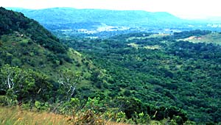
Shimba Hills Reserve in December 1997
Looking West from the Risley's Ridge Lookout
Mwele Mdogo is off in the distance with another forest in the foreground
Details

Dr. Steve Mihok, ICIPE
with EU Training Course Participants

Area: Mwele Mdogo, Shimba Hills National Reserve
Habitat: Coastal Humid Lowland Forest, Quite dense overall
Traps set mostly in clearings near narrow track running through forest
Details: 350 m asl, 4° 17' S, 39° 23' E
Season: Rainy Season, A few days with evening/early morning rain
Date: 26 November to 3 December , 1997
Design: 8x8 Latin Square in Duplicate
Odours: Acetone, Cow Urine from bottles, Octenol from Sachet

Standard: Epsilon made of Mountex Cotton, White Polyester Netting
Std Cage: Uniform top suspension system with bottle + large bag

NOTE NEW MATERIALS & ADDITIONAL TREATMENTS

In this and the companion experiment in Ethiopia, new fabrics were used as standards. These were compared to weathered versions of the old standards, along with other treatments.

The standard cotton was from a new supplier (Mount Kenya Textiles, Nanyuki). It was still pure Phthalogen Blue (Indian knock-off of Bayer IF3GM - confirmed in person with manager of the textile factory), but dyed somewhat darker than the Ethiopian cotton from Awassa Textiles, and with a peak at a slightly higher wavelength.

The standard polyester was still from Vestergaard Frandsen but was slightly different from the original Pongee #2 (slightly heavier weight and some subtle spectral differences). An opaque version of this new VF fabric was also used to make up hybrid cotton and polyester traps.

VF used three suppliers from 1995 to 1997 - starting with a company in Thailand [shiny and partially-texturised fabrics tested in Mihok (2002)], and then shifting to Cheng Cheng Textiles (original Pongee #2 tested in these trials) in Taiwan in late 1995. It then shifted to yet another company in Taiwan to produce the fabrics tested here. These three Asian companies obtained their dyes from various sources. Hence, the new lot used here was only an imitation of the original Pongee #2. VF relied on the Asian textile industry for this work and cannot provide further details on the exact dyestuffs used.

Trap Codes

These are the SAME TRAPS used just before in Ethiopia in an identical trial with a NG2G standard - same people doing the work as well.

Standard Traps
NZI-COT - Phthalogen Blue cotton drill from Mount Kenya Textiles, depth of shade is slightly darker than standard Ethiopian cotton, opaque, weight is 175 g/m²
NZI-POL - VF light-weight polyester Pongee #2 (from a new lot, nearly identical colour and texture, 75 g/m² versus 54 g/m² in original material), VF Code #10

EPSILON - Version of Bonar Industries trap made out of Mount Kenya Textiles cotton drill, with white netting instead of the grey-black netting used in Zimbabwe
Additional Treatments

COT OLD - Nzi trap made of Ethiopian cotton drill, allowed to weather for three months in full sun at high altitude at Nairobi (noticeably faded - spectra differ considerably from new material)

POL OLD - Nzi trap made of light blue KVF polyester Pongee #2, allowed to weather for three months in full sun at high altitude at Nairobi (looks nearly new - spectra almost identical)

POL OPQ - Nzi trap made from a new lot of OPAQUE VF blue and black polyester, VF Code #15, 136 g/m²

BLK/BLU - Nzi trap made from BLACK cotton drill and BLUE opaque polyester

BLU/BLK - Nzi trap made from BLUE cotton drill and BLACK opaque polyester
All traps have the same kind of VF white polyester netting
OLD Traps were weathered in Nairobi from 15 July to 17 October 1996
This is a mostly dry period with a mixture of sun and cloud

The Epsilon trap is described in the FAO Tsetse training manuals and is illustrated in the following publication:

Hargrove, J.W. & Langley, P.A. (1990) Sterilizing tsetse in the field: a successful field trial. Bulletin of Entomological Research 80, 397-403.

Site Effects

The data can also be analyzed/adjusted by the variable SCREEN$, but note that this factor is not balanced across Latin Square replicates. SCREEN$ holds a code for the local environment in terms of vegetation / sunlight at the trap site. As the traps were set, I took advantage of a few natural clearings to set some traps in very open sites in the "SUN". The transect ran along a narrow road in a large, dense forest. Hence most sites near the road were entered with the code "SPARSE", indicating a mixture of sun and shade. I also managed to find a few narrow elephant trails off the road; these were classed as being in the "SHADE".

I have colour slides of all sites taken during fair weather on the first day. Visibility/habitat had major effects mainly on Glossina pallidipes - with greatly increased catches in open clearings in the "SUN". This is the phenomenon documented by Vale (1998) in Zimbabwe.

Vale, G.A. (1998) Responses of tsetse flies (Diptera: Glossinidae) to vegetation in Zimbabwe: implications for population distribution and bait siting. Bulletin of Entomological Research 88 Supplement 1, S7-S59.
Photos from Day 1, November 26, 1997 about 9-11 am
Standing about 10 metres in front of trap
Shade | Sparse | Sun
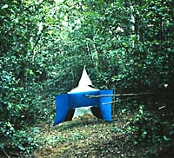 | 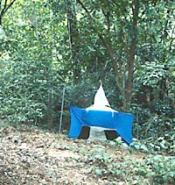 | 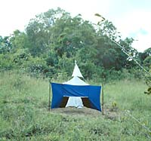
Elephant Pathway  Site #13 POL-OLD | Road verge  Site #15 NZI-POL | Large clearing  Site #9 NZI-COT
Worst site for G. pallidipes  Poor site for G. brevipalpis | Poor site for G. pallidipes  Mid site for G. brevipalpis | Best site for G. pallidipes  Good site for G. brevipalpis

Detransformed Mean Catches at Each Trap Site
Sorted by Catch of Glossina pallidipes
Category | Site | G. pallidipes | G. brevipalpis | G. austeni | Tabanidae | Stomoxyinae | Muscinae
SHADE | 13 | 9.6 | 9.6 | 0.5 | 0.1 | 0.0 | 0.5
SHADE | 14 | 11.6 | 11.0 | 0.4 | 0.3 | 0.1 | 0.3
SHADE | 11 | 17.6 | 3.1 | 0.3 | 0.4 | 0.0 | 0.2
SPARSE | 15 | 26.0 | 11.8 | 0.8 | 0.6 | 0.1 | 0.0
SPARSE | 12 | 32.2 | 8.5 | 1.4 | 0.5 | 0.4 | 0.5
SHADE | 16 | 40.3 | 13.6 | 0.4 | 0.7 | 0.1 | 0.1
SPARSE | 1 | 54.2 | 27.3 | 0.9 | 0.8 | 0.3 | 1.2
SPARSE | 10 | 63.3 | 17.4 | 1.5 | 0.8 | 0.0 | 0.5
SUN | 7 | 72.3 | 10.3 | 0.9 | 1.2 | 0.1 | 1.3
SPARSE | 3 | 86.1 | 10.1 | 0.9 | 0.3 | 0.0 | 0.6
SHADE | 4 | 108.7 | 7.6 | 2.4 | 0.8 | 0.1 | 0.5
SUN | 8 | 167.8 | 12.2 | 1.1 | 2.3 | 0.0 | 0.6
SUN | 6 | 180.8 | 17.3 | 0.8 | 5.0 | 0.5 | 6.6
SUN | 2 | 196.4 | 19.5 | 4.2 | 7.5 | 0.5 | 5.0
SUN | 5 | 200.0 | 28.7 | 1.4 | 3.3 | 0.3 | 3.7
SUN | 9 | 223.4 | 25.2 | 0.2 | 4.0 | 0.6 | 6.9

Fabrics

Note many subtle differences in fabrics are being tested for their significance to the catch

Fabrics denoted with "=" are simply new lots of the same material
Fabrics denoted with "~" are nearly the same, but not identical

 | Blue |  | Black |  | Netting
Trap | Code | Notes | Code | Notes | Code | Notes
Nzi Trap Standards (New materials used)
POL | 162  ~101 | Standard Polyester Fabric (New Lot)  VF #10 Phthalogen Blue Pongee 2 Polyester, Lot #2 Jan, 1997 (75 g/m²) | 102 | Standard  Matching Black | 179  =103 | Standard (New lot)  VF #13 White Polynet
COT | 184  ~105 | Standard Cotton Fabric (New Lot)  Mountex, Kenya Phthalogen Blue Drill Lot #2 May 1997 | 185  ~106 | Standard  Matching Black | 179  =103 | Standard (New lot)  VF #13 White Polynet
Old Standards- Weathered for 3 months in Nairobi
POL-OLD | 101 | Standard Polyester Fabric  VF #10 Phthalogen Blue Pongee 2 Polyester, Lot #1 Mar, 1996 (54 g/m²) | 102 | Standard  Matching Black | 103 | Standard  VF #13 White Polynet
COT-OLD | 107  =105 | Standard Cotton Fabric  Ethiopia Awassa Textiles Phthalogen Blue Drill, Lot #2 May 1996 | 106 | Standard  Matching Black | 103 | Standard  VF #13 White Polynet
Local Standard - (not exactly "local", tested to confirm poor performance in Kenya vs Zimbabwe)
EPSILON | 184 | Standard Cotton Fabric (New Lot)  Mountex, Kenya Phthalogen Blue Drill Lot #2 May 1997 | 185 | Standard  Matching Black | 179  =103 | Standard (New lot)  VF #13 White Polynet

…. CONTINUED

 | Blue |  | Black |  | Netting
Trap | Code | Notes | Code | Notes | Code | Notes
Opaque Polyester Trap AND COMPLEMENTARY Hybrid Traps from Opaque Cotton and Polyester
POL-OPQ | 161  ~162 | Opaque NEW Polyester Fabric  VF #15 Phthalogen Blue Pongee 2 Polyester, Lot #2 Jan, 1997 (136 g/m²)  Code ART RTM 11470 | 160  ~102 | Opaque NEW  Polyester  VF #16 | 179  =103 | Standard (New lot)  VF #13 White Polynet
BLK-BLU | 161  ~162 | Opaque NEW Polyester Fabric  VF #15 Phthalogen Blue Pongee 2 Polyester, Lot #2 Jan, 1997 (136 g/m²)  Code ART RTM 11470 | 185  ~106 | Standard  Mountex Kenya Cotton Drill | 179  =103 | Standard (New lot)  VF #13 White Polynet
BLU-BLK | 184  ~105 | Standard Cotton Fabric (New Lot)  Mountex, Kenya Phthalogen Blue Drill Lot #2 May 1997 | 160  ~102 | Opaque NEW  Polyester  VF #16 | 179  =103 | Standard (New lot)  VF #13 White Polynet

Weathering Effects
See also later graphs - especially for fading of black cotton, darkening of netting
Blue cotton fades somewhat at 3 months, Polyester with only a subtle change
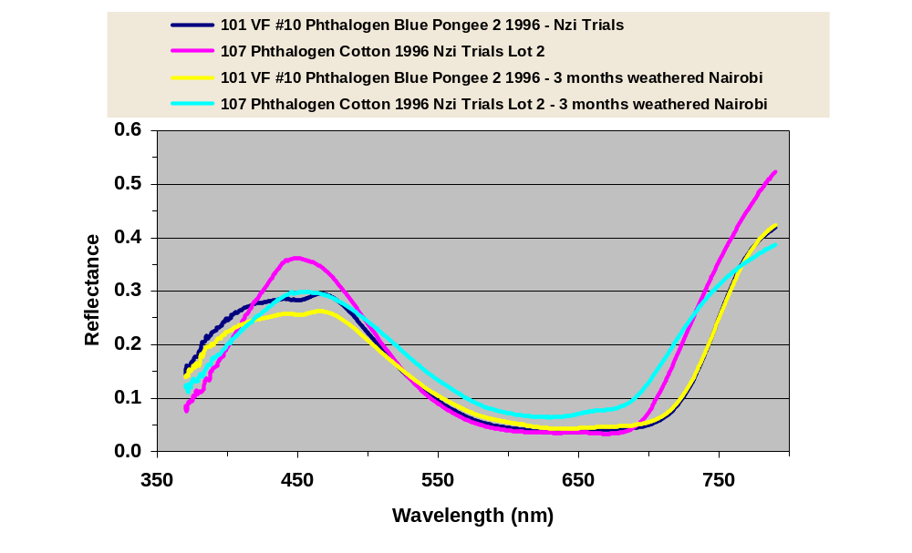

New Lots of Polyester/Cotton
Note reddish tint in new polyester, better defined blue peak
Kenyan Phthalogen Blue is dyed darker with peak at slightly higher wavelength
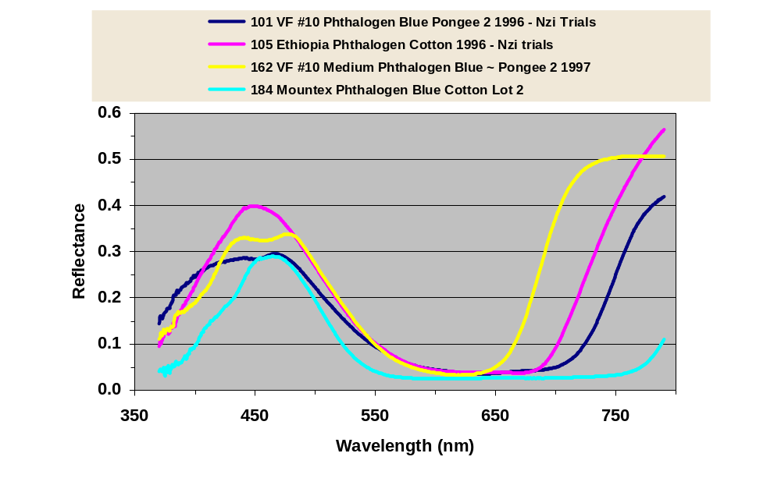

Blue

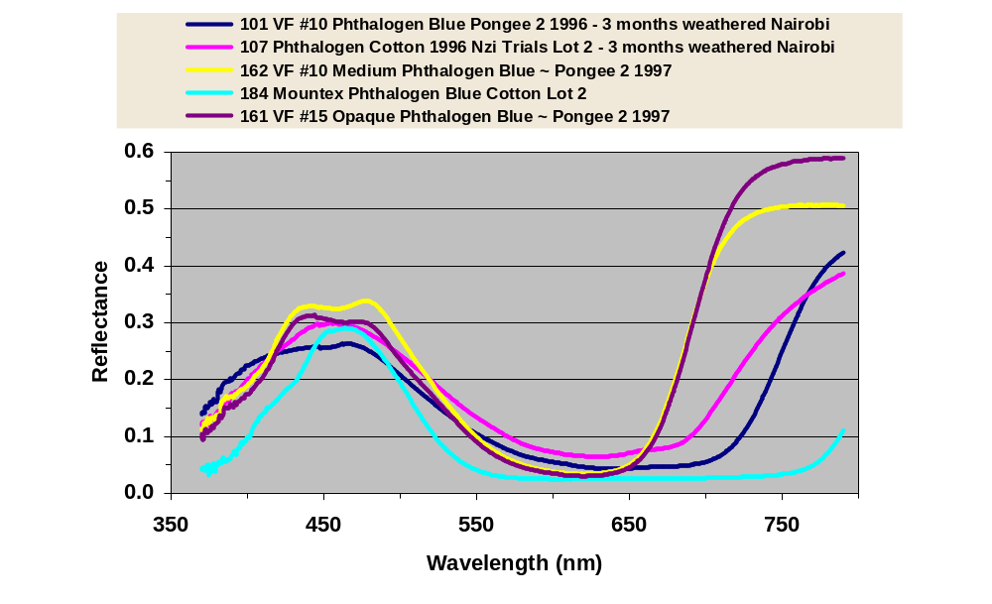

Black

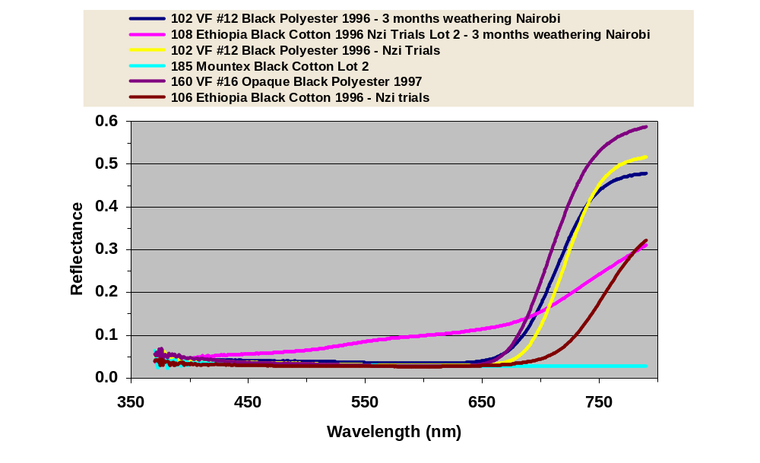

Netting

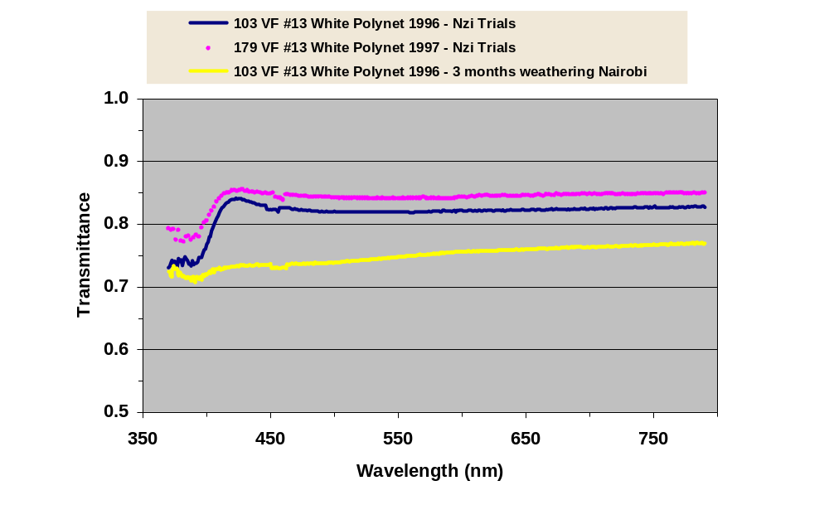

ANOVAS

SYSTAT Rectangular file d:\personal\Trials\final\Kenya\TrShimba.SYD,
created Thu May 18, 2006 at 12:46:41, contains variables:
AREA$ LATITUDE$ LONGITUDE$ SITE DATE RISK
TRAP$ DAY HRSET HRCHK MINT MAXT
WEATHER EXPT$ ODOURS$ HABITAT$ CALCITRANS TAENIATUS
NIGER BOUETI TRANSVITTATU INORNATUS PALLIDUS VARIPES
OCHROSOMA BRUNNIPES BILINEATUS SITIENS OMEGA STOMOXYS
RHINOMUSCA RDUM RDUF STOMOXYINAE SINM SINF
SBIM SBIF STAM STAF SBRM SBRF
SNIM SNIF SCAM SCAF SBOM SBOF
SVAM SVAF SOCM SOCF SPAM SPAF
STRM STRF SSIM SSIF SOMM SOMF
MUSCA CRASSIROSTRI MUSCINAE TABANUS TAENIOLA VARIATUS
BIGUTTATUS LAVERANI FRATERNUS THORACINUS ATRIMANUS PAR
GRATUS CONIFORMIS LEUCOSTOMUS INSIGNIS UNILINEATUS COPEMANI
PULLULUS CONSPICUUS LIVENTIPES XTABANUS HAEMATOPOTA POTTSI
SIMILIS DENSHAMI ALBIHIRTA PATELLICORNE VULNERANS HIRTA
NOCENS THEOBALDI RUBENS MACULOSIFACI BRUNNESCENS XHAEMATOPOTA
MESOMYIA ATYLOTUS AGRESTIS AFUSCIPES PHILOLICHE SAGITTARIA
ZONATA MAKUENI DISTINCTA ELONGATA XPHILOLICHE ANCALA
HYBOMITRA TABANIDAE HAEMATOBIA MINUTA XHAEMATOBIA SPINGERA
IRRITANS ORTHELLIA OTHER CALLIPHORIDA HYMENOPTERA SARCOPHAGIDA
COMMENT$ EXPCOMM$ SYRPHIDAE ASILIDAE HAEMATOBOSCA AURATA
HAURM HAURF LATIFRONS HLAM HLAF HIRTIFRONS
HHIM HHIF SQUALIDA HSQM HSQF PROSTOMOXYS
PSAM PSAF STYGEROMYIA MACULOSA SMAM SMAF
SANGUINARIA SSAM SSAF MPALL FPALL MLONG
FLONG MBREV FBREV MAUST FAUST MSWYN
FSWYN MFUSC FFUSC MMORS FMORS MCENT
FCENT MSUBM FSUBM MTACH FTACH MPALP
FPALP MPALG FPALG TACH PALP PALG
CENT SUBM MORS PALL LONG BREV
AUST SWYN FUSC REPLICATE ZONE$ LOCATION$
HIPPOBOSCA CAMELINA LONGIPENNIS XHIPPOBOSCA EUANCALA CHRYSOPS
BICOLOR FUSCIPENNIS XCHRYSOPS SCREEN$ SIDE ORIENTATION
CONFIGURATIO SURFACE HEIGHT COUNTRY$ ELEVATION PERSON$
SOURCE$ FLIES$ SEASON$ ALBIPALPUS LINEOLA FUSCICOSTATU
LEUCOTABANUS LIMBATINERVI TABOTHER

***WARNING***
The file
d:\personal\Trials\final\Kenya\TrShimba.SYD
was read for processing, and its contents have been replaced by saving
the processed data into it.

192 cases and 214 variables processed and saved.

Frequencies
SITE (rows) by DAY (columns)
TRAP$ = BLK/BLU

1 2 3 4 5 6 7
+---------------------------------------------------------+
1 | 0 1 0 0 0 0 0 |
2 | 0 0 1 0 0 0 0 |
3 | 0 0 0 1 0 0 0 |
4 | 0 0 0 0 1 0 0 |
5 | 0 0 0 0 0 1 0 |
6 | 0 0 0 0 0 0 1 |
7 | 0 0 0 0 0 0 0 |
8 | 1 0 0 0 0 0 0 |
9 | 0 0 0 0 0 1 0 |
10 | 0 0 0 0 0 0 1 |
11 | 0 0 0 0 0 0 0 |
12 | 1 0 0 0 0 0 0 |
13 | 0 1 0 0 0 0 0 |
14 | 0 0 1 0 0 0 0 |
15 | 0 0 0 1 0 0 0 |
16 | 0 0 0 0 1 0 0 |
+---------------------------------------------------------+
Total 2 2 2 2 2 2 2

8 Total
+---------+
1 | 0 | 1
2 | 0 | 1
3 | 0 | 1
4 | 0 | 1
5 | 0 | 1
6 | 0 | 1
7 | 1 | 1
8 | 0 | 1
9 | 0 | 1
10 | 0 | 1
11 | 1 | 1
12 | 0 | 1
13 | 0 | 1
14 | 0 | 1
15 | 0 | 1
16 | 0 | 1
+---------+
Total 2 16

TRAP$ = BLU/BLK

1 2 3 4 5 6 7
+---------------------------------------------------------+
1 | 0 0 1 0 0 0 0 |
2 | 0 0 0 1 0 0 0 |
3 | 0 0 0 0 1 0 0 |
4 | 0 0 0 0 0 1 0 |
5 | 0 0 0 0 0 0 1 |
6 | 0 0 0 0 0 0 0 |
7 | 1 0 0 0 0 0 0 |
8 | 0 1 0 0 0 0 0 |
9 | 0 0 0 1 0 0 0 |
10 | 0 0 0 0 1 0 0 |
11 | 0 0 0 0 0 1 0 |
12 | 0 0 0 0 0 0 1 |
13 | 0 0 0 0 0 0 0 |
14 | 1 0 0 0 0 0 0 |
15 | 0 1 0 0 0 0 0 |
16 | 0 0 1 0 0 0 0 |
+---------------------------------------------------------+
Total 2 2 2 2 2 2 2

8 Total
+---------+
1 | 0 | 1
2 | 0 | 1
3 | 0 | 1
4 | 0 | 1
5 | 0 | 1
6 | 1 | 1
7 | 0 | 1
8 | 0 | 1
9 | 0 | 1
10 | 0 | 1
11 | 0 | 1
12 | 0 | 1
13 | 1 | 1
14 | 0 | 1
15 | 0 | 1
16 | 0 | 1
+---------+
Total 2 16

TRAP$ = COT OLD

1 2 3 4 5 6 7
+---------------------------------------------------------+
1 | 0 0 0 0 0 1 0 |
2 | 0 0 0 0 0 0 1 |
3 | 0 0 0 0 0 0 0 |
4 | 1 0 0 0 0 0 0 |
5 | 0 1 0 0 0 0 0 |
6 | 0 0 1 0 0 0 0 |
7 | 0 0 0 1 0 0 0 |
8 | 0 0 0 0 1 0 0 |
9 | 0 1 0 0 0 0 0 |
10 | 0 0 1 0 0 0 0 |
11 | 0 0 0 1 0 0 0 |
12 | 0 0 0 0 1 0 0 |
13 | 0 0 0 0 0 1 0 |
14 | 0 0 0 0 0 0 1 |
15 | 0 0 0 0 0 0 0 |
16 | 1 0 0 0 0 0 0 |
+---------------------------------------------------------+
Total 2 2 2 2 2 2 2

8 Total
+---------+
1 | 0 | 1
2 | 0 | 1
3 | 1 | 1
4 | 0 | 1
5 | 0 | 1
6 | 0 | 1
7 | 0 | 1
8 | 0 | 1
9 | 0 | 1
10 | 0 | 1
11 | 0 | 1
12 | 0 | 1
13 | 0 | 1
14 | 0 | 1
15 | 1 | 1
16 | 0 | 1
+---------+
Total 2 16

TRAP$ = EPSILON

1 2 3 4 5 6 7
+---------------------------------------------------------+
1 | 0 0 0 1 0 0 0 |
2 | 0 0 0 0 1 0 0 |
3 | 0 0 0 0 0 1 0 |
4 | 0 0 0 0 0 0 1 |
5 | 0 0 0 0 0 0 0 |
6 | 1 0 0 0 0 0 0 |
7 | 0 1 0 0 0 0 0 |
8 | 0 0 1 0 0 0 0 |
9 | 0 0 0 0 0 0 0 |
10 | 1 0 0 0 0 0 0 |
11 | 0 1 0 0 0 0 0 |
12 | 0 0 1 0 0 0 0 |
13 | 0 0 0 1 0 0 0 |
14 | 0 0 0 0 1 0 0 |
15 | 0 0 0 0 0 1 0 |
16 | 0 0 0 0 0 0 1 |
+---------------------------------------------------------+
Total 2 2 2 2 2 2 2

8 Total
+---------+
1 | 0 | 1
2 | 0 | 1
3 | 0 | 1
4 | 0 | 1
5 | 1 | 1
6 | 0 | 1
7 | 0 | 1
8 | 0 | 1
9 | 1 | 1
10 | 0 | 1
11 | 0 | 1
12 | 0 | 1
13 | 0 | 1
14 | 0 | 1
15 | 0 | 1
16 | 0 | 1
+---------+
Total 2 16

TRAP$ = NZI-COT

1 2 3 4 5 6 7
+---------------------------------------------------------+
1 | 0 0 0 0 0 0 0 |
2 | 1 0 0 0 0 0 0 |
3 | 0 1 0 0 0 0 0 |
4 | 0 0 1 0 0 0 0 |
5 | 0 0 0 1 0 0 0 |
6 | 0 0 0 0 1 0 0 |
7 | 0 0 0 0 0 1 0 |
8 | 0 0 0 0 0 0 1 |
9 | 1 0 0 0 0 0 0 |
10 | 0 1 0 0 0 0 0 |
11 | 0 0 1 0 0 0 0 |
12 | 0 0 0 1 0 0 0 |
13 | 0 0 0 0 1 0 0 |
14 | 0 0 0 0 0 1 0 |
15 | 0 0 0 0 0 0 1 |
16 | 0 0 0 0 0 0 0 |
+---------------------------------------------------------+
Total 2 2 2 2 2 2 2

8 Total
+---------+
1 | 1 | 1
2 | 0 | 1
3 | 0 | 1
4 | 0 | 1
5 | 0 | 1
6 | 0 | 1
7 | 0 | 1
8 | 0 | 1
9 | 0 | 1
10 | 0 | 1
11 | 0 | 1
12 | 0 | 1
13 | 0 | 1
14 | 0 | 1
15 | 0 | 1
16 | 1 | 1
+---------+
Total 2 16

TRAP$ = NZI-POL

1 2 3 4 5 6 7
+---------------------------------------------------------+
1 | 0 0 0 0 1 0 0 |
2 | 0 0 0 0 0 1 0 |
3 | 0 0 0 0 0 0 1 |
4 | 0 0 0 0 0 0 0 |
5 | 1 0 0 0 0 0 0 |
6 | 0 1 0 0 0 0 0 |
7 | 0 0 1 0 0 0 0 |
8 | 0 0 0 1 0 0 0 |
9 | 0 0 1 0 0 0 0 |
10 | 0 0 0 1 0 0 0 |
11 | 0 0 0 0 1 0 0 |
12 | 0 0 0 0 0 1 0 |
13 | 0 0 0 0 0 0 1 |
14 | 0 0 0 0 0 0 0 |
15 | 1 0 0 0 0 0 0 |
16 | 0 1 0 0 0 0 0 |
+---------------------------------------------------------+
Total 2 2 2 2 2 2 2

8 Total
+---------+
1 | 0 | 1
2 | 0 | 1
3 | 0 | 1
4 | 1 | 1
5 | 0 | 1
6 | 0 | 1
7 | 0 | 1
8 | 0 | 1
9 | 0 | 1
10 | 0 | 1
11 | 0 | 1
12 | 0 | 1
13 | 0 | 1
14 | 1 | 1
15 | 0 | 1
16 | 0 | 1
+---------+
Total 2 16

TRAP$ = POL OLD

1 2 3 4 5 6 7
+---------------------------------------------------------+
1 | 0 0 0 0 0 0 1 |
2 | 0 0 0 0 0 0 0 |
3 | 1 0 0 0 0 0 0 |
4 | 0 1 0 0 0 0 0 |
5 | 0 0 1 0 0 0 0 |
6 | 0 0 0 1 0 0 0 |
7 | 0 0 0 0 1 0 0 |
8 | 0 0 0 0 0 1 0 |
9 | 0 0 0 0 1 0 0 |
10 | 0 0 0 0 0 1 0 |
11 | 0 0 0 0 0 0 1 |
12 | 0 0 0 0 0 0 0 |
13 | 1 0 0 0 0 0 0 |
14 | 0 1 0 0 0 0 0 |
15 | 0 0 1 0 0 0 0 |
16 | 0 0 0 1 0 0 0 |
+---------------------------------------------------------+
Total 2 2 2 2 2 2 2

8 Total
+---------+
1 | 0 | 1
2 | 1 | 1
3 | 0 | 1
4 | 0 | 1
5 | 0 | 1
6 | 0 | 1
7 | 0 | 1
8 | 0 | 1
9 | 0 | 1
10 | 0 | 1
11 | 0 | 1
12 | 1 | 1
13 | 0 | 1
14 | 0 | 1
15 | 0 | 1
16 | 0 | 1
+---------+
Total 2 16

TRAP$ = POL OPQ

1 2 3 4 5 6 7
+---------------------------------------------------------+
1 | 1 0 0 0 0 0 0 |
2 | 0 1 0 0 0 0 0 |
3 | 0 0 1 0 0 0 0 |
4 | 0 0 0 1 0 0 0 |
5 | 0 0 0 0 1 0 0 |
6 | 0 0 0 0 0 1 0 |
7 | 0 0 0 0 0 0 1 |
8 | 0 0 0 0 0 0 0 |
9 | 0 0 0 0 0 0 1 |
10 | 0 0 0 0 0 0 0 |
11 | 1 0 0 0 0 0 0 |
12 | 0 1 0 0 0 0 0 |
13 | 0 0 1 0 0 0 0 |
14 | 0 0 0 1 0 0 0 |
15 | 0 0 0 0 1 0 0 |
16 | 0 0 0 0 0 1 0 |
+---------------------------------------------------------+
Total 2 2 2 2 2 2 2

8 Total
+---------+
1 | 0 | 1
2 | 0 | 1
3 | 0 | 1
4 | 0 | 1
5 | 0 | 1
6 | 0 | 1
7 | 0 | 1
8 | 1 | 1
9 | 0 | 1
10 | 1 | 1
11 | 0 | 1
12 | 0 | 1
13 | 0 | 1
14 | 0 | 1
15 | 0 | 1
16 | 0 | 1
+---------+
Total 2 16

Effects coding used for categorical variables in model.

Categorical values encountered during processing are:
TRAP$ (8 levels)
BLK/BLU, BLU/BLK, COT OLD, EPSILON, NZI-COT, NZI-POL, POL OLD, POL OPQ
REPLICATE (2 levels)
1, 2
SITE (16 levels)
1, 2, 3, 4, 5, 6, 7,
8, 9, 10, 11, 12, 13, 14,
15, 16
DAY (8 levels)
1, 2, 3, 4, 5, 6, 7,
8
64 case(s) deleted due to missing data.

Dep Var: PALL N: 128 Multiple R: 0.907 Squared multiple R: 0.823

Analysis of Variance
Source Sum-of-Squares df Mean-Square F-ratio P

TRAP$ 0.962 7 0.137 2.355 0.029
REPLICATE 10.354 1 10.354 177.396 0.000
DAY 2.419 7 0.346 5.921 0.000
SITE(REPLICATE) 12.844 14 0.917 15.719 0.000

Error 5.720 98 0.058

-------------------------------------------------------------------------------

Least squares means
LS Mean SE N
TRAP$ =BLK/BLU 1.860 0.060 16
TRAP$ =BLU/BLK 1.847 0.060 16
TRAP$ =COT OLD 1.761 0.060 16
TRAP$ =EPSILON 1.594 0.060 16
TRAP$ =NZI-COT 1.824 0.060 16
TRAP$ =NZI-POL 1.867 0.060 16
TRAP$ =POL OLD 1.867 0.060 16
TRAP$ =POL OPQ 1.777 0.060 16

-------------------------------------------------------------------------------
REPLICATE =1 2.084 0.030 64
REPLICATE =2 1.515 0.030 64

-------------------------------------------------------------------------------
DAY =1 1.960 0.060 16
DAY =2 1.847 0.060 16
DAY =3 1.982 0.060 16
DAY =4 1.714 0.060 16
DAY =5 1.674 0.060 16
DAY =6 1.752 0.060 16
DAY =7 1.903 0.060 16
DAY =8 1.567 0.060 16

-------------------------------------------------------------------------------
SITE =1
REPLICATE =1 1.742 0.085 8
SITE =2
REPLICATE =1 2.295 0.085 8
SITE =3
REPLICATE =1 1.940 0.085 8
SITE =4
REPLICATE =1 2.040 0.085 8
SITE =5
REPLICATE =1 2.303 0.085 8
SITE =6
REPLICATE =1 2.260 0.085 8
SITE =7
REPLICATE =1 1.865 0.085 8
SITE =8
REPLICATE =1 2.227 0.085 8
SITE =9
REPLICATE =2 2.351 0.085 8
SITE =10
REPLICATE =2 1.808 0.085 8
SITE =11
REPLICATE =2 1.269 0.085 8
SITE =12
REPLICATE =2 1.521 0.085 8
SITE =13
REPLICATE =2 1.025 0.085 8
SITE =14
REPLICATE =2 1.102 0.085 8
SITE =15
REPLICATE =2 1.431 0.085 8
SITE =16
REPLICATE =2 1.616 0.085 8

-------------------------------------------------------------------------------
*** WARNING ***
Case 61 is an outlier (Studentized Residual = -3.686)
Case 113 is an outlier (Studentized Residual = -4.283)

Durbin-Watson D Statistic 1.420
First Order Autocorrelation 0.271
COL/
ROW TRAP$
1 BLK/BLU
2 BLU/BLK
3 COT OLD
4 EPSILON
5 NZI-COT
6 NZI-POL
7 POL OLD
8 POL OPQ
Using least squares means.
Post Hoc test of PALL

-------------------------------------------------------------------------------
Using model MSE of 0.058 with 98 df.

Matrix of pairwise mean differences:
1 2 3 4 5
1 0.000
2 -0.013 0.000
3 -0.099 -0.086 0.000
4 -0.267 -0.254 -0.167 0.000
5 -0.036 -0.023 0.063 0.231 0.000
6 0.006 0.019 0.106 0.273 0.042
7 0.006 0.019 0.106 0.273 0.042
8 -0.084 -0.071 0.016 0.183 -0.048

6 7 8
6 0.000
7 0.000 0.000
8 -0.090 -0.090 0.000

Tukey HSD Multiple Comparisons.

Matrix of pairwise comparison probabilities:
1 2 3 4 5
1 1.000
2 1.000 1.000
3 0.940 0.972 1.000
4 0.046 0.070 0.514 1.000
5 1.000 1.000 0.995 0.134 1.000
6 1.000 1.000 0.918 0.038 1.000
7 1.000 1.000 0.918 0.038 1.000
8 0.976 0.991 1.000 0.396 0.999

6 7 8
6 1.000
7 1.000 1.000
8 0.964 0.964 1.000

-------------------------------------------------------------------------------

Effects coding used for categorical variables in model.

Categorical values encountered during processing are:
TRAP$ (8 levels)
BLK/BLU, BLU/BLK, COT OLD, EPSILON, NZI-COT, NZI-POL, POL OLD, POL OPQ
REPLICATE (2 levels)
1, 2
SITE (16 levels)
1, 2, 3, 4, 5, 6, 7,
8, 9, 10, 11, 12, 13, 14,
15, 16
DAY (8 levels)
1, 2, 3, 4, 5, 6, 7,
8
64 case(s) deleted due to missing data.

Dep Var: MPALL N: 128 Multiple R: 0.890 Squared multiple R: 0.791

Analysis of Variance
Source Sum-of-Squares df Mean-Square F-ratio P

TRAP$ 1.106 7 0.158 2.524 0.020
REPLICATE 9.358 1 9.358 149.504 0.000
DAY 1.473 7 0.210 3.363 0.003
SITE(REPLICATE) 11.336 14 0.810 12.936 0.000

Error 6.134 98 0.063

-------------------------------------------------------------------------------

Least squares means
LS Mean SE N
TRAP$ =BLK/BLU 1.295 0.063 16
TRAP$ =BLU/BLK 1.297 0.063 16
TRAP$ =COT OLD 1.169 0.063 16
TRAP$ =EPSILON 1.070 0.063 16
TRAP$ =NZI-COT 1.231 0.063 16
TRAP$ =NZI-POL 1.394 0.063 16
TRAP$ =POL OLD 1.319 0.063 16
TRAP$ =POL OPQ 1.248 0.063 16

-------------------------------------------------------------------------------
REPLICATE =1 1.523 0.031 64
REPLICATE =2 0.982 0.031 64

-------------------------------------------------------------------------------
DAY =1 1.355 0.063 16
DAY =2 1.298 0.063 16
DAY =3 1.406 0.063 16
DAY =4 1.171 0.063 16
DAY =5 1.083 0.063 16
DAY =6 1.206 0.063 16
DAY =7 1.348 0.063 16
DAY =8 1.156 0.063 16

-------------------------------------------------------------------------------
SITE =1
REPLICATE =1 1.204 0.088 8
SITE =2
REPLICATE =1 1.770 0.088 8
SITE =3
REPLICATE =1 1.359 0.088 8
SITE =4
REPLICATE =1 1.575 0.088 8
SITE =5
REPLICATE =1 1.663 0.088 8
SITE =6
REPLICATE =1 1.737 0.088 8
SITE =7
REPLICATE =1 1.237 0.088 8
SITE =8
REPLICATE =1 1.642 0.088 8
SITE =9
REPLICATE =2 1.779 0.088 8
SITE =10
REPLICATE =2 1.175 0.088 8
SITE =11
REPLICATE =2 0.765 0.088 8
SITE =12
REPLICATE =2 1.021 0.088 8
SITE =13
REPLICATE =2 0.627 0.088 8
SITE =14
REPLICATE =2 0.522 0.088 8
SITE =15
REPLICATE =2 0.938 0.088 8
SITE =16
REPLICATE =2 1.032 0.088 8

-------------------------------------------------------------------------------
*** WARNING ***
Case 46 is an outlier (Studentized Residual = -3.458)

Durbin-Watson D Statistic 1.597
First Order Autocorrelation 0.182
COL/
ROW TRAP$
1 BLK/BLU
2 BLU/BLK
3 COT OLD
4 EPSILON
5 NZI-COT
6 NZI-POL
7 POL OLD
8 POL OPQ
Using least squares means.
Post Hoc test of MPALL

-------------------------------------------------------------------------------
Using model MSE of 0.063 with 98 df.

Matrix of pairwise mean differences:
1 2 3 4 5
1 0.000
2 0.002 0.000
3 -0.126 -0.128 0.000
4 -0.225 -0.227 -0.099 0.000
5 -0.064 -0.066 0.063 0.161 0.000
6 0.099 0.098 0.226 0.324 0.163
7 0.024 0.022 0.150 0.249 0.088
8 -0.047 -0.049 0.079 0.178 0.016

6 7 8
6 0.000
7 -0.075 0.000
8 -0.147 -0.071 0.000

Tukey HSD Multiple Comparisons.

Matrix of pairwise comparison probabilities:
1 2 3 4 5
1 1.000
2 1.000 1.000
3 0.842 0.832 1.000
4 0.189 0.182 0.952 1.000
5 0.996 0.995 0.997 0.606 1.000
6 0.951 0.955 0.187 0.009 0.593
7 1.000 1.000 0.688 0.103 0.975
8 0.999 0.999 0.986 0.481 1.000

6 7 8
6 1.000
7 0.989 1.000
8 0.714 0.992 1.000

-------------------------------------------------------------------------------

Effects coding used for categorical variables in model.

Categorical values encountered during processing are:
TRAP$ (8 levels)
BLK/BLU, BLU/BLK, COT OLD, EPSILON, NZI-COT, NZI-POL, POL OLD, POL OPQ
REPLICATE (2 levels)
1, 2
SITE (16 levels)
1, 2, 3, 4, 5, 6, 7,
8, 9, 10, 11, 12, 13, 14,
15, 16
DAY (8 levels)
1, 2, 3, 4, 5, 6, 7,
8
64 case(s) deleted due to missing data.

Dep Var: FPALL N: 128 Multiple R: 0.904 Squared multiple R: 0.817

Analysis of Variance
Source Sum-of-Squares df Mean-Square F-ratio P

TRAP$ 0.837 7 0.120 1.969 0.067
REPLICATE 10.037 1 10.037 165.195 0.000
DAY 2.906 7 0.415 6.833 0.000
SITE(REPLICATE) 12.864 14 0.919 15.123 0.000

Error 5.955 98 0.061

-------------------------------------------------------------------------------

Least squares means
LS Mean SE N
TRAP$ =BLK/BLU 1.727 0.062 16
TRAP$ =BLU/BLK 1.706 0.062 16
TRAP$ =COT OLD 1.627 0.062 16
TRAP$ =EPSILON 1.469 0.062 16
TRAP$ =NZI-COT 1.706 0.062 16
TRAP$ =NZI-POL 1.690 0.062 16
TRAP$ =POL OLD 1.725 0.062 16
TRAP$ =POL OPQ 1.630 0.062 16

-------------------------------------------------------------------------------
REPLICATE =1 1.940 0.031 64
REPLICATE =2 1.380 0.031 64

-------------------------------------------------------------------------------
DAY =1 1.839 0.062 16
DAY =2 1.704 0.062 16
DAY =3 1.849 0.062 16
DAY =4 1.598 0.062 16
DAY =5 1.555 0.062 16
DAY =6 1.618 0.062 16
DAY =7 1.753 0.062 16
DAY =8 1.366 0.062 16

-------------------------------------------------------------------------------
SITE =1
REPLICATE =1 1.599 0.087 8
SITE =2
REPLICATE =1 2.129 0.087 8
SITE =3
REPLICATE =1 1.800 0.087 8
SITE =4
REPLICATE =1 1.859 0.087 8
SITE =5
REPLICATE =1 2.186 0.087 8
SITE =6
REPLICATE =1 2.100 0.087 8
SITE =7
REPLICATE =1 1.752 0.087 8
SITE =8
REPLICATE =1 2.097 0.087 8
SITE =9
REPLICATE =2 2.214 0.087 8
SITE =10
REPLICATE =2 1.691 0.087 8
SITE =11
REPLICATE =2 1.133 0.087 8
SITE =12
REPLICATE =2 1.357 0.087 8
SITE =13
REPLICATE =2 0.872 0.087 8
SITE =14
REPLICATE =2 0.994 0.087 8
SITE =15
REPLICATE =2 1.285 0.087 8
SITE =16
REPLICATE =2 1.494 0.087 8

-------------------------------------------------------------------------------
*** WARNING ***
Case 113 is an outlier (Studentized Residual = -4.411)

Durbin-Watson D Statistic 1.445
First Order Autocorrelation 0.260
COL/
ROW TRAP$
1 BLK/BLU
2 BLU/BLK
3 COT OLD
4 EPSILON
5 NZI-COT
6 NZI-POL
7 POL OLD
8 POL OPQ
Using least squares means.
Post Hoc test of FPALL

-------------------------------------------------------------------------------
Using model MSE of 0.061 with 98 df.

Matrix of pairwise mean differences:
1 2 3 4 5
1 0.000
2 -0.021 0.000
3 -0.100 -0.079 0.000
4 -0.258 -0.237 -0.158 0.000
5 -0.021 -0.000 0.079 0.237 0.000
6 -0.037 -0.016 0.063 0.221 -0.015
7 -0.002 0.019 0.098 0.256 0.019
8 -0.097 -0.076 0.003 0.161 -0.076

6 7 8
6 0.000
7 0.035 0.000
8 -0.060 -0.095 0.000

Tukey HSD Multiple Comparisons.

Matrix of pairwise comparison probabilities:
1 2 3 4 5
1 1.000
2 1.000 1.000
3 0.943 0.985 1.000
4 0.072 0.130 0.615 1.000
5 1.000 1.000 0.985 0.130 1.000
6 1.000 1.000 0.996 0.192 1.000
7 1.000 1.000 0.949 0.076 1.000
8 0.952 0.988 1.000 0.590 0.988

6 7 8
6 1.000
7 1.000 1.000
8 0.997 0.957 1.000

-------------------------------------------------------------------------------

Effects coding used for categorical variables in model.

Categorical values encountered during processing are:
TRAP$ (8 levels)
BLK/BLU, BLU/BLK, COT OLD, EPSILON, NZI-COT, NZI-POL, POL OLD, POL OPQ
REPLICATE (2 levels)
1, 2
SITE (16 levels)
1, 2, 3, 4, 5, 6, 7,
8, 9, 10, 11, 12, 13, 14,
15, 16
DAY (8 levels)
1, 2, 3, 4, 5, 6, 7,
8
64 case(s) deleted due to missing data.

Dep Var: BREV N: 128 Multiple R: 0.858 Squared multiple R: 0.736

Analysis of Variance
Source Sum-of-Squares df Mean-Square F-ratio P

TRAP$ 7.349 7 1.050 18.564 0.000
REPLICATE 0.498 1 0.498 8.803 0.004
DAY 2.327 7 0.332 5.878 0.000
SITE(REPLICATE) 5.300 14 0.379 6.694 0.000

Error 5.543 98 0.057

-------------------------------------------------------------------------------

Least squares means
LS Mean SE N
TRAP$ =BLK/BLU 1.252 0.059 16
TRAP$ =BLU/BLK 1.370 0.059 16
TRAP$ =COT OLD 1.162 0.059 16
TRAP$ =EPSILON 0.543 0.059 16
TRAP$ =NZI-COT 1.274 0.059 16
TRAP$ =NZI-POL 1.155 0.059 16
TRAP$ =POL OLD 1.277 0.059 16
TRAP$ =POL OPQ 1.120 0.059 16

-------------------------------------------------------------------------------
REPLICATE =1 1.206 0.030 64
REPLICATE =2 1.082 0.030 64

-------------------------------------------------------------------------------
DAY =1 1.325 0.059 16
DAY =2 1.256 0.059 16
DAY =3 1.149 0.059 16
DAY =4 1.263 0.059 16
DAY =5 1.111 0.059 16
DAY =6 1.111 0.059 16
DAY =7 1.076 0.059 16
DAY =8 0.862 0.059 16

-------------------------------------------------------------------------------
SITE =1
REPLICATE =1 1.452 0.084 8
SITE =2
REPLICATE =1 1.311 0.084 8
SITE =3
REPLICATE =1 1.045 0.084 8
SITE =4
REPLICATE =1 0.934 0.084 8
SITE =5
REPLICATE =1 1.473 0.084 8
SITE =6
REPLICATE =1 1.263 0.084 8
SITE =7
REPLICATE =1 1.055 0.084 8
SITE =8
REPLICATE =1 1.120 0.084 8
SITE =9
REPLICATE =2 1.418 0.084 8
SITE =10
REPLICATE =2 1.266 0.084 8
SITE =11
REPLICATE =2 0.616 0.084 8
SITE =12
REPLICATE =2 0.976 0.084 8
SITE =13
REPLICATE =2 1.027 0.084 8
SITE =14
REPLICATE =2 1.080 0.084 8
SITE =15
REPLICATE =2 1.107 0.084 8
SITE =16
REPLICATE =2 1.165 0.084 8

-------------------------------------------------------------------------------
*** WARNING ***
Case 2 is an outlier (Studentized Residual = -4.006)

Durbin-Watson D Statistic 1.870
First Order Autocorrelation 0.046
COL/
ROW TRAP$
1 BLK/BLU
2 BLU/BLK
3 COT OLD
4 EPSILON
5 NZI-COT
6 NZI-POL
7 POL OLD
8 POL OPQ
Using least squares means.
Post Hoc test of BREV

-------------------------------------------------------------------------------
Using model MSE of 0.057 with 98 df.

Matrix of pairwise mean differences:
1 2 3 4 5
1 0.000
2 0.118 0.000
3 -0.089 -0.207 0.000
4 -0.709 -0.827 -0.619 0.000
5 0.022 -0.095 0.112 0.731 0.000
6 -0.097 -0.214 -0.007 0.612 -0.119
7 0.025 -0.093 0.114 0.734 0.003
8 -0.132 -0.250 -0.042 0.577 -0.154

6 7 8
6 0.000
7 0.121 0.000
8 -0.035 -0.157 0.000

Tukey HSD Multiple Comparisons.

Matrix of pairwise comparison probabilities:
1 2 3 4 5
1 1.000
2 0.855 1.000
3 0.963 0.224 1.000
4 0.000 0.000 0.000 1.000
5 1.000 0.947 0.886 0.000 1.000
6 0.944 0.188 1.000 0.000 0.849
7 1.000 0.954 0.873 0.000 1.000
8 0.768 0.070 1.000 0.000 0.600

6 7 8
6 1.000
7 0.834 1.000
8 1.000 0.579 1.000

-------------------------------------------------------------------------------

Effects coding used for categorical variables in model.

Categorical values encountered during processing are:
TRAP$ (8 levels)
BLK/BLU, BLU/BLK, COT OLD, EPSILON, NZI-COT, NZI-POL, POL OLD, POL OPQ
REPLICATE (2 levels)
1, 2
SITE (16 levels)
1, 2, 3, 4, 5, 6, 7,
8, 9, 10, 11, 12, 13, 14,
15, 16
DAY (8 levels)
1, 2, 3, 4, 5, 6, 7,
8
64 case(s) deleted due to missing data.

Dep Var: MBREV N: 128 Multiple R: 0.788 Squared multiple R: 0.622

Analysis of Variance
Source Sum-of-Squares df Mean-Square F-ratio P

TRAP$ 5.317 7 0.760 12.097 0.000
REPLICATE 0.113 1 0.113 1.807 0.182
DAY 1.710 7 0.244 3.891 0.001
SITE(REPLICATE) 2.970 14 0.212 3.378 0.000

Error 6.154 98 0.063

-------------------------------------------------------------------------------

Least squares means
LS Mean SE N
TRAP$ =BLK/BLU 0.834 0.063 16
TRAP$ =BLU/BLK 0.885 0.063 16
TRAP$ =COT OLD 0.691 0.063 16
TRAP$ =EPSILON 0.200 0.063 16
TRAP$ =NZI-COT 0.794 0.063 16
TRAP$ =NZI-POL 0.697 0.063 16
TRAP$ =POL OLD 0.831 0.063 16
TRAP$ =POL OPQ 0.632 0.063 16

-------------------------------------------------------------------------------
REPLICATE =1 0.725 0.031 64
REPLICATE =2 0.666 0.031 64

-------------------------------------------------------------------------------
DAY =1 0.906 0.063 16
DAY =2 0.767 0.063 16
DAY =3 0.691 0.063 16
DAY =4 0.749 0.063 16
DAY =5 0.637 0.063 16
DAY =6 0.661 0.063 16
DAY =7 0.681 0.063 16
DAY =8 0.472 0.063 16

-------------------------------------------------------------------------------
SITE =1
REPLICATE =1 0.860 0.089 8
SITE =2
REPLICATE =1 0.772 0.089 8
SITE =3
REPLICATE =1 0.655 0.089 8
SITE =4
REPLICATE =1 0.510 0.089 8
SITE =5
REPLICATE =1 0.909 0.089 8
SITE =6
REPLICATE =1 0.823 0.089 8
SITE =7
REPLICATE =1 0.596 0.089 8
SITE =8
REPLICATE =1 0.677 0.089 8
SITE =9
REPLICATE =2 1.013 0.089 8
SITE =10
REPLICATE =2 0.781 0.089 8
SITE =11
REPLICATE =2 0.414 0.089 8
SITE =12
REPLICATE =2 0.498 0.089 8
SITE =13
REPLICATE =2 0.683 0.089 8
SITE =14
REPLICATE =2 0.681 0.089 8
SITE =15
REPLICATE =2 0.691 0.089 8
SITE =16
REPLICATE =2 0.564 0.089 8

-------------------------------------------------------------------------------
*** WARNING ***
Case 2 is an outlier (Studentized Residual = -5.656)

Durbin-Watson D Statistic 2.060
First Order Autocorrelation -0.039
COL/
ROW TRAP$
1 BLK/BLU
2 BLU/BLK
3 COT OLD
4 EPSILON
5 NZI-COT
6 NZI-POL
7 POL OLD
8 POL OPQ
Using least squares means.
Post Hoc test of MBREV

-------------------------------------------------------------------------------
Using model MSE of 0.063 with 98 df.

Matrix of pairwise mean differences:
1 2 3 4 5
1 0.000
2 0.051 0.000
3 -0.143 -0.194 0.000
4 -0.634 -0.684 -0.491 0.000
5 -0.039 -0.090 0.104 0.594 0.000
6 -0.137 -0.188 0.006 0.496 -0.098
7 -0.003 -0.053 0.140 0.631 0.037
8 -0.201 -0.252 -0.058 0.432 -0.162

6 7 8
6 0.000
7 0.135 0.000
8 -0.064 -0.199 0.000

Tukey HSD Multiple Comparisons.

Matrix of pairwise comparison probabilities:
1 2 3 4 5
1 1.000
2 0.999 1.000
3 0.740 0.369 1.000
4 0.000 0.000 0.000 1.000
5 1.000 0.971 0.939 0.000 1.000
6 0.778 0.409 1.000 0.000 0.954
7 1.000 0.999 0.758 0.000 1.000
8 0.319 0.096 0.998 0.000 0.603

6 7 8
6 1.000
7 0.795 1.000
8 0.996 0.336 1.000

-------------------------------------------------------------------------------

Effects coding used for categorical variables in model.

Categorical values encountered during processing are:
TRAP$ (8 levels)
BLK/BLU, BLU/BLK, COT OLD, EPSILON, NZI-COT, NZI-POL, POL OLD, POL OPQ
REPLICATE (2 levels)
1, 2
SITE (16 levels)
1, 2, 3, 4, 5, 6, 7,
8, 9, 10, 11, 12, 13, 14,
15, 16
DAY (8 levels)
1, 2, 3, 4, 5, 6, 7,
8
64 case(s) deleted due to missing data.

Dep Var: FBREV N: 128 Multiple R: 0.827 Squared multiple R: 0.684

Analysis of Variance
Source Sum-of-Squares df Mean-Square F-ratio P

TRAP$ 5.356 7 0.765 11.062 0.000
REPLICATE 0.619 1 0.619 8.951 0.004
DAY 2.279 7 0.326 4.707 0.000
SITE(REPLICATE) 6.443 14 0.460 6.653 0.000

Error 6.778 98 0.069

-------------------------------------------------------------------------------

Least squares means
LS Mean SE N
TRAP$ =BLK/BLU 1.058 0.066 16
TRAP$ =BLU/BLK 1.202 0.066 16
TRAP$ =COT OLD 1.004 0.066 16
TRAP$ =EPSILON 0.482 0.066 16
TRAP$ =NZI-COT 1.119 0.066 16
TRAP$ =NZI-POL 1.004 0.066 16
TRAP$ =POL OLD 1.090 0.066 16
TRAP$ =POL OPQ 0.976 0.066 16

-------------------------------------------------------------------------------
REPLICATE =1 1.061 0.033 64
REPLICATE =2 0.922 0.033 64

-------------------------------------------------------------------------------
DAY =1 1.130 0.066 16
DAY =2 1.123 0.066 16
DAY =3 0.999 0.066 16
DAY =4 1.139 0.066 16
DAY =5 0.986 0.066 16
DAY =6 0.953 0.066 16
DAY =7 0.875 0.066 16
DAY =8 0.729 0.066 16

-------------------------------------------------------------------------------
SITE =1
REPLICATE =1 1.320 0.093 8
SITE =2
REPLICATE =1 1.192 0.093 8
SITE =3
REPLICATE =1 0.863 0.093 8
SITE =4
REPLICATE =1 0.801 0.093 8
SITE =5
REPLICATE =1 1.332 0.093 8
SITE =6
REPLICATE =1 1.106 0.093 8
SITE =7
REPLICATE =1 0.919 0.093 8
SITE =8
REPLICATE =1 0.958 0.093 8
SITE =9
REPLICATE =2 1.239 0.093 8
SITE =10
REPLICATE =2 1.100 0.093 8
SITE =11
REPLICATE =2 0.345 0.093 8
SITE =12
REPLICATE =2 0.856 0.093 8
SITE =13
REPLICATE =2 0.825 0.093 8
SITE =14
REPLICATE =2 0.947 0.093 8
SITE =15
REPLICATE =2 0.986 0.093 8
SITE =16
REPLICATE =2 1.079 0.093 8

-------------------------------------------------------------------------------
*** WARNING ***
Case 106 is an outlier (Studentized Residual = -3.423)

Durbin-Watson D Statistic 1.819
First Order Autocorrelation 0.072
COL/
ROW TRAP$
1 BLK/BLU
2 BLU/BLK
3 COT OLD
4 EPSILON
5 NZI-COT
6 NZI-POL
7 POL OLD
8 POL OPQ
Using least squares means.
Post Hoc test of FBREV

-------------------------------------------------------------------------------
Using model MSE of 0.069 with 98 df.

Matrix of pairwise mean differences:
1 2 3 4 5
1 0.000
2 0.144 0.000
3 -0.054 -0.197 0.000
4 -0.576 -0.720 -0.522 0.000
5 0.061 -0.082 0.115 0.637 0.000
6 -0.054 -0.198 -0.001 0.522 -0.116
7 0.032 -0.111 0.086 0.608 -0.029
8 -0.082 -0.226 -0.028 0.494 -0.143

6 7 8
6 0.000
7 0.087 0.000
8 -0.028 -0.114 0.000

Tukey HSD Multiple Comparisons.

Matrix of pairwise comparison probabilities:
1 2 3 4 5
1 1.000
2 0.781 1.000
3 0.999 0.408 1.000
4 0.000 0.000 0.000 1.000
5 0.998 0.987 0.918 0.000 1.000
6 0.999 0.404 1.000 0.000 0.916
7 1.000 0.931 0.983 0.000 1.000
8 0.987 0.241 1.000 0.000 0.784

6 7 8
6 1.000
7 0.982 1.000
8 1.000 0.922 1.000

-------------------------------------------------------------------------------

Effects coding used for categorical variables in model.

Categorical values encountered during processing are:
TRAP$ (8 levels)
BLK/BLU, BLU/BLK, COT OLD, EPSILON, NZI-COT, NZI-POL, POL OLD, POL OPQ
REPLICATE (2 levels)
1, 2
SITE (16 levels)
1, 2, 3, 4, 5, 6, 7,
8, 9, 10, 11, 12, 13, 14,
15, 16
DAY (8 levels)
1, 2, 3, 4, 5, 6, 7,
8
64 case(s) deleted due to missing data.

Dep Var: AUST N: 128 Multiple R: 0.710 Squared multiple R: 0.504

Analysis of Variance
Source Sum-of-Squares df Mean-Square F-ratio P

TRAP$ 0.075 7 0.011 0.203 0.984
REPLICATE 0.887 1 0.887 16.831 0.000
DAY 1.922 7 0.275 5.212 0.000
SITE(REPLICATE) 2.357 14 0.168 3.196 0.000

Error 5.162 98 0.053

-------------------------------------------------------------------------------

Least squares means
LS Mean SE N
TRAP$ =BLK/BLU 0.324 0.057 16
TRAP$ =BLU/BLK 0.318 0.057 16
TRAP$ =COT OLD 0.291 0.057 16
TRAP$ =EPSILON 0.259 0.057 16
TRAP$ =NZI-COT 0.309 0.057 16
TRAP$ =NZI-POL 0.290 0.057 16
TRAP$ =POL OLD 0.304 0.057 16
TRAP$ =POL OPQ 0.254 0.057 16

-------------------------------------------------------------------------------
REPLICATE =1 0.377 0.029 64
REPLICATE =2 0.211 0.029 64

-------------------------------------------------------------------------------
DAY =1 0.540 0.057 16
DAY =2 0.362 0.057 16
DAY =3 0.376 0.057 16
DAY =4 0.246 0.057 16
DAY =5 0.235 0.057 16
DAY =6 0.127 0.057 16
DAY =7 0.291 0.057 16
DAY =8 0.173 0.057 16

-------------------------------------------------------------------------------
SITE =1
REPLICATE =1 0.270 0.081 8
SITE =2
REPLICATE =1 0.714 0.081 8
SITE =3
REPLICATE =1 0.282 0.081 8
SITE =4
REPLICATE =1 0.532 0.081 8
SITE =5
REPLICATE =1 0.373 0.081 8
SITE =6
REPLICATE =1 0.252 0.081 8
SITE =7
REPLICATE =1 0.270 0.081 8
SITE =8
REPLICATE =1 0.323 0.081 8
SITE =9
REPLICATE =2 0.075 0.081 8
SITE =10
REPLICATE =2 0.395 0.081 8
SITE =11
REPLICATE =2 0.097 0.081 8
SITE =12
REPLICATE =2 0.389 0.081 8
SITE =13
REPLICATE =2 0.173 0.081 8
SITE =14
REPLICATE =2 0.151 0.081 8
SITE =15
REPLICATE =2 0.248 0.081 8
SITE =16
REPLICATE =2 0.157 0.081 8

-------------------------------------------------------------------------------
*** WARNING ***
Case 6 is an outlier (Studentized Residual = 3.410)

Durbin-Watson D Statistic 2.087
First Order Autocorrelation -0.066
COL/
ROW TRAP$
1 BLK/BLU
2 BLU/BLK
3 COT OLD
4 EPSILON
5 NZI-COT
6 NZI-POL
7 POL OLD
8 POL OPQ
Using least squares means.
Post Hoc test of AUST

-------------------------------------------------------------------------------
Using model MSE of 0.053 with 98 df.

Matrix of pairwise mean differences:
1 2 3 4 5
1 0.000
2 -0.006 0.000
3 -0.033 -0.027 0.000
4 -0.065 -0.059 -0.032 0.000
5 -0.016 -0.010 0.017 0.049 0.000
6 -0.035 -0.029 -0.002 0.031 -0.019
7 -0.020 -0.014 0.013 0.045 -0.004
8 -0.071 -0.065 -0.038 -0.005 -0.055

6 7 8
6 0.000
7 0.015 0.000
8 -0.036 -0.050 0.000

Tukey HSD Multiple Comparisons.

Matrix of pairwise comparison probabilities:
1 2 3 4 5
1 1.000
2 1.000 1.000
3 1.000 1.000 1.000
4 0.993 0.996 1.000 1.000
5 1.000 1.000 1.000 0.999 1.000
6 1.000 1.000 1.000 1.000 1.000
7 1.000 1.000 1.000 0.999 1.000
8 0.988 0.993 1.000 1.000 0.997

6 7 8
6 1.000
7 1.000 1.000
8 1.000 0.999 1.000

-------------------------------------------------------------------------------

Effects coding used for categorical variables in model.

Categorical values encountered during processing are:
TRAP$ (8 levels)
BLK/BLU, BLU/BLK, COT OLD, EPSILON, NZI-COT, NZI-POL, POL OLD, POL OPQ
REPLICATE (2 levels)
1, 2
SITE (16 levels)
1, 2, 3, 4, 5, 6, 7,
8, 9, 10, 11, 12, 13, 14,
15, 16
DAY (8 levels)
1, 2, 3, 4, 5, 6, 7,
8
64 case(s) deleted due to missing data.

Dep Var: MAUST N: 128 Multiple R: 0.563 Squared multiple R: 0.317

Analysis of Variance
Source Sum-of-Squares df Mean-Square F-ratio P

TRAP$ 0.040 7 0.006 0.345 0.931
REPLICATE 0.065 1 0.065 3.890 0.051
DAY 0.253 7 0.036 2.162 0.044
SITE(REPLICATE) 0.401 14 0.029 1.715 0.064

Error 1.639 98 0.017

-------------------------------------------------------------------------------

Least squares means
LS Mean SE N
TRAP$ =BLK/BLU 0.060 0.032 16
TRAP$ =BLU/BLK 0.049 0.032 16
TRAP$ =COT OLD 0.038 0.032 16
TRAP$ =EPSILON 0.094 0.032 16
TRAP$ =NZI-COT 0.067 0.032 16
TRAP$ =NZI-POL 0.056 0.032 16
TRAP$ =POL OLD 0.086 0.032 16
TRAP$ =POL OPQ 0.075 0.032 16

-------------------------------------------------------------------------------
REPLICATE =1 0.088 0.016 64
REPLICATE =2 0.043 0.016 64

-------------------------------------------------------------------------------
DAY =1 0.124 0.032 16
DAY =2 0.097 0.032 16
DAY =3 0.038 0.032 16
DAY =4 0.116 0.032 16
DAY =5 0.019 0.032 16
DAY =6 0.000 0.032 16
DAY =7 0.094 0.032 16
DAY =8 0.038 0.032 16

-------------------------------------------------------------------------------
SITE =1
REPLICATE =1 0.060 0.046 8
SITE =2
REPLICATE =1 0.248 0.046 8
SITE =3
REPLICATE =1 0.075 0.046 8
SITE =4
REPLICATE =1 0.075 0.046 8
SITE =5
REPLICATE =1 0.038 0.046 8
SITE =6
REPLICATE =1 0.075 0.046 8
SITE =7
REPLICATE =1 0.000 0.046 8
SITE =8
REPLICATE =1 0.135 0.046 8
SITE =9
REPLICATE =2 0.000 0.046 8
SITE =10
REPLICATE =2 0.097 0.046 8
SITE =11
REPLICATE =2 0.075 0.046 8
SITE =12
REPLICATE =2 0.075 0.046 8
SITE =13
REPLICATE =2 0.038 0.046 8
SITE =14
REPLICATE =2 0.000 0.046 8
SITE =15
REPLICATE =2 0.000 0.046 8
SITE =16
REPLICATE =2 0.060 0.046 8

-------------------------------------------------------------------------------
*** WARNING ***
Case 17 is an outlier (Studentized Residual = 3.679)

Durbin-Watson D Statistic 2.063
First Order Autocorrelation -0.037
COL/
ROW TRAP$
1 BLK/BLU
2 BLU/BLK
3 COT OLD
4 EPSILON
5 NZI-COT
6 NZI-POL
7 POL OLD
8 POL OPQ
Using least squares means.
Post Hoc test of MAUST

-------------------------------------------------------------------------------
Using model MSE of 0.017 with 98 df.

Matrix of pairwise mean differences:
1 2 3 4 5
1 0.000
2 -0.011 0.000
3 -0.022 -0.011 0.000
4 0.034 0.045 0.056 0.000
5 0.008 0.019 0.030 -0.027 0.000
6 -0.003 0.008 0.019 -0.038 -0.011
7 0.027 0.038 0.049 -0.008 0.019
8 0.016 0.027 0.038 -0.019 0.008

6 7 8
6 0.000
7 0.030 0.000
8 0.019 -0.011 0.000

Tukey HSD Multiple Comparisons.

Matrix of pairwise comparison probabilities:
1 2 3 4 5
1 1.000
2 1.000 1.000
3 1.000 1.000 1.000
4 0.995 0.974 0.920 1.000
5 1.000 1.000 0.998 0.999 1.000
6 1.000 1.000 1.000 0.991 1.000
7 0.999 0.991 0.963 1.000 1.000
8 1.000 0.999 0.991 1.000 1.000

6 7 8
6 1.000
7 0.998 1.000
8 1.000 1.000 1.000

-------------------------------------------------------------------------------

Effects coding used for categorical variables in model.

Categorical values encountered during processing are:
TRAP$ (8 levels)
BLK/BLU, BLU/BLK, COT OLD, EPSILON, NZI-COT, NZI-POL, POL OLD, POL OPQ
REPLICATE (2 levels)
1, 2
SITE (16 levels)
1, 2, 3, 4, 5, 6, 7,
8, 9, 10, 11, 12, 13, 14,
15, 16
DAY (8 levels)
1, 2, 3, 4, 5, 6, 7,
8
64 case(s) deleted due to missing data.

Dep Var: FAUST N: 128 Multiple R: 0.681 Squared multiple R: 0.463

Analysis of Variance
Source Sum-of-Squares df Mean-Square F-ratio P

TRAP$ 0.072 7 0.010 0.196 0.986
REPLICATE 0.659 1 0.659 12.614 0.001
DAY 1.783 7 0.255 4.875 0.000
SITE(REPLICATE) 1.905 14 0.136 2.605 0.003

Error 5.121 98 0.052

-------------------------------------------------------------------------------

Least squares means
LS Mean SE N
TRAP$ =BLK/BLU 0.284 0.057 16
TRAP$ =BLU/BLK 0.281 0.057 16
TRAP$ =COT OLD 0.269 0.057 16
TRAP$ =EPSILON 0.224 0.057 16
TRAP$ =NZI-COT 0.268 0.057 16
TRAP$ =NZI-POL 0.257 0.057 16
TRAP$ =POL OLD 0.243 0.057 16
TRAP$ =POL OPQ 0.216 0.057 16

-------------------------------------------------------------------------------
REPLICATE =1 0.327 0.029 64
REPLICATE =2 0.183 0.029 64

-------------------------------------------------------------------------------
DAY =1 0.495 0.057 16
DAY =2 0.300 0.057 16
DAY =3 0.357 0.057 16
DAY =4 0.141 0.057 16
DAY =5 0.229 0.057 16
DAY =6 0.127 0.057 16
DAY =7 0.244 0.057 16
DAY =8 0.149 0.057 16

-------------------------------------------------------------------------------
SITE =1
REPLICATE =1 0.210 0.081 8
SITE =2
REPLICATE =1 0.594 0.081 8
SITE =3
REPLICATE =1 0.254 0.081 8
SITE =4
REPLICATE =1 0.472 0.081 8
SITE =5
REPLICATE =1 0.357 0.081 8
SITE =6
REPLICATE =1 0.210 0.081 8
SITE =7
REPLICATE =1 0.270 0.081 8
SITE =8
REPLICATE =1 0.248 0.081 8
SITE =9
REPLICATE =2 0.075 0.081 8
SITE =10
REPLICATE =2 0.357 0.081 8
SITE =11
REPLICATE =2 0.038 0.081 8
SITE =12
REPLICATE =2 0.345 0.081 8
SITE =13
REPLICATE =2 0.157 0.081 8
SITE =14
REPLICATE =2 0.151 0.081 8
SITE =15
REPLICATE =2 0.248 0.081 8
SITE =16
REPLICATE =2 0.097 0.081 8

-------------------------------------------------------------------------------
*** WARNING ***
Case 6 is an outlier (Studentized Residual = 3.485)

Durbin-Watson D Statistic 1.958
First Order Autocorrelation 0.004
COL/
ROW TRAP$
1 BLK/BLU
2 BLU/BLK
3 COT OLD
4 EPSILON
5 NZI-COT
6 NZI-POL
7 POL OLD
8 POL OPQ
Using least squares means.
Post Hoc test of FAUST

-------------------------------------------------------------------------------
Using model MSE of 0.052 with 98 df.

Matrix of pairwise mean differences:
1 2 3 4 5
1 0.000
2 -0.003 0.000
3 -0.015 -0.012 0.000
4 -0.060 -0.057 -0.045 0.000
5 -0.016 -0.013 -0.001 0.044 0.000
6 -0.027 -0.024 -0.012 0.033 -0.011
7 -0.041 -0.038 -0.026 0.019 -0.025
8 -0.067 -0.065 -0.053 -0.008 -0.052

6 7 8
6 0.000
7 -0.014 0.000
8 -0.041 -0.027 0.000

Tukey HSD Multiple Comparisons.

Matrix of pairwise comparison probabilities:
1 2 3 4 5
1 1.000
2 1.000 1.000
3 1.000 1.000 1.000
4 0.996 0.997 0.999 1.000
5 1.000 1.000 1.000 0.999 1.000
6 1.000 1.000 1.000 1.000 1.000
7 1.000 1.000 1.000 1.000 1.000
8 0.991 0.993 0.998 1.000 0.998

6 7 8
6 1.000
7 1.000 1.000
8 1.000 1.000 1.000

-------------------------------------------------------------------------------

Effects coding used for categorical variables in model.

Categorical values encountered during processing are:
TRAP$ (8 levels)
BLK/BLU, BLU/BLK, COT OLD, EPSILON, NZI-COT, NZI-POL, POL OLD, POL OPQ
REPLICATE (2 levels)
1, 2
SITE (16 levels)
1, 2, 3, 4, 5, 6, 7,
8, 9, 10, 11, 12, 13, 14,
15, 16
DAY (8 levels)
1, 2, 3, 4, 5, 6, 7,
8
64 case(s) deleted due to missing data.

Dep Var: TABANIDAE N: 128 Multiple R: 0.855 Squared multiple R: 0.731

Analysis of Variance
Source Sum-of-Squares df Mean-Square F-ratio P

TRAP$ 0.434 7 0.062 1.305 0.256
REPLICATE 1.973 1 1.973 41.488 0.000
DAY 3.406 7 0.487 10.231 0.000
SITE(REPLICATE) 6.866 14 0.490 10.312 0.000

Error 4.661 98 0.048

-------------------------------------------------------------------------------

Least squares means
LS Mean SE N
TRAP$ =BLK/BLU 0.416 0.055 16
TRAP$ =BLU/BLK 0.441 0.055 16
TRAP$ =COT OLD 0.311 0.055 16
TRAP$ =EPSILON 0.302 0.055 16
TRAP$ =NZI-COT 0.389 0.055 16
TRAP$ =NZI-POL 0.386 0.055 16
TRAP$ =POL OLD 0.267 0.055 16
TRAP$ =POL OPQ 0.320 0.055 16

-------------------------------------------------------------------------------
REPLICATE =1 0.478 0.027 64
REPLICATE =2 0.230 0.027 64

-------------------------------------------------------------------------------
DAY =1 0.715 0.055 16
DAY =2 0.469 0.055 16
DAY =3 0.380 0.055 16
DAY =4 0.318 0.055 16
DAY =5 0.244 0.055 16
DAY =6 0.282 0.055 16
DAY =7 0.280 0.055 16
DAY =8 0.143 0.055 16

-------------------------------------------------------------------------------
SITE =1
REPLICATE =1 0.263 0.077 8
SITE =2
REPLICATE =1 0.932 0.077 8
SITE =3
REPLICATE =1 0.113 0.077 8
SITE =4
REPLICATE =1 0.248 0.077 8
SITE =5
REPLICATE =1 0.635 0.077 8
SITE =6
REPLICATE =1 0.779 0.077 8
SITE =7
REPLICATE =1 0.342 0.077 8
SITE =8
REPLICATE =1 0.513 0.077 8
SITE =9
REPLICATE =2 0.699 0.077 8
SITE =10
REPLICATE =2 0.248 0.077 8
SITE =11
REPLICATE =2 0.157 0.077 8
SITE =12
REPLICATE =2 0.173 0.077 8
SITE =13
REPLICATE =2 0.038 0.077 8
SITE =14
REPLICATE =2 0.097 0.077 8
SITE =15
REPLICATE =2 0.195 0.077 8
SITE =16
REPLICATE =2 0.232 0.077 8

-------------------------------------------------------------------------------

Durbin-Watson D Statistic 2.148
First Order Autocorrelation -0.074
COL/
ROW TRAP$
1 BLK/BLU
2 BLU/BLK
3 COT OLD
4 EPSILON
5 NZI-COT
6 NZI-POL
7 POL OLD
8 POL OPQ
Using least squares means.
Post Hoc test of TABANIDAE

-------------------------------------------------------------------------------
Using model MSE of 0.048 with 98 df.

Matrix of pairwise mean differences:
1 2 3 4 5
1 0.000
2 0.025 0.000
3 -0.105 -0.130 0.000
4 -0.115 -0.139 -0.009 0.000
5 -0.027 -0.052 0.078 0.088 0.000
6 -0.030 -0.055 0.075 0.085 -0.003
7 -0.150 -0.174 -0.044 -0.035 -0.123
8 -0.097 -0.121 0.009 0.018 -0.070

6 7 8
6 0.000
7 -0.120 0.000
8 -0.067 0.053 0.000

Tukey HSD Multiple Comparisons.

Matrix of pairwise comparison probabilities:
1 2 3 4 5
1 1.000
2 1.000 1.000
3 0.870 0.696 1.000
4 0.813 0.617 1.000 1.000
5 1.000 0.998 0.971 0.947 1.000
6 1.000 0.997 0.977 0.956 1.000
7 0.527 0.326 0.999 1.000 0.754
8 0.913 0.764 1.000 1.000 0.985

6 7 8
6 1.000
7 0.777 1.000
8 0.988 0.997 1.000

-------------------------------------------------------------------------------

Effects coding used for categorical variables in model.

Categorical values encountered during processing are:
TRAP$ (8 levels)
BLK/BLU, BLU/BLK, COT OLD, EPSILON, NZI-COT, NZI-POL, POL OLD, POL OPQ
REPLICATE (2 levels)
1, 2
SITE (16 levels)
1, 2, 3, 4, 5, 6, 7,
8, 9, 10, 11, 12, 13, 14,
15, 16
DAY (8 levels)
1, 2, 3, 4, 5, 6, 7,
8
64 case(s) deleted due to missing data.

Dep Var: HAEMATOPOTA N: 128 Multiple R: 0.839 Squared multiple R: 0.704

Analysis of Variance
Source Sum-of-Squares df Mean-Square F-ratio P

TRAP$ 0.282 7 0.040 0.818 0.575
REPLICATE 1.456 1 1.456 29.554 0.000
DAY 4.123 7 0.589 11.956 0.000
SITE(REPLICATE) 5.602 14 0.400 8.122 0.000

Error 4.828 98 0.049

-------------------------------------------------------------------------------

Least squares means
LS Mean SE N
TRAP$ =BLK/BLU 0.349 0.055 16
TRAP$ =BLU/BLK 0.345 0.055 16
TRAP$ =COT OLD 0.237 0.055 16
TRAP$ =EPSILON 0.302 0.055 16
TRAP$ =NZI-COT 0.317 0.055 16
TRAP$ =NZI-POL 0.356 0.055 16
TRAP$ =POL OLD 0.229 0.055 16
TRAP$ =POL OPQ 0.273 0.055 16

-------------------------------------------------------------------------------
REPLICATE =1 0.407 0.028 64
REPLICATE =2 0.194 0.028 64

-------------------------------------------------------------------------------
DAY =1 0.704 0.055 16
DAY =2 0.401 0.055 16
DAY =3 0.343 0.055 16
DAY =4 0.267 0.055 16
DAY =5 0.240 0.055 16
DAY =6 0.227 0.055 16
DAY =7 0.138 0.055 16
DAY =8 0.086 0.055 16

-------------------------------------------------------------------------------
SITE =1
REPLICATE =1 0.226 0.078 8
SITE =2
REPLICATE =1 0.807 0.078 8
SITE =3
REPLICATE =1 0.113 0.078 8
SITE =4
REPLICATE =1 0.210 0.078 8
SITE =5
REPLICATE =1 0.560 0.078 8
SITE =6
REPLICATE =1 0.603 0.078 8
SITE =7
REPLICATE =1 0.320 0.078 8
SITE =8
REPLICATE =1 0.422 0.078 8
SITE =9
REPLICATE =2 0.697 0.078 8
SITE =10
REPLICATE =2 0.188 0.078 8
SITE =11
REPLICATE =2 0.113 0.078 8
SITE =12
REPLICATE =2 0.135 0.078 8
SITE =13
REPLICATE =2 0.000 0.078 8
SITE =14
REPLICATE =2 0.097 0.078 8
SITE =15
REPLICATE =2 0.151 0.078 8
SITE =16
REPLICATE =2 0.173 0.078 8

-------------------------------------------------------------------------------

Durbin-Watson D Statistic 2.276
First Order Autocorrelation -0.138
COL/
ROW TRAP$
1 BLK/BLU
2 BLU/BLK
3 COT OLD
4 EPSILON
5 NZI-COT
6 NZI-POL
7 POL OLD
8 POL OPQ
Using least squares means.
Post Hoc test of HAEMATOPOTA

-------------------------------------------------------------------------------
Using model MSE of 0.049 with 98 df.

Matrix of pairwise mean differences:
1 2 3 4 5
1 0.000
2 -0.004 0.000
3 -0.112 -0.108 0.000
4 -0.047 -0.043 0.065 0.000
5 -0.032 -0.028 0.080 0.015 0.000
6 0.007 0.011 0.119 0.055 0.039
7 -0.120 -0.116 -0.008 -0.073 -0.088
8 -0.076 -0.072 0.036 -0.029 -0.044

6 7 8
6 0.000
7 -0.127 0.000
8 -0.083 0.044 0.000

Tukey HSD Multiple Comparisons.

Matrix of pairwise comparison probabilities:
1 2 3 4 5
1 1.000
2 1.000 1.000
3 0.843 0.864 1.000
4 0.999 0.999 0.991 1.000
5 1.000 1.000 0.970 1.000 1.000
6 1.000 1.000 0.794 0.997 1.000
7 0.791 0.817 1.000 0.983 0.951
8 0.978 0.983 1.000 1.000 0.999

6 7 8
6 1.000
7 0.737 1.000
8 0.963 0.999 1.000

-------------------------------------------------------------------------------

Effects coding used for categorical variables in model.

Categorical values encountered during processing are:
TRAP$ (8 levels)
BLK/BLU, BLU/BLK, COT OLD, EPSILON, NZI-COT, NZI-POL, POL OLD, POL OPQ
REPLICATE (2 levels)
1, 2
SITE (16 levels)
1, 2, 3, 4, 5, 6, 7,
8, 9, 10, 11, 12, 13, 14,
15, 16
DAY (8 levels)
1, 2, 3, 4, 5, 6, 7,
8
64 case(s) deleted due to missing data.

Dep Var: MUSCINAE N: 128 Multiple R: 0.805 Squared multiple R: 0.649

Analysis of Variance
Source Sum-of-Squares df Mean-Square F-ratio P

TRAP$ 0.605 7 0.086 1.212 0.304
REPLICATE 1.811 1 1.811 25.405 0.000
DAY 1.315 7 0.188 2.635 0.015
SITE(REPLICATE) 9.177 14 0.655 9.195 0.000

Error 6.986 98 0.071

-------------------------------------------------------------------------------

Least squares means
LS Mean SE N
TRAP$ =BLK/BLU 0.388 0.067 16
TRAP$ =BLU/BLK 0.257 0.067 16
TRAP$ =COT OLD 0.244 0.067 16
TRAP$ =EPSILON 0.301 0.067 16
TRAP$ =NZI-COT 0.395 0.067 16
TRAP$ =NZI-POL 0.261 0.067 16
TRAP$ =POL OLD 0.339 0.067 16
TRAP$ =POL OPQ 0.439 0.067 16

-------------------------------------------------------------------------------
REPLICATE =1 0.447 0.033 64
REPLICATE =2 0.209 0.033 64

-------------------------------------------------------------------------------
DAY =1 0.363 0.067 16
DAY =2 0.406 0.067 16
DAY =3 0.111 0.067 16
DAY =4 0.375 0.067 16
DAY =5 0.460 0.067 16
DAY =6 0.248 0.067 16
DAY =7 0.360 0.067 16
DAY =8 0.301 0.067 16

-------------------------------------------------------------------------------
SITE =1
REPLICATE =1 0.335 0.094 8
SITE =2
REPLICATE =1 0.780 0.094 8
SITE =3
REPLICATE =1 0.195 0.094 8
SITE =4
REPLICATE =1 0.163 0.094 8
SITE =5
REPLICATE =1 0.669 0.094 8
SITE =6
REPLICATE =1 0.882 0.094 8
SITE =7
REPLICATE =1 0.357 0.094 8
SITE =8
REPLICATE =1 0.195 0.094 8
SITE =9
REPLICATE =2 0.896 0.094 8
SITE =10
REPLICATE =2 0.173 0.094 8
SITE =11
REPLICATE =2 0.075 0.094 8
SITE =12
REPLICATE =2 0.173 0.094 8
SITE =13
REPLICATE =2 0.185 0.094 8
SITE =14
REPLICATE =2 0.113 0.094 8
SITE =15
REPLICATE =2 0.000 0.094 8
SITE =16
REPLICATE =2 0.060 0.094 8

-------------------------------------------------------------------------------

Durbin-Watson D Statistic 1.908
First Order Autocorrelation 0.045
COL/
ROW TRAP$
1 BLK/BLU
2 BLU/BLK
3 COT OLD
4 EPSILON
5 NZI-COT
6 NZI-POL
7 POL OLD
8 POL OPQ
Using least squares means.
Post Hoc test of MUSCINAE

-------------------------------------------------------------------------------
Using model MSE of 0.071 with 98 df.

Matrix of pairwise mean differences:
1 2 3 4 5
1 0.000
2 -0.131 0.000
3 -0.144 -0.013 0.000
4 -0.088 0.043 0.056 0.000
5 0.007 0.138 0.151 0.094 0.000
6 -0.127 0.004 0.017 -0.040 -0.134
7 -0.049 0.082 0.095 0.039 -0.056
8 0.050 0.181 0.194 0.138 0.044

6 7 8
6 0.000
7 0.078 0.000
8 0.178 0.099 0.000

Tukey HSD Multiple Comparisons.

Matrix of pairwise comparison probabilities:
1 2 3 4 5
1 1.000
2 0.860 1.000
3 0.791 1.000 1.000
4 0.982 1.000 0.999 1.000
5 1.000 0.827 0.751 0.973 1.000
6 0.877 1.000 1.000 1.000 0.846
7 1.000 0.988 0.972 1.000 0.999
8 0.999 0.539 0.448 0.825 1.000

6 7 8
6 1.000
7 0.991 1.000
8 0.566 0.965 1.000

-------------------------------------------------------------------------------

