Shizunai, Hokkaido, Japan
Late August, 1996

Files: TRJAPAN (old and new formats)

Standard 3x3 Latin Square Trial in Triplicate with no missing values, no idiosyncrasies.

Details 2
Fabrics 3
Blue 3
Black 4
Netting 4
ANOVAS 5

Details
Dr. Hitoshi Sasaki
Rakuno Gakuen University
Ebetsu, Hokkaido, Japan

Area: Shizunai on the island of Hokkaido, Japan
Habitat: Paddocks near pasture at Experimental Farm of Hokkaido University

Details: 69 m asl, 42.3° North and 142.5° West
Season: Late summer, Min of 7.9-17.0 °C, Max of 19.0-24.2 °C
A few mm / trace precipitation on days 3, 4, 9

Date: August 20-29, 1996

Design: Modified 3x3 Latin Square in triplicate as per trial design

Odours: Unbaited
Standard: Box-type "local" Malaise trap
Resembling a Stoneville Malaise trap, but without a cone

  Fabric # 173  on a light blue background | 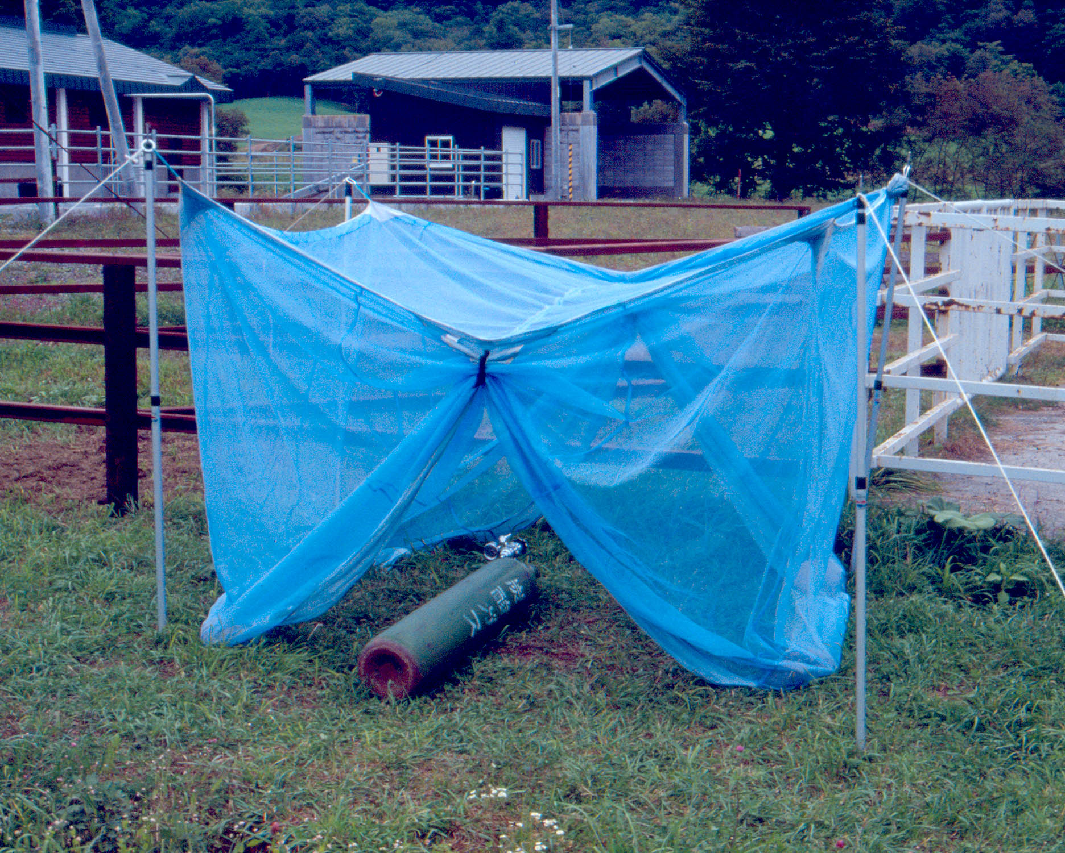  Trap with gas cylinder underneath  CO2 was not used in this experiment

Locality Reference & Malaise Reference

Sasaki, H. (2001) Comparison of capturing tabanid flies (Diptera: Tabanidae) by five different color traps in the fields. Applied Entomology and Zoology 36, 515-519.

Roberts, R.H. (1972) The effectiveness of several types of Malaise traps for the collection of Tabanidae and Culicidae. Mosquito News 32, 542-547.

Fabrics

 | Blue |  | Black |  | Netting
Trap | Code | Notes | Code | Notes | Code | Notes
Nzi Trap Standards
POL | 101 | Standard Polyester Fabric  VF #10 Phthalogen Blue Pongee 2 Polyester, Lot #1 March, 1996 (54 g/m²) | 102 | Standard  Matching Black | 103 | Standard  VF #13 White Polynet
COT | 105 | Standard Cotton Fabric  Ethiopia Awassa Textiles Phthalogen Blue Drill, Lot #1 January 1996 | 106 | Standard  Matching Black | 103 | Standard  VF #13 White Polynet
Local Standard
Malaise |  | No Blue fabric component, whole trap is made out of blue netting |  | No Black component | 173 | Blue Synthetic, Probably Vinyl or Nylon

Blue
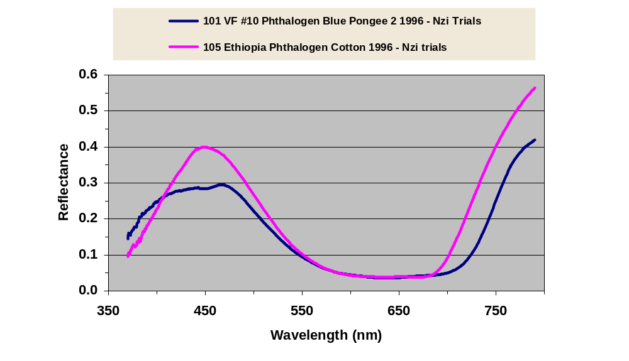

Black
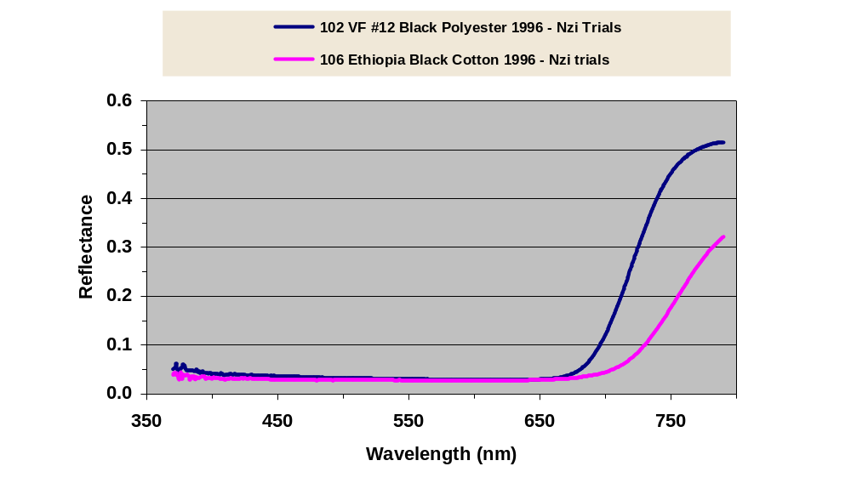

Netting
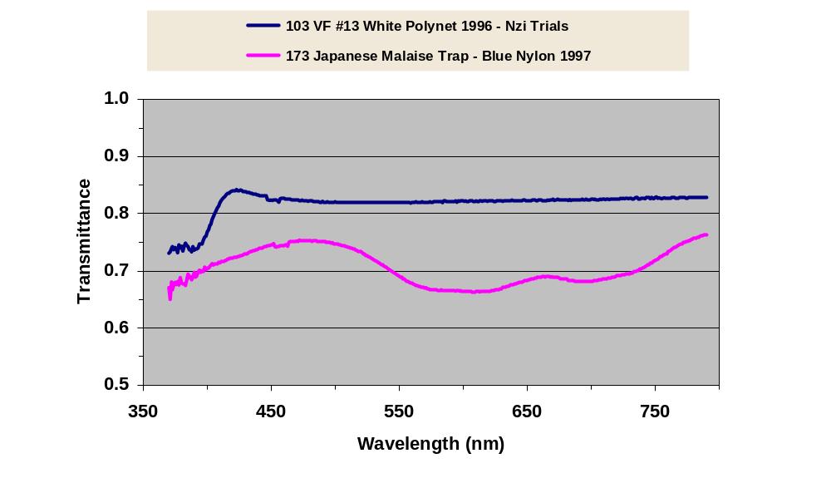

ANOVAS

SYSTAT Rectangular file D:\PERSONAL\Trials\FINAL\\North\Trjapan.SYD,
created Tue Jan 16, 2007 at 13:40:14, contains variables:
AREA$ LATITUDE$ LONGITUDE$ SITE DATE RISK
TRAP$ DAY HRSET HRCHK MINT MAXT
WEATHER$ EXPT$ ODOURS$ HABITAT$ CALCITRANS TAENIATUS
NIGER BOUETI TRANSVITTATU INORNATUS PALLIDUS VARIPES
OCHROSOMA BRUNNIPES BILINEATUS SITIENS OMEGA STOMOXYS
RHINOMUSCA RDUM RDUF STOMOXYINAE SINM SINF
SBIM SBIF STAM STAF SBRM SBRF
SNIM SNIF SCAM SCAF SBOM SBOF
SVAM SVAF SOCM SOCF SPAM SPAF
STRM STRF SSIM SSIF SOMM SOMF
MUSCA CRASSIROSTRI MUSCINAE TABANUS TAENIOLA VARIATUS
BIGUTTATUS LAVERANI FRATERNUS THORACINUS ATRIMANUS PAR
GRATUS CONIFORMIS LEUCOSTOMUS INSIGNIS UNILINEATUS COPEMANI
PULLULUS CONSPICUUS LIVENTIPES XTABANUS HAEMATOPOTA POTTSI
SIMILIS DENSHAMI ALBIHIRTA PATELLICORNE VULNERANS HIRTA
NOCENS THEOBALDI RUBENS MACULOSIFACI BRUNNESCENS XHAEMATOPOTA
MESOMYIA ATYLOTUS AGRESTIS AFUSCIPES PHILOLICHE SAGITTARIA
ZONATA MAKUENI DISTINCTA ELONGATA XPHILOLICHE ANCALA
HYBOMITRA TABANIDAE HAEMATOBIA MINUTA XHAEMATOBIA SPINGERA
IRRITANS ORTHELLIA OTHER CALLIPHORIDA HYMENOPTERA SARCOPHAGIDA
COMMENT$ EXPCOMM$ SYRPHIDAE ASILIDAE HAEMATOBOSCA AURATA
HAURM HAURF LATIFRONS HLAM HLAF HIRTIFRONS
HHIM HHIF SQUALIDA HSQM HSQF PROSTOMOXYS
PSAM PSAF STYGEROMYIA MACULOSA SMAM SMAF
SANGUINARIA SSAM SSAF MPALL FPALL MLONG
FLONG MBREV FBREV MAUST FAUST MSWYN
FSWYN MFUSC FFUSC MMORS FMORS MCENT
FCENT MSUBM FSUBM MTACH FTACH MPALP
FPALP MPALG FPALG TACH PALP PALG
CENT SUBM MORS PALL LONG BREV
AUST SWYN FUSC REPLICATE ZONE LOCATION$
HIPPOBOSCA CAMELINA LONGIPENNIS XHIPPOBOSCA EUANCALA CHRYSOPS
BICOLOR FUSCIPENNIS XCHRYSOPS SCREEN SIDE ORIENTATION
CONFIGURATIO SURFACE HEIGHT COUNTRY$ ELEVATION PERSON$
SOURCE$ FLIES$ SEASON$ ALBIPALPUS LINEOLA FUSCICOSTATU
LEUCOTABANUS LIMBATINERVI TABOTHER

***WARNING***
The file
D:\PERSONAL\Trials\FINAL\\North\Trjapan.SYD
was read for processing, and its contents have been replaced by saving
the processed data into it.

81 cases and 214 variables processed and saved.

Frequencies
SITE (rows) by DAY (columns)
TRAP$ = MALAISE

1 2 3 4 5 6 7
+---------------------------------------------------------+
1 | 0 0 0 1 1 1 0 |
2 | 0 0 0 0 0 0 1 |
3 | 1 1 1 0 0 0 0 |
4 | 0 0 0 0 0 0 1 |
5 | 1 1 1 0 0 0 0 |
6 | 0 0 0 1 1 1 0 |
7 | 1 1 1 0 0 0 0 |
8 | 0 0 0 1 1 1 0 |
9 | 0 0 0 0 0 0 1 |
+---------------------------------------------------------+
Total 3 3 3 3 3 3 3

8 9 Total
+-----------------+
1 | 0 0 | 3
2 | 1 1 | 3
3 | 0 0 | 3
4 | 1 1 | 3
5 | 0 0 | 3
6 | 0 0 | 3
7 | 0 0 | 3
8 | 0 0 | 3
9 | 1 1 | 3
+-----------------+
Total 3 3 27

TRAP$ = NZI-COT

1 2 3 4 5 6 7
+---------------------------------------------------------+
1 | 1 1 1 0 0 0 0 |
2 | 0 0 0 1 1 1 0 |
3 | 0 0 0 0 0 0 1 |
4 | 0 0 0 1 1 1 0 |
5 | 0 0 0 0 0 0 1 |
6 | 1 1 1 0 0 0 0 |
7 | 0 0 0 1 1 1 0 |
8 | 0 0 0 0 0 0 1 |
9 | 1 1 1 0 0 0 0 |
+---------------------------------------------------------+
Total 3 3 3 3 3 3 3

8 9 Total
+-----------------+
1 | 0 0 | 3
2 | 0 0 | 3
3 | 1 1 | 3
4 | 0 0 | 3
5 | 1 1 | 3
6 | 0 0 | 3
7 | 0 0 | 3
8 | 1 1 | 3
9 | 0 0 | 3
+-----------------+
Total 3 3 27

TRAP$ = NZI-POL

1 2 3 4 5 6 7
+---------------------------------------------------------+
1 | 0 0 0 0 0 0 1 |
2 | 1 1 1 0 0 0 0 |
3 | 0 0 0 1 1 1 0 |
4 | 1 1 1 0 0 0 0 |
5 | 0 0 0 1 1 1 0 |
6 | 0 0 0 0 0 0 1 |
7 | 0 0 0 0 0 0 1 |
8 | 1 1 1 0 0 0 0 |
9 | 0 0 0 1 1 1 0 |
+---------------------------------------------------------+
Total 3 3 3 3 3 3 3

8 9 Total
+-----------------+
1 | 1 1 | 3
2 | 0 0 | 3
3 | 0 0 | 3
4 | 0 0 | 3
5 | 0 0 | 3
6 | 1 1 | 3
7 | 1 1 | 3
8 | 0 0 | 3
9 | 0 0 | 3
+-----------------+
Total 3 3 27

Effects coding used for categorical variables in model.

Categorical values encountered during processing are:
TRAP$ (3 levels)
MALAISE, NZI-COT, NZI-POL
REPLICATE (3 levels)
1, 2, 3
SITE (9 levels)
1, 2, 3, 4, 5, 6, 7,
8, 9
PERIOD (3 levels)
1, 2, 3
DAY (9 levels)
1, 2, 3, 4, 5, 6, 7,
8, 9

Dep Var: TABANIDAE N: 81 Multiple R: 0.640 Squared multiple R: 0.410

Analysis of Variance
Source Sum-of-Squares df Mean-Square F-ratio P

TRAP$ 1.134 2 0.567 5.514 0.006
REPLICATE 0.207 2 0.103 1.005 0.372
PERIOD 0.288 2 0.144 1.403 0.254
SITE(REPLICATE) 1.311 6 0.219 2.126 0.063
DAY(PERIOD) 1.489 6 0.248 2.415 0.037

Error 6.373 62 0.103

-------------------------------------------------------------------------------

Least squares means
LS Mean SE N
TRAP$ =MALAISE 0.291 0.062 27
TRAP$ =NZI-COT 0.516 0.062 27
TRAP$ =NZI-POL 0.562 0.062 27

-------------------------------------------------------------------------------
REPLICATE =1 0.388 0.062 27
REPLICATE =2 0.473 0.062 27
REPLICATE =3 0.508 0.062 27

-------------------------------------------------------------------------------
PERIOD =1 0.509 0.062 27
PERIOD =2 0.487 0.062 27
PERIOD =3 0.373 0.062 27

-------------------------------------------------------------------------------
SITE =1
REPLICATE =1 0.254 0.107 9
SITE =2
REPLICATE =1 0.321 0.107 9
SITE =3
REPLICATE =1 0.589 0.107 9
SITE =4
REPLICATE =2 0.254 0.107 9
SITE =5
REPLICATE =2 0.570 0.107 9
SITE =6
REPLICATE =2 0.594 0.107 9
SITE =7
REPLICATE =3 0.549 0.107 9
SITE =8
REPLICATE =3 0.425 0.107 9
SITE =9
REPLICATE =3 0.550 0.107 9

-------------------------------------------------------------------------------
DAY =1
PERIOD =1 0.321 0.107 9
DAY =2
PERIOD =1 0.587 0.107 9
DAY =3
PERIOD =1 0.618 0.107 9
DAY =4
PERIOD =2 0.242 0.107 9
DAY =5
PERIOD =2 0.691 0.107 9
DAY =6
PERIOD =2 0.529 0.107 9
DAY =7
PERIOD =3 0.411 0.107 9
DAY =8
PERIOD =3 0.409 0.107 9
DAY =9
PERIOD =3 0.298 0.107 9

-------------------------------------------------------------------------------
*** WARNING ***
Case 22 is an outlier (Studentized Residual = 3.298)

Durbin-Watson D Statistic 2.301
First Order Autocorrelation -0.156
COL/
ROW TRAP$
1 MALAISE
2 NZI-COT
3 NZI-POL
Using least squares means.
Post Hoc test of TABANIDAE

-------------------------------------------------------------------------------
Using model MSE of 0.103 with 62 df.

Matrix of pairwise mean differences:
1 2 3
1 0.000
2 0.224 0.000
3 0.271 0.047 0.000

Tukey HSD Multiple Comparisons.

Matrix of pairwise comparison probabilities:
1 2 3
1 1.000
2 0.033 1.000
3 0.008 0.855 1.000

-------------------------------------------------------------------------------

Effects coding used for categorical variables in model.

Categorical values encountered during processing are:
TRAP$ (3 levels)
MALAISE, NZI-COT, NZI-POL
REPLICATE (3 levels)
1, 2, 3
SITE (9 levels)
1, 2, 3, 4, 5, 6, 7,
8, 9
PERIOD (3 levels)
1, 2, 3
DAY (9 levels)
1, 2, 3, 4, 5, 6, 7,
8, 9

Dep Var: TABANUS N: 81 Multiple R: 0.575 Squared multiple R: 0.331

Analysis of Variance
Source Sum-of-Squares df Mean-Square F-ratio P

TRAP$ 0.945 2 0.473 4.198 0.020
REPLICATE 0.095 2 0.047 0.421 0.658
PERIOD 0.169 2 0.085 0.751 0.476
SITE(REPLICATE) 1.435 6 0.239 2.123 0.063
DAY(PERIOD) 0.809 6 0.135 1.197 0.320

Error 6.982 62 0.113

-------------------------------------------------------------------------------

Least squares means
LS Mean SE N
TRAP$ =MALAISE 0.227 0.065 27
TRAP$ =NZI-COT 0.395 0.065 27
TRAP$ =NZI-POL 0.489 0.065 27

-------------------------------------------------------------------------------
REPLICATE =1 0.325 0.065 27
REPLICATE =2 0.379 0.065 27
REPLICATE =3 0.407 0.065 27

-------------------------------------------------------------------------------
PERIOD =1 0.383 0.065 27
PERIOD =2 0.419 0.065 27
PERIOD =3 0.309 0.065 27

-------------------------------------------------------------------------------
SITE =1
REPLICATE =1 0.220 0.112 9
SITE =2
REPLICATE =1 0.201 0.112 9
SITE =3
REPLICATE =1 0.554 0.112 9
SITE =4
REPLICATE =2 0.164 0.112 9
SITE =5
REPLICATE =2 0.432 0.112 9
SITE =6
REPLICATE =2 0.540 0.112 9
SITE =7
REPLICATE =3 0.379 0.112 9
SITE =8
REPLICATE =3 0.374 0.112 9
SITE =9
REPLICATE =3 0.469 0.112 9

-------------------------------------------------------------------------------
DAY =1
PERIOD =1 0.287 0.112 9
DAY =2
PERIOD =1 0.437 0.112 9
DAY =3
PERIOD =1 0.424 0.112 9
DAY =4
PERIOD =2 0.208 0.112 9
DAY =5
PERIOD =2 0.557 0.112 9
DAY =6
PERIOD =2 0.492 0.112 9
DAY =7
PERIOD =3 0.337 0.112 9
DAY =8
PERIOD =3 0.351 0.112 9
DAY =9
PERIOD =3 0.240 0.112 9

-------------------------------------------------------------------------------

Durbin-Watson D Statistic 2.116
First Order Autocorrelation -0.062
COL/
ROW TRAP$
1 MALAISE
2 NZI-COT
3 NZI-POL
Using least squares means.
Post Hoc test of TABANUS

-------------------------------------------------------------------------------
Using model MSE of 0.113 with 62 df.

Matrix of pairwise mean differences:
1 2 3
1 0.000
2 0.168 0.000
3 0.261 0.094 0.000

Tukey HSD Multiple Comparisons.

Matrix of pairwise comparison probabilities:
1 2 3
1 1.000
2 0.167 1.000
3 0.016 0.565 1.000

-------------------------------------------------------------------------------

Effects coding used for categorical variables in model.

Categorical values encountered during processing are:
TRAP$ (3 levels)
MALAISE, NZI-COT, NZI-POL
REPLICATE (3 levels)
1, 2, 3
SITE (9 levels)
1, 2, 3, 4, 5, 6, 7,
8, 9
PERIOD (3 levels)
1, 2, 3
DAY (9 levels)
1, 2, 3, 4, 5, 6, 7,
8, 9

Dep Var: CHRYSOPS N: 81 Multiple R: 0.569 Squared multiple R: 0.324

Analysis of Variance
Source Sum-of-Squares df Mean-Square F-ratio P

TRAP$ 0.172 2 0.086 3.870 0.026
REPLICATE 0.096 2 0.048 2.159 0.124
PERIOD 0.016 2 0.008 0.359 0.700
SITE(REPLICATE) 0.131 6 0.022 0.981 0.446
DAY(PERIOD) 0.247 6 0.041 1.845 0.105

Error 1.382 62 0.022

-------------------------------------------------------------------------------

Least squares means
LS Mean SE N
TRAP$ =MALAISE 0.033 0.029 27
TRAP$ =NZI-COT 0.144 0.029 27
TRAP$ =NZI-POL 0.069 0.029 27

-------------------------------------------------------------------------------
REPLICATE =1 0.033 0.029 27
REPLICATE =2 0.104 0.029 27
REPLICATE =3 0.109 0.029 27

-------------------------------------------------------------------------------
PERIOD =1 0.093 0.029 27
PERIOD =2 0.091 0.029 27
PERIOD =3 0.062 0.029 27

-------------------------------------------------------------------------------
SITE =1
REPLICATE =1 0.033 0.050 9
SITE =2
REPLICATE =1 0.000 0.050 9
SITE =3
REPLICATE =1 0.067 0.050 9
SITE =4
REPLICATE =2 0.120 0.050 9
SITE =5
REPLICATE =2 0.106 0.050 9
SITE =6
REPLICATE =2 0.086 0.050 9
SITE =7
REPLICATE =3 0.187 0.050 9
SITE =8
REPLICATE =3 0.033 0.050 9
SITE =9
REPLICATE =3 0.106 0.050 9

-------------------------------------------------------------------------------
DAY =1
PERIOD =1 0.053 0.050 9
DAY =2
PERIOD =1 0.139 0.050 9
DAY =3
PERIOD =1 0.086 0.050 9
DAY =4
PERIOD =2 0.000 0.050 9
DAY =5
PERIOD =2 0.206 0.050 9
DAY =6
PERIOD =2 0.067 0.050 9
DAY =7
PERIOD =3 0.086 0.050 9
DAY =8
PERIOD =3 0.033 0.050 9
DAY =9
PERIOD =3 0.067 0.050 9

-------------------------------------------------------------------------------

Durbin-Watson D Statistic 2.450
First Order Autocorrelation -0.227
COL/
ROW TRAP$
1 MALAISE
2 NZI-COT
3 NZI-POL
Using least squares means.
Post Hoc test of CHRYSOPS

-------------------------------------------------------------------------------
Using model MSE of 0.022 with 62 df.

Matrix of pairwise mean differences:
1 2 3
1 0.000
2 0.111 0.000
3 0.035 -0.075 0.000

Tukey HSD Multiple Comparisons.

Matrix of pairwise comparison probabilities:
1 2 3
1 1.000
2 0.023 1.000
3 0.661 0.161 1.000

-------------------------------------------------------------------------------

Effects coding used for categorical variables in model.

Categorical values encountered during processing are:
TRAP$ (3 levels)
MALAISE, NZI-COT, NZI-POL
REPLICATE (3 levels)
1, 2, 3
SITE (9 levels)
1, 2, 3, 4, 5, 6, 7,
8, 9
PERIOD (3 levels)
1, 2, 3
DAY (9 levels)
1, 2, 3, 4, 5, 6, 7,
8, 9

Dep Var: HAEMATOPOTA N: 81 Multiple R: 0.692 Squared multiple R: 0.478

Analysis of Variance
Source Sum-of-Squares df Mean-Square F-ratio P

TRAP$ 0.041 2 0.021 0.948 0.393
REPLICATE 0.039 2 0.019 0.895 0.414
PERIOD 0.356 2 0.178 8.204 0.001
SITE(REPLICATE) 0.219 6 0.037 1.682 0.141
DAY(PERIOD) 0.579 6 0.097 4.444 0.001

Error 1.347 62 0.022

-------------------------------------------------------------------------------

Least squares means
LS Mean SE N
TRAP$ =MALAISE 0.069 0.028 27
TRAP$ =NZI-COT 0.056 0.028 27
TRAP$ =NZI-POL 0.109 0.028 27

-------------------------------------------------------------------------------
REPLICATE =1 0.062 0.028 27
REPLICATE =2 0.109 0.028 27
REPLICATE =3 0.062 0.028 27

-------------------------------------------------------------------------------
PERIOD =1 0.171 0.028 27
PERIOD =2 0.040 0.028 27
PERIOD =3 0.022 0.028 27

-------------------------------------------------------------------------------
SITE =1
REPLICATE =1 0.000 0.049 9
SITE =2
REPLICATE =1 0.120 0.049 9
SITE =3
REPLICATE =1 0.067 0.049 9
SITE =4
REPLICATE =2 0.120 0.049 9
SITE =5
REPLICATE =2 0.173 0.049 9
SITE =6
REPLICATE =2 0.033 0.049 9
SITE =7
REPLICATE =3 0.120 0.049 9
SITE =8
REPLICATE =3 0.000 0.049 9
SITE =9
REPLICATE =3 0.067 0.049 9

-------------------------------------------------------------------------------
DAY =1
PERIOD =1 0.000 0.049 9
DAY =2
PERIOD =1 0.167 0.049 9
DAY =3
PERIOD =1 0.346 0.049 9
DAY =4
PERIOD =2 0.033 0.049 9
DAY =5
PERIOD =2 0.086 0.049 9
DAY =6
PERIOD =2 0.000 0.049 9
DAY =7
PERIOD =3 0.033 0.049 9
DAY =8
PERIOD =3 0.000 0.049 9
DAY =9
PERIOD =3 0.033 0.049 9

-------------------------------------------------------------------------------
*** WARNING ***
Case 22 is an outlier (Studentized Residual = 6.684)

Durbin-Watson D Statistic 2.729
First Order Autocorrelation -0.368
COL/
ROW TRAP$
1 MALAISE
2 NZI-COT
3 NZI-POL
Using least squares means.
Post Hoc test of HAEMATOPOTA

-------------------------------------------------------------------------------
Using model MSE of 0.022 with 62 df.

Matrix of pairwise mean differences:
1 2 3
1 0.000
2 -0.013 0.000
3 0.040 0.053 0.000

Tukey HSD Multiple Comparisons.

Matrix of pairwise comparison probabilities:
1 2 3
1 1.000
2 0.943 1.000
3 0.582 0.389 1.000

-------------------------------------------------------------------------------

