CAPECOD2: Massachusetts, USA - July, 2008

Gabrielle Sakolsky & Bart Morris
Cape Cod Greenhead Fly Control Project
86 Willow Street
Yarmouth Port, MA 02675
Email: GSAKOLSKY@aol.com, Telephone (508) 775-1510
Objective: Test various cloth Nzi traps and a painted plywood version versus Cape Cod
standard greenhead control box trap

Data: Original data outside of ACCESS are in “CCnzi2008 Original 20Aug08.xls”
Retyped into standard format in ACCESS database for this analysis
Data Email is “Cape Cod 2008 Data” dated 20 August, 2008

Design: Seven traps rotated forward among 7 sites in 7 x 7 Latin squares for 14 days on weekdays to provide two sequential replicates. Four additional data points provide identical results in alternative ANOVA.

Area: Cape Cod, Massachusetts, USA

Habitat: Salt Marsh, East - West transect
Details: ~0 m asl, 70° 22' 5.35" W 41° 42' 54.19" N (exact GPS)
Date: July 7 - 25, 2007, traps set only between 10:00 am and 01:00 pm

Baits: Biosensory Octenol Lure
Standard: Turquoise Nzi Trap, all traps set facing North as in 2007
Collector: BOTTLE or Cage from old mosquito trap, unspecified exit diameter in trap cone

Counts limited to T. nigrovittatus / T. conterminus, less than 2% T. lineola present.

24,093 Tabanidae in 98 trap-days (ignoring days 15-18 to July 31)
Arithmetic mean catch in standard Nzi trap was 260.9 per day (3-hr at risk only per day)
Geometric mean catch in standard Nzi trap was 178.4 per day
Daily max was 2,088 in painted plywood Nzi trap, turquoise cloth Nzi max catch was 861

Statistics reported as in other experiments for log (X+1) transformation, could be re-calculated for just a log transformation as no zero catches.

Standard Turquoise Nzi trap caught 5.9 x the Greenhead box trap (raw totals), much higher difference than in 2007 experiment
Plywood Nzi trap caught 17.2 x the Greenhead box trap
Fiddling with the Nzi trap blue-black layout resulted in much lower catches
Blocking ultraviolet light with a PVC cone had no effect on catches
The OCEAN BLUE polyester may not be a good choice in place of Sunbrella, agreeing with preliminary results from Canada for other tabanids. The Top Notch Blue looks best from thorough testing in Canada but a plain Nzi in this material was not included in this experiment.

Traps

1. NZI-TURQ3MG (coded as Nzi 2007 in Excel original)

Standard (sulphonated copper phthalocyanine turquoise colour, not phthalogen blue)

Used in 2007 in CapeCod1 but only left outdoors for 3-hours each day so still quite new

2. GREENHEAD1 (coded as CC in Excel original)

Local Cape Cod Greenhead Box Trap - same design as in CapeCod1 in 2007

3. NZI-PLYWOOD (coded as Nzi plywood in Excel original)
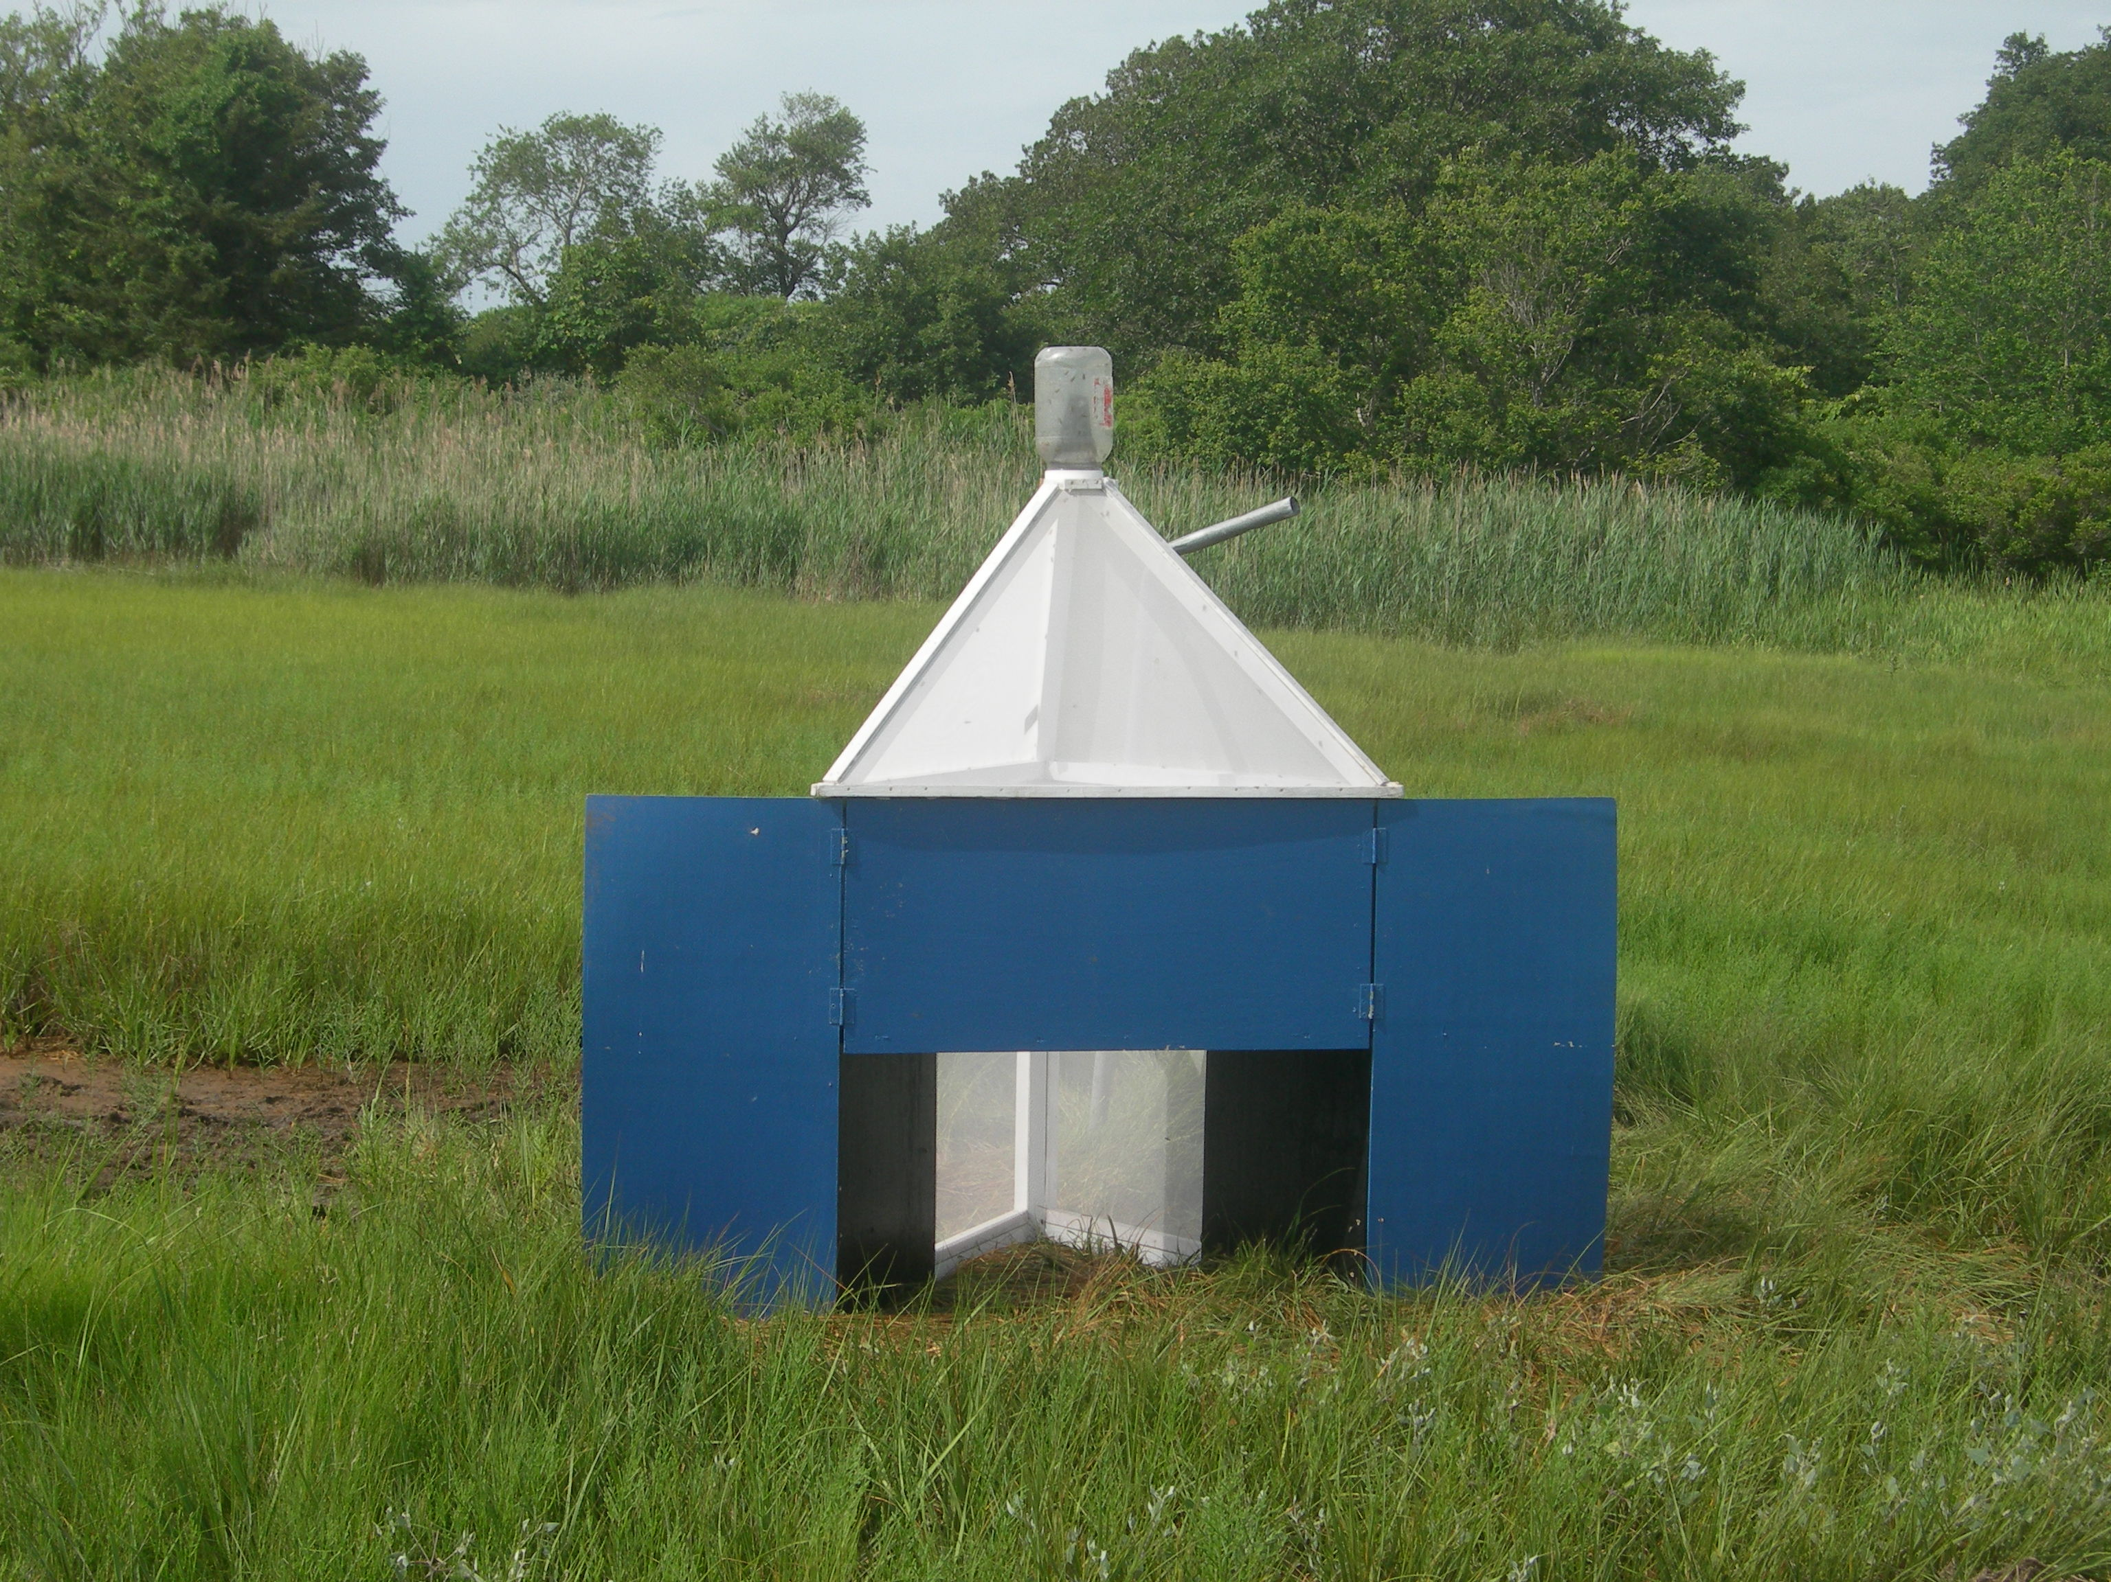

Same paint as in trap #2 (Dutch Boy Royal Blue), white polyester mosquito netting

4. NZI-TNB-MIRROR (coded as TNB mirror in Excel Original)

Top Notch blue and black polyester seconds with Bionet cone and Econet L back
Nzi trap with the blue wing and black side inverted on one side

5. NZI-TNB-TARGET (coded as TNB Target in Excel Original)

Top Notch blue and black polyester seconds with Bionet cone and Econet L back
Nzi trap with the black side and netting back inverted on both sides so that the black is consolidated in the back corner with netting between the blue and the black on the sides

6. NZI-TNO (coded as Top Notch Ocean in Excel Original)

Top Notch OCEAN BLUE polyester (darker than TN BLUE) and black, standard IN6 white polyester mosquito netting, no changes to format of Nzi trap

6. NZI-SUN-CRY-BIO (coded as NZI UV in Excel Original)
Sunbrella Pacific Blue and black acrylic seconds, Bionet back, cone is Crystal Clear 20/20 PVC blocking all ultraviolet light, otherwise no changes to format of Nzi trap
The traps below were used previously but were nearly new when tested at Cape Cod

Photos of traps in Canada before use in this experiment
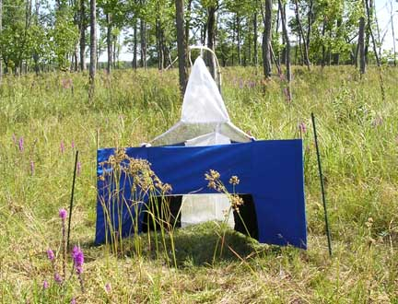 | 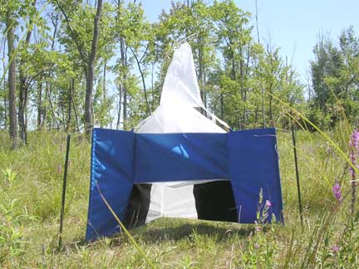
NZI-SUN-CRY-BIO Site #25 - August 2008  Sunbrella Pacific Blue acrylic  (normal Nzi format with special cone)  Crystal Clear 20/20 PVC cone, Bionet back | NZI-TNO Site #25 - July 2007  Top Notch Ocean Blue polyester  (normal Nzi format)  IN6 white polyester mosquito netting
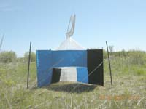 | 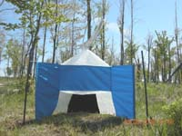
NZI-TNB-MIRROR Site #30 June 2008  Top Notch Blue Polyester  (blue-black inverted on opposite side)  Bionet cone, Econet L back | NZI-TNB-TARGET Site #27 June 2008  Top Notch Blue polyester  (black consolidated in the center)  Bionet cone, Econet L back

Fabric Colours

Pantone colours below are approximate, codes can vary among lots of fabric or duplicate scans on different scanners; these codes are from a simultaneous scan of all four fabrics.

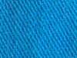  Procion Turquoise M-G bull denim cotton after one month outdoors  ~ Pantone 3015 | 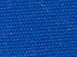  Sunbrella Pacific Blue acrylic canvas  ~ Pantone 2945
  Top Notch Blue 563 marine polyester canvas  ~ Pantone 660 | 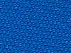  Top Notch Blue 594 marine polyester canvas  ~ Pantone 294

New reflectance spectra are available from Patrick Guerin, University of Neuchatel for Top Notch fabrics but digital data have not yet been provided, just JPEG images of the scans

The Top Notch Blue is a perfect match for phthalogen blue cotton

Location

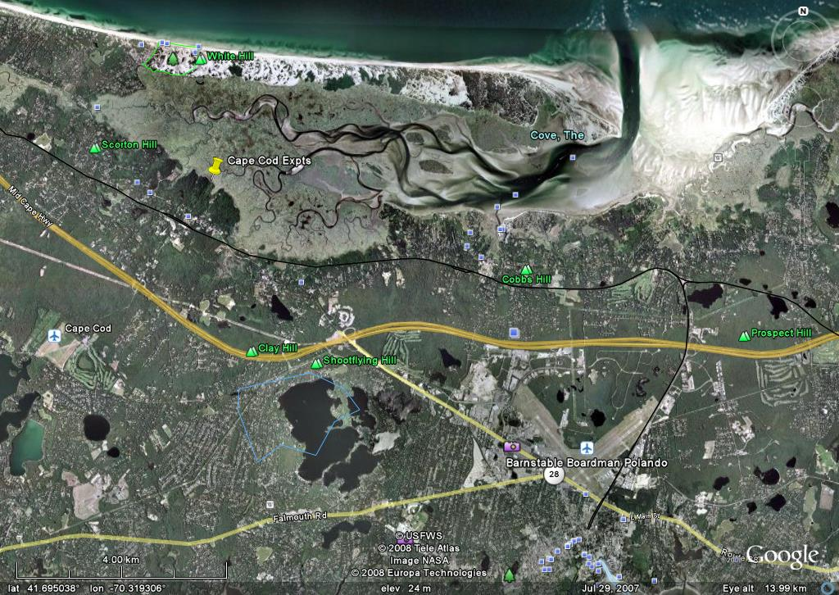

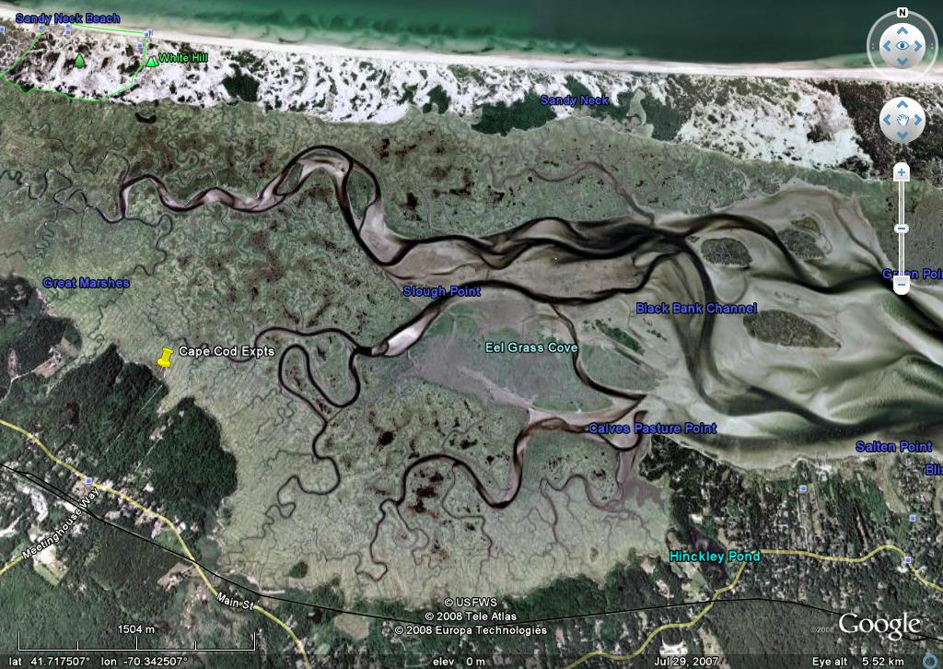

Somewhat oblique view in this close-up

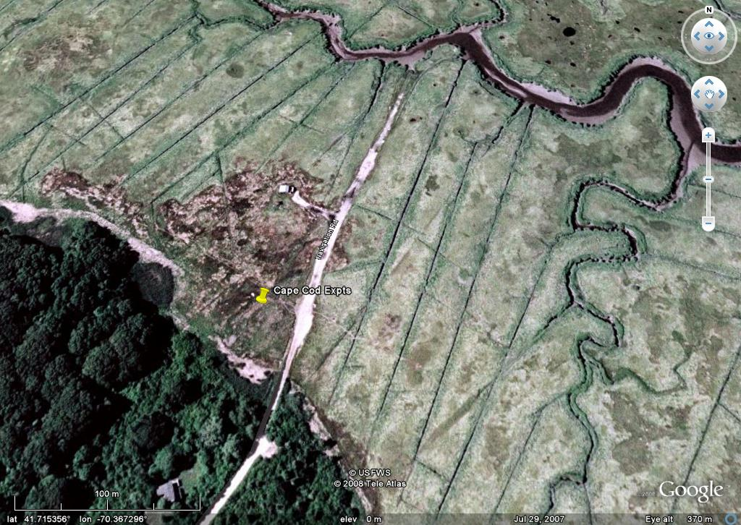

Weather: http://www.weatherunderground.com

Trap days are in bold, four extra days of trapping also available at the end
Date | Max (F) | Avg | Low | Humidity Avg | Wind Avg (MPH) | Gusts | Rain (inches)
7-Jul | 78 | 72 | 66 | 89 | 6 | - | 0
8-Jul | 79 | 72 | 66 | 82 | 6 | 22 | 0
9-Jul | 80 | 72 | 66 | 71 | 13 | 30 | 0
10-Jul | 75 | 68 | 62 | 81 | 10 | 22 | 0
11-Jul | 69 | 64 | 61 | 94 | 3 | - | 0.13
12-Jul | 75 | 68 | 62 | 92 | 3 | - | 0
13-Jul | 80 | 74 | 69 | 86 | 9 | - | 0
14-Jul | 82 | 76 | 71 | 80 | 13 | 31 | 0
15-Jul | 80 | 75 | 71 | 82 | 15 | 33 | 0
16-Jul | 84 | 75 | 64 | 73 | 14 | 21 | 0.23
17-Jul | 77 | 68 | 59 | 59 | 2 | - | 0
18-Jul | 78 | 70 | 63 | 68 | 3 | 18 | 0
19-Jul | 79 | 74 | 70 | 76 | 12 | 26 | 0
20-Jul | 82 | 75 | 68 | 84 | 8 | 26 | 0.07
21-Jul | 82 | 70 | 60 | 68 | 1 | - | 0
22-Jul | 82 | 70 | 57 | 72 | 1 | - | 0
23-Jul | 84 | 70 | 57 | 72 | 3 | - | 0
24-Jul | 84 | 76 | 66 | 77 | 6 | 21 | 0.14
25-Jul | 87 | 75 | 66 | 82 | 6 | 28 | 0
26-Jul | 82 | 76 | 69 | 84 | 13 | 25 | 0
27-Jul | 80 | 72 | 64 | 90 | 16 | 30 | 0.01
28-Jul | 75 | 68 | 62 | 86 | 6 | 17 | 0
29-Jul | 82 | 73 | 66 | 82 | 6 | 36 | 0.08
30-Jul | 82 | 76 | 71 | 84 | 10 | 29 | 1.07
31-Jul | 79 | 74 | 69 | 86 | 10 | 28 | 0.87

Results

Dep Var: TABANIDAE N: 98 Multiple R: 0.9684 Squared multiple R: 0.9377

Source Sum-of-Squares df Mean-Square F-ratio P
TYPE$ 16.1308 6 2.6885 88.6559 0.0000
REPLICATE 0.1128 1 0.1128 3.7213 0.0577
SITE 0.3295 6 0.0549 1.8110 0.1090
SEQ(REPLICATE) 16.2916 12 1.3576 44.7699 0.0000
Error 2.1834 72 0.0303

Average of Tabanidae |  | Backtrans | Index of | Response
TYPE$ | Total | Mean | Increase | Ratio
NZI-TURQ3MG | 2.251 | 177.38 | 1.00 | 1.00
NZI-TNO | 2.054 | 112.34 | 0.63 | 0.64
NZI-SUN-CRY-BIO | 2.171 | 147.36 | 0.83 | 0.83
NZI-TNB-TARGET | 1.502 | 30.76 | 0.17 | 0.18
NZI-TNB-MIRROR | 2.094 | 123.24 | 0.69 | 0.70
GREENHEAD1 | 1.464 | 28.11 | 0.16 | 0.16
NZI-PLYWOOD | 2.723 | 526.97 | 2.97 | 2.96
Grand Total | 2.037 | 107.92

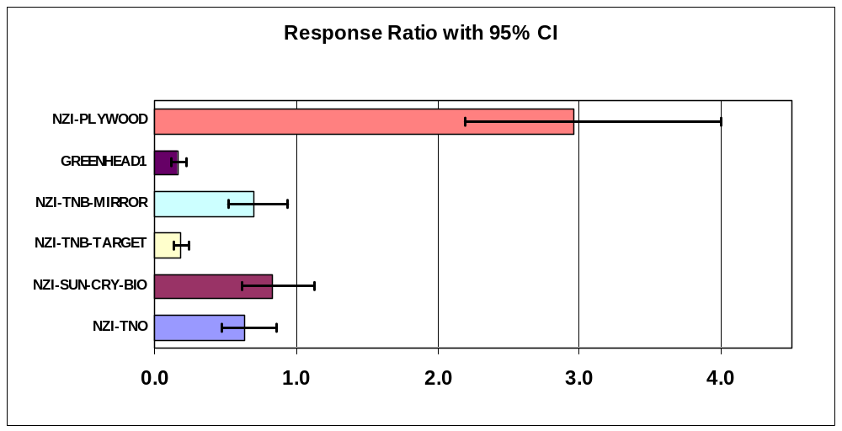

Arithmetic Mean |  |  | Maximum
Average of Tabanidae |  |  | Max of Tabanidae
TYPE$ | Total |  | TYPE$ | Total
NZI-TURQ3MG | 260.9 |  | NZI-TURQ3MG | 861
NZI-TNO | 196.6 |  | NZI-TNO | 638
NZI-SUN-CRY-BIO | 219.6 |  | NZI-SUN-CRY-BIO | 691
NZI-TNB-TARGET | 53.9 |  | NZI-TNB-TARGET | 197
NZI-TNB-MIRROR | 184.1 |  | NZI-TNB-MIRROR | 438
GREENHEAD1 | 44.2 |  | GREENHEAD1 | 150
NZI-PLYWOOD | 761.5 |  | NZI-PLYWOOD | 2088
Grand Total | 245.8 |  | Grand Total | 2088
ANOVA Notes

If the extra four days of trapping are used then an ANOVA is possible only for main effects as interaction effects cannot be entered

Results are identical so use of the first 14 days of data as two replicates of a balanced 7x7 Latin square design is best for statistical interpretation, especially with the large day-to-day variation in catches and the site difference in the previous ANOVA approaching significance at P=0.011.

Dep Var: TABANIDAE N: 126 Multiple R: 0.9676 Squared multiple R: 0.9363

Analysis of Variance
Source Sum-of-Squares df Mean-Square F-ratio P

TYPE$ 21.8428 6 3.6405 124.4150 0.0000
SITE 0.6912 6 0.1152 3.9373 0.0015
SEQ 18.5476 17 1.0910 37.2867 0.0000

Error 2.8090 96 0.0293

CapeCod2X
REFRESH TABLES
Average of Tabanidae |  | Backtrans | Index of | Response
TYPE$ | Total | Mean | Increase | Ratio
NZI-TURQ3MG | 2.206 | 159.64 | 1.00 | 1.00
NZI-TNO | 2.035 | 107.48 | 0.67 | 0.68
NZI-SUN-CRY-BIO | 2.144 | 138.37 | 0.87 | 0.87
NZI-TNB-TARGET | 1.454 | 27.45 | 0.17 | 0.18
NZI-TNB-MIRROR | 2.052 | 111.65 | 0.70 | 0.70
GREENHEAD1 | 1.393 | 23.73 | 0.15 | 0.15
NZI-PLYWOOD | 2.700 | 500.58 | 3.14 | 3.12
Grand Total | 1.998 | 98.50

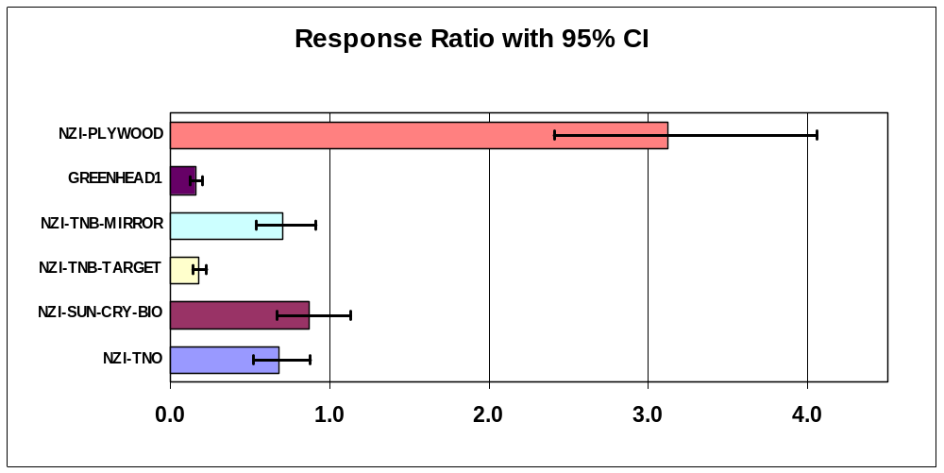
Test of two of these traps in Canada in July-August 2007 (Expt Farm123)

Tabanus quinquevittatus - about the same response for the Top Notch Ocean trap with a slightly lower catch versus the standard NZI-COT, very poor catch with the uv-blocking cone, not a proper balanced experiment but probably indicative of trap performance as catches were high

Average of TAQUIF |  | Backtrans | Index of | Response
TYPE$ | Total | Mean | Increase | Ratio
NZI-COT | 1.730 | 52.73 | 1.00 | 1.00
NZI-SUN-BIO | 1.962 | 90.69 | 1.72 | 1.71
NZI-COT-SUN-ECO | 1.802 | 62.32 | 1.18 | 1.18
NZI-TNB | 2.057 | 112.96 | 2.14 | 2.12
NZI-TNO | 1.611 | 39.80 | 0.75 | 0.76
NZI-SUN-CRY-BIO | 1.240 | 16.36 | 0.31 | 0.32
Grand Total | 1.767 | 57.50

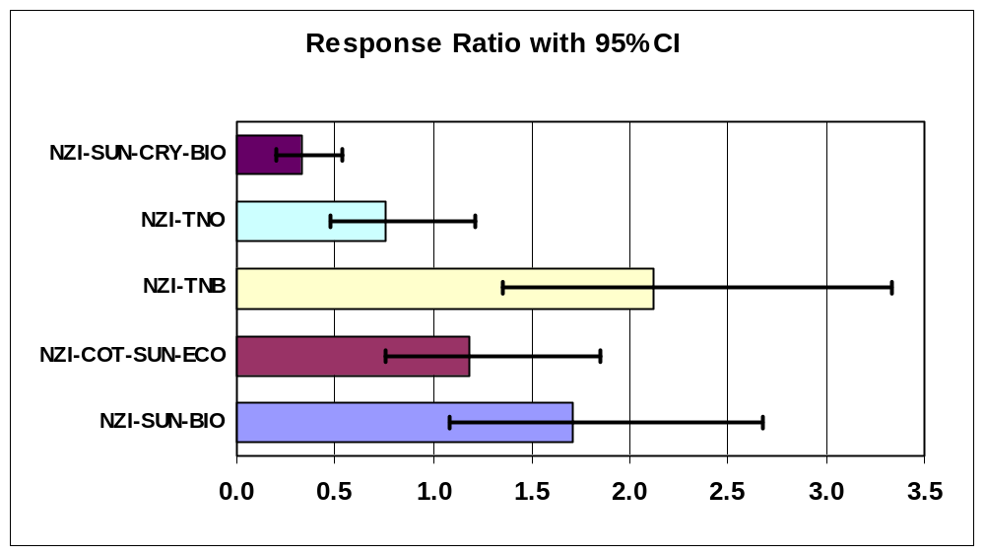

Test of two of these traps in Canada in June 2008 (first half of Expt Farm4)

TABANIDAE (87% Hybomitra lasiophthalma ) - not a particularly good comparison in this experiment due to large site effects and only a few rotations of the traps during a period of very rapid increase in numbers

Mainly shows how poorly the TARGET and MIRROR traps performed relative to other speculative designs, this was a surprise given the relatively small change in format

Arithmetic Mean |  |  | Maximum
Average of Tabanidae |  |  | Max of Tabanidae
TYPE$ | Total |  | TYPE$ | Total
NZI-COT | 36.8 |  | NZI-COT | 119
NZI-TNO-TNB | 3.8 |  | NZI-TNO-TNB | 13
NZI-SIDE-SOLID | 3.4 |  | NZI-SIDE-SOLID | 13
NZI-TNB-TARGET | 2.2 |  | NZI-TNB-TARGET | 11
NZI-TURQ-CIBA2 | 107.5 |  | NZI-TURQ-CIBA2 | 355
NZI-TNB-STAGGER | 28.0 |  | NZI-TNB-STAGGER | 127
NZI-TNB-MIRROR | 13.5 |  | NZI-TNB-MIRROR | 59
NZI-TNB-NAVY | 27.3 |  | NZI-TNB-NAVY | 108
NZI-TNB-FOREST | 10.0 |  | NZI-TNB-FOREST | 20
NZI-TURQ4MG | 39.3 |  | NZI-TURQ4MG | 116
NZI-TNB-TNO | 8.3 |  | NZI-TNB-TNO | 32
NZI-TNB-BIO-ECO | 18.2 |  | NZI-TNB-BIO-ECO | 65
Grand Total | 25.2 |  | Grand Total | 355



