FARM1: Edwards, Ontario, Canada - Jun-Aug 2007

Steve Mihok smihok@rogers.com
Objective: Compare alternative nettings and Sunbrella fabric
Compliment tests of similar traps sent to Sudan/Philippines

Data: Farm1 ***.xls, query linked to reference data in Canada nzi.mdb
Design: Two 4 x 4 Latin square set sequentially over 8 weeks
Area: Idle Farm ~9.0 km @ 320° (~ NW) from my home in Russell
Edwards is a hamlet incorporated into the city of Ottawa

Habitat: Abandoned pasture and wet meadow with adjacent woodland
Details: 71 m asl, 45°18.998 N and 75° 75° 26.112 (site #21 at the barn)
Date: June 16 - August 12, 2007, weekly collections

Baits: Biosensory Octenol lure ~1.5 mg/h release rate
Standard: Kenyan Phthalogen Blue IF3GM cotton Nzi trap with fine mesh white polyester, nearly-new trap used in 2006, set just off the ground, all traps facing WEST
Collector: 2-L Coke bottle plastic “funnel” inserted into trap cone (21 mm diameter neck)
Funnel then inserted into 2-L angled plastic Coke bottle pointing forward
Flies collected in a 60 x 40 cm plastic bag shaped into a large tetrahedron

The catch of nonbiting insects of all kinds was very low; very few mosquitoes were caught, but I cannot be sure of mosquito numbers because of the state of the catch with weekly collections

41,841 Tabanidae in 228 trap days, 13+ species (some Hybomitra in poor shape)

Arithmetic mean catch in standard trap was 1,308 per calendar week, 184 per calendar trap-day
Fair-weather trap days were 184, hence mean catch of 227 per fair-weather trap-day
Weekly maximum in standard was 2,783 tabanids, up to 3,155 in other traps

32,520 | Tabanus quinquevittatus (77.7%) | 24 | Chrysops aberrans
6,554 | Tabanus similis (15.7%) | 11 | Chrysops cincticornis
1,784 | Hybomitra lasiophthalma (4.3%) | 6 | Hybomitra illota
273 | Hybomitra frontalis | 5 | Chrysops vittatus
268 | Chrysops frigidus | 2 | Tabanus reinwardtii
99 | Chrysops univittatus
94 | Tabanus lineola | 45 | Hybomitra spp. (mostly epistates)

156 male T. quinquevittatus caught (included in “Tabanidae”), other totals are females only
559 Stomoxys calcitrans also captured during experiment (81% male)
Note seasonal flight periods taken into account in ANOVAs
Setting

Arrow points to the first site coded as #21 at the barn
Large fields of corn were to the west and south; traps were set from the barn to the corner of the woodland, and then NW along the electric transmission line (diagonal on the image). The area was mostly planted in corn, with soybean quite far to the NE. There is also a large woodlot to the NE. The nearest cattle were several km away. The barn contained two horses and five goats that grazed in the area near where the traps were set. The pastures had not been grazed for a few years.

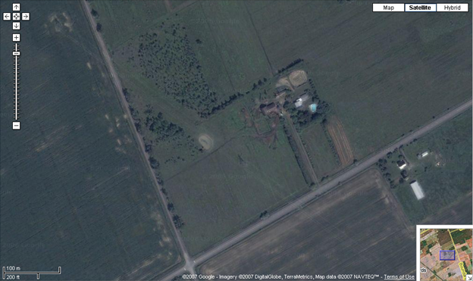
Corn
Corn
Pasture
Pasture
Woodland

The area is flat with an altitude of 67-72 m asl; it is very wet in the spring; there is marshy vegetation in the area of the woodland; the pond is permanent.
Sites 23-24 are ~ 5 m from the sharply-defined edge of the line of trees
Sites 25-27 are just outside the edge of the last trees within the open woodland

Site | Latitude | Longitude | Bearing  from #21 (°) | Trap Site Interval (m) | Distance  from #21 (m)
21 | 45°18.998 N | 75° 26.112 W | - | - | -
22 | 45°19.005 | 75° 26.134 | 294.3 | 31.5 | 31.5
23 | 45°19.006 | 75° 26.164 | 282.3 | 39.2 | 69.6
24 | 45°18.992 | 75° 26.198 | 264.4 | 51.4 | 112.9
Sites set late in the experiment for other contrasts
25 | 45°19.009 | 75° 26.223 | 278.0 | 45.4 | 146.5
26 | 45°19.024 | 75° 26.245 | 285.5 | 40.0 | 180.4
27 | 45°19.044 | 75° 26.272 | 292.2 | 51.1 | 225.8

Distances are based on GPS readings http://williams.best.vwh.net/gccalc.htm
Positions below are very close to the actual sites, but were only fitted by eye

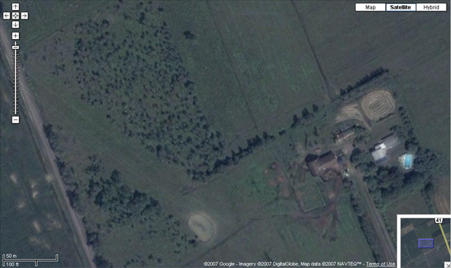
21
22
23
24
25
26
27
Grazing Area
Pond
Corn
Very open woodland
Not grazed - wet
Stable

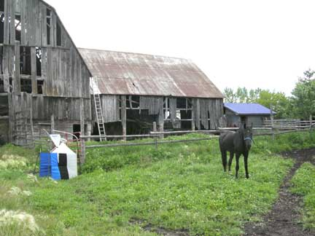 | 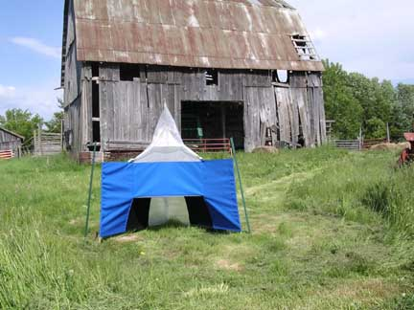
Site #21 at the stable looking NE  July 15, 2007 | Site #22 near barn looking East  June 16, 2007
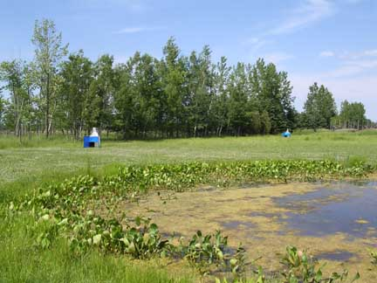 | 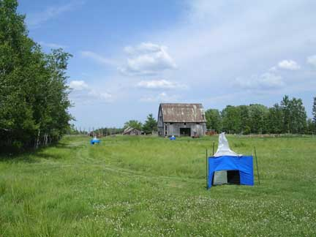
Site #24 at left, #23 at back, viewed from the pond - June 16, 2007 | Site #24 in foreground, #23 and #22 in the distance - June 16, 2007
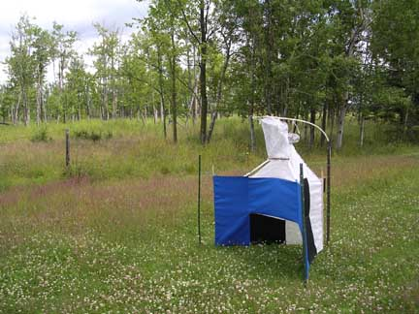 | 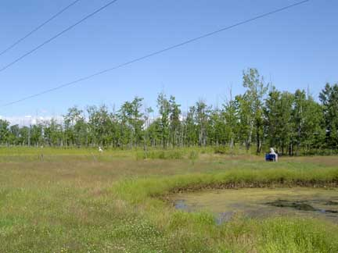
Site #24 looking North towards the woodland - July 15, 2007 | Sites #24, 25, 26 right to left  along woodland edge - July 29, 2007

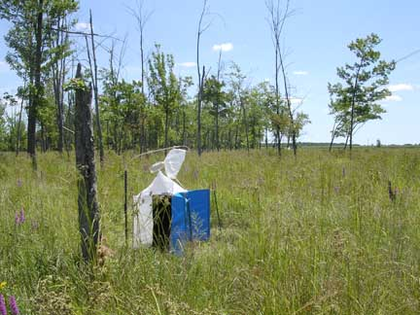 | 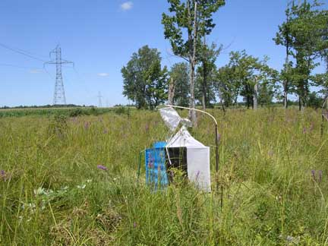
Site #27 looking south towards #26  August 5, 2007 | Site #27 looking North towards  August 5, 2007
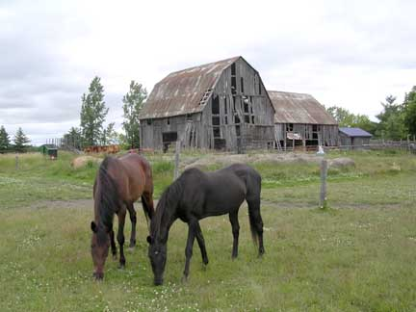 | 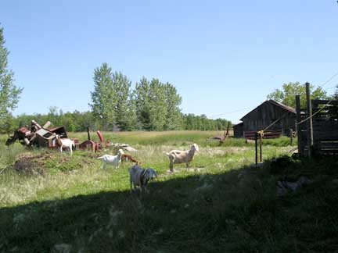
Grazing area of the horses  June 30, 2007 | Goats grazing behind the barn  July 22, 2007

The horses grazed throughout the pasture area. They were stabled next to site #21 and obviously spent time in the immediate vicinity of this trap; e.g. there was always fresh horse dung right at the trap.

The goats were mostly confined to the barn as were constrained outside by electric fencing. They were sometimes present at sites #21 and #22.

None of the animals interfered with the traps over a total of 3 months of trapping.
Trap Codes

All traps were new except for the standard which was used in 2006.

Standard (Response ratios are calculated relative to this trap)

1. NZI-COT Phthalogen Blue IF3GM cotton, Black local cotton twill
Fine mesh white polyester netting (Type IN6 - Barre Army/Navy)
(80% vis, 53% uv transmittance)

This is essentially the same standard trap as in recent publications. The IF3GM cloth dates to a large lot of custom-dyed fabric from Kenya in the mid-1990s. The trap differs only from the traps used earlier in Africa in terms of use of local black cotton twill, and substitution of a fine mesh white polyester netting for the more open mesh Vestergaard Frandsen (VF) netting.

Experimental

2. NZI-SUN-BIO Pacific Blue and Black Sunbrella acrylic awning fabric
All BIONET netting (90% vis, 40% uv transmittance)

3. NZI-SUN-ECO Pacific Blue and Black Sunbrella acrylic awning fabric
All ECONET L netting (86% vis, 62% uv transmittance)

The above two traps were made with “SECONDS” of Sunbrella. It is very hard to see any difference between seconds and the normal fabric - just a subtle difference in finish/weave.

4. NZI-COT-SUN-ECO Phthalogen Blue IF3GM cotton, Black Sunbrella acrylic
All ECONET L netting (86% vis, 62% uv transmittance)

This trap was tested as an alternative standard to understand the effects of small changes to the black and/or netting. It had black acrylic substituted for cotton (ever so slightly shiny), and clear polyethylene netting substituted for white polyester netting (very slight difference in finish and reflectance, almost the same visible and ultraviolet transmission properties).

Fabric Codes (full details are in Fabrics.mdb or FabricMaster.xls)

184 Phthalogen Blue IF3GM cotton twill from Mount Kenya Textiles, Kenya
214f SECONDS of Sunbrella Pacific Blue acrylic awning fabric, USA

215b SECONDS of Sunbrella Black acrylic awning fabric, USA
217 Black “Galaxy” 100% cotton twill, Fabricland, Canada

357 Econet L from Ludvig Svensson, Sweden via Gintec Shade Technologies, Canada
360 Bionet from Klayman Meteor, Israel (polyethylene, patented uv blocking treatment)
323c Army Navy Type IN6 fine mesh white polyester netting, lot from 2007

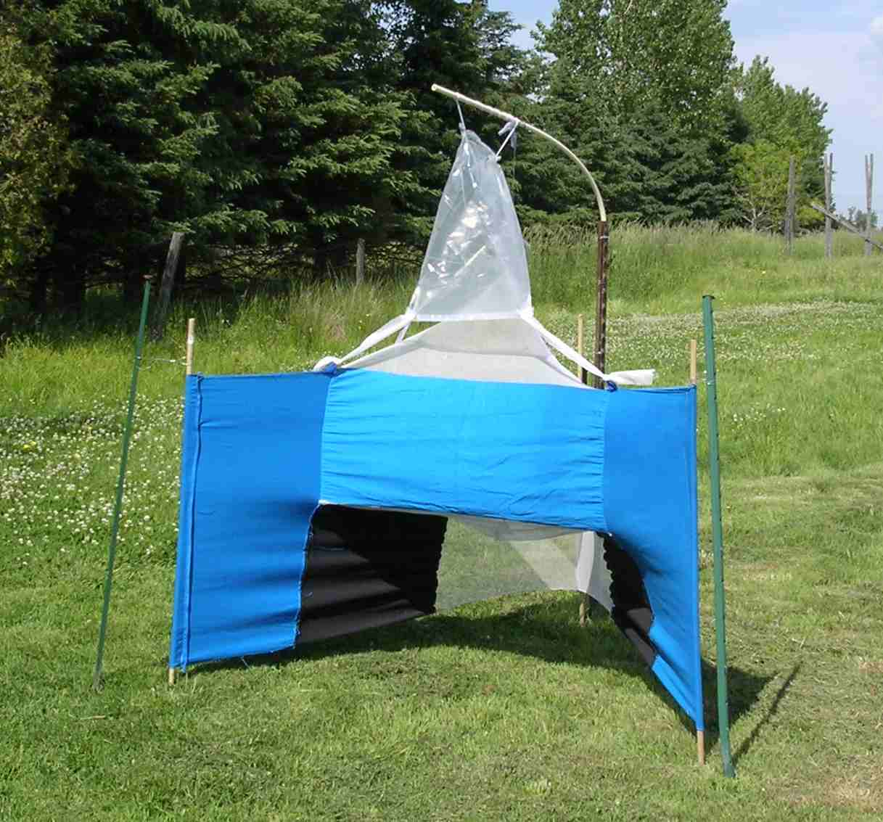 | 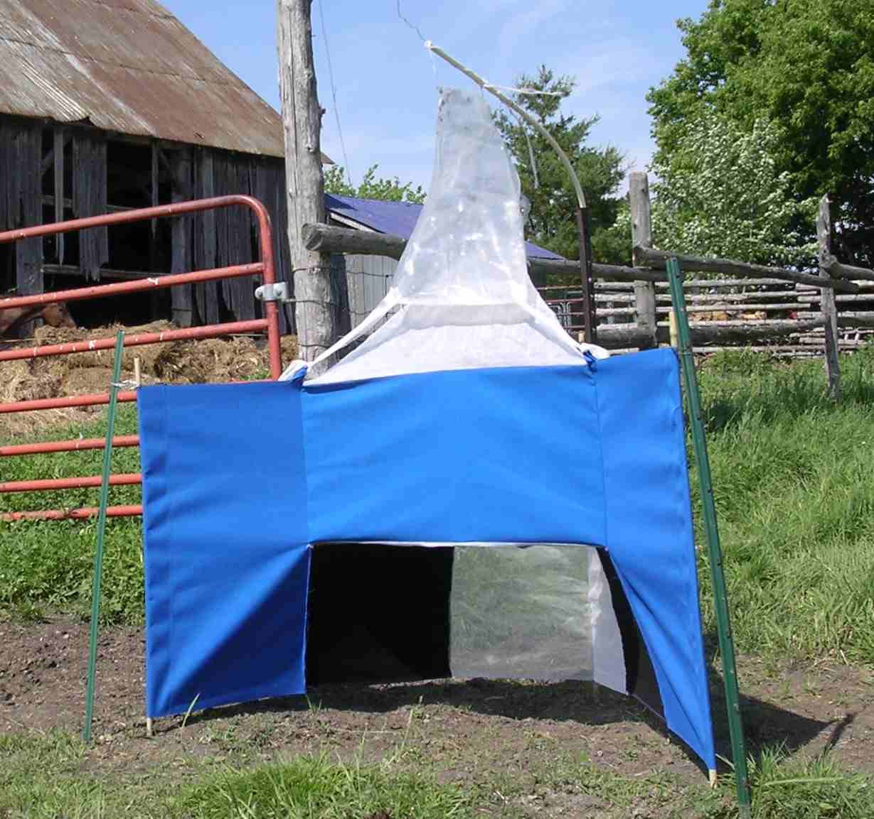
NZI-COT Site #23 - June 16 | NZI-SUN-ECO Site #21 - June 16
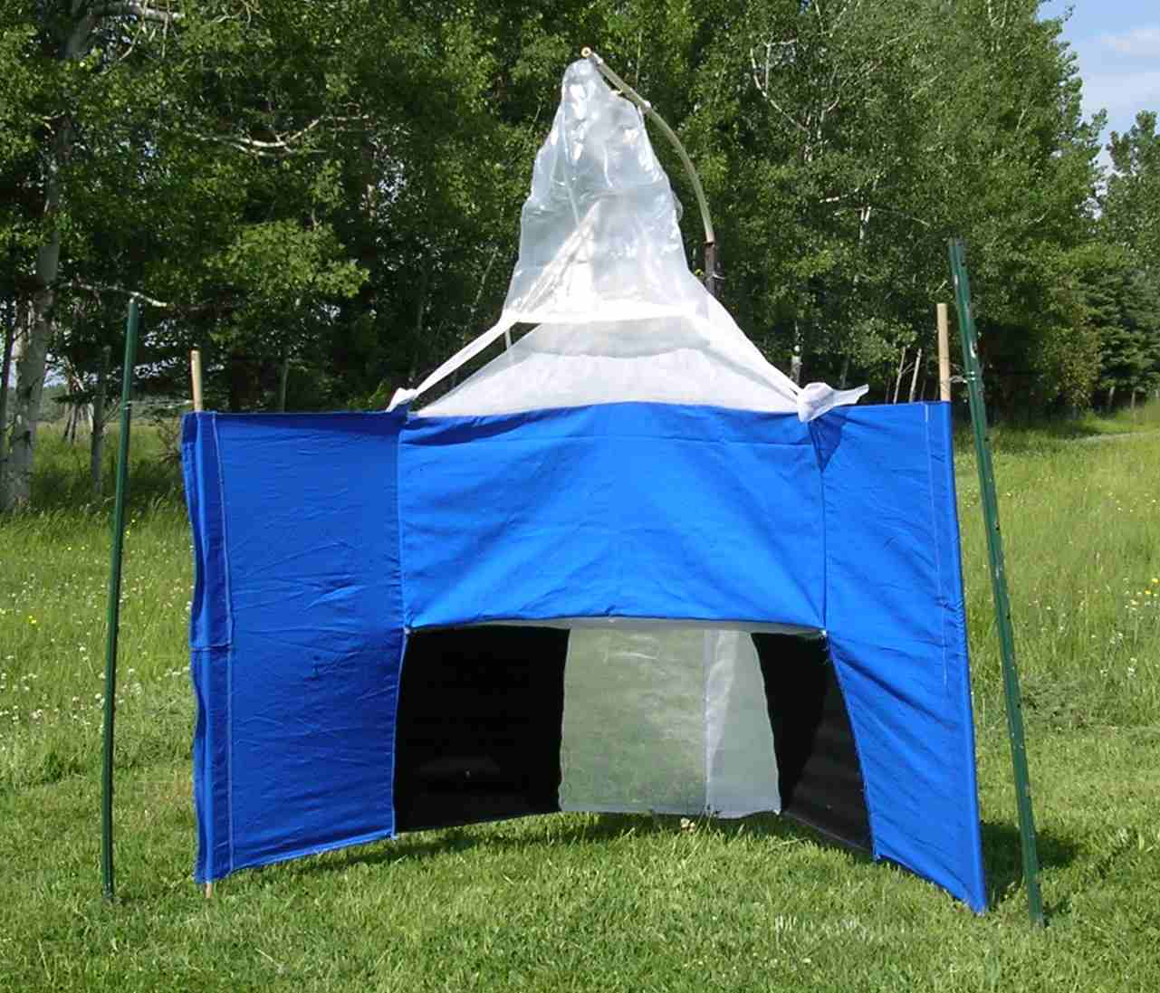 | 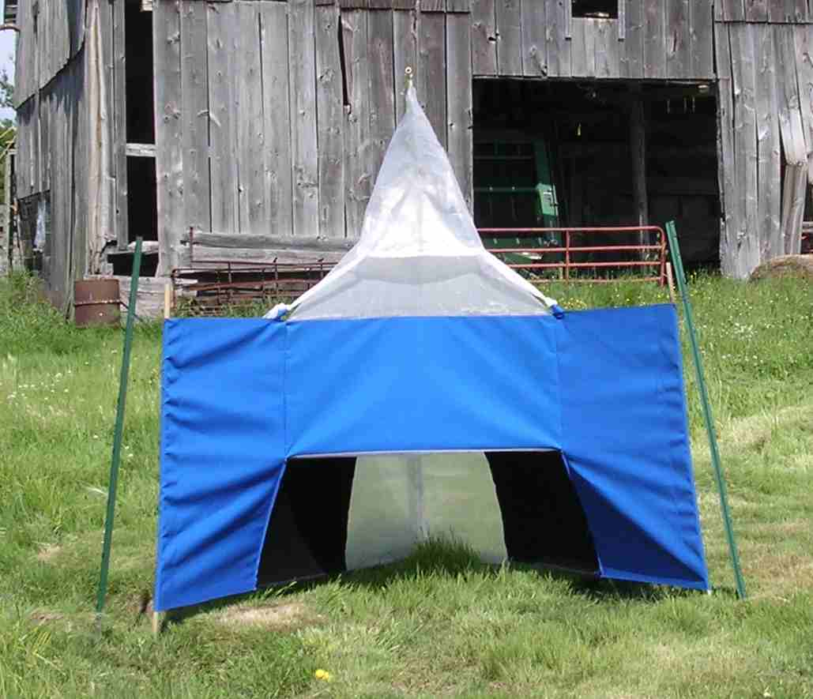
NZI-COT-SUN-ECO Site #24 - June 16 | NZI-SUN-BIO Site #22 - June 16

Collecting system at the end of a week with a few thousand tabanids captured
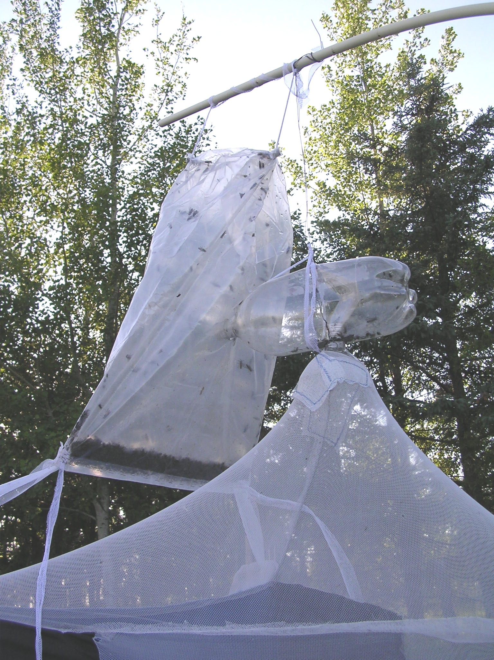
Note the tie from the hole in the bag running back to the suspension wire and bottle. This tie is critical and must be tight to keep the neck of the bottle inserted into the collecting bag.
The bottom ties are attached to loops sewn into the top of the trap wings and provide tension to spread the bag. The top ties also provide tension and help spread the bag.

In wet weather, these large catches begin to rot with weekly collections. It might be possible to improve on this system with a netting window in the bag to help the flies to dry out?
Weather: The experiment included the hot part of the summer and bracketed the tabanid peak which occurred in late July. Mid-summer had an unusual number of bad-weather days with highs only around 20 °C and with more rain than usual.
Hourly Statistics: http://www.climate.weatheroffice.ec.gc.ca/climateData/hourlydata_e.html

OTTAWA MACDONALD-CARTIER INT'L A
ONTARIO
Latitude: | 45° 19.200' N | Longitude: | 75° 40.200' W | Elevation: | 114.00 m
Climate ID: | 6106000 | WMO ID: | 71628 | TC ID: | YOW

This airport weather station is the best reference weather for the Russell/Edwards area.

The first tabanids appear in mid-May and decline rapidly in early September. Stable flies appear a month after tabanids and can peak very late in the year, e.g. in early October.

Maximum daily temperatures during this experiment were about 25 °C.

Average of Max | Year
Month | 2001 | 2002 | 2003 | 2004 | 2005 | 2000 | 2006 | 2007
5 | 20.6 | 16.5 | 18.3 | 18.7 | 17.2 | 18.5 | 19.7 | 20.0
6 | 25.3 | 22.5 | 24.4 | 23.3 | 26.8 | 21.8 | 24.0 | 25.4
7 | 25.7 | 27.5 | 26.4 | 26.1 | 27.7 | 24.3 | 27.8 | 25.2
8 | 28.4 | 27.6 | 26.4 | 23.8 | 27.1 | 24.5 | 25.3 | 25.8
9 | 21.7 | 24.3 | 22.5 | 21.9 | 22.8 | 19.2 | 19.1 | 22.5
10 | 14.0 | 11.0 | 11.6 | 13.8 | 13.6 | 13.3 | 11.4 | 16.1

Many rainy days where catch would have been ~ZERO based on what was caught in traps set at Russell. Total “fair-weather” trap days were 184 only.

Pattern by Replicate | 1 | 2 | 3 | 4 | 5 | 6 | 7 | 8
Actual Calendar Days | 7 | 8 | 7 | 7 | 7 | 7 | 7 | 7
Fair Weather Days with a catch | 5 | 7 | 5 | 4 | 5 | 6 | 7 | 7

Data were analyzed in terms of catch per unit effort to be consistent with typical daily trap checks in other experiments.
First Latin Square

Date | Min | Max | Rain | Replicate | Zero Catch Likely
16-Jun-07 | 16.6 | 31.1 | 0 | 1
17-Jun-07 | 15.6 | 26.9 | 0.2 | 1
18-Jun-07 | 13.7 | 25.1 | 0 | 1
19-Jun-07 | 15 | 31.3 | 6.4 | 1
20-Jun-07 | 12.6 | 23.3 | 0 | 1
21-Jun-07 | 10.8 | 21.8 | 1.6 | 1 | Marginal day
22-Jun-07 | 10 | 19.7 | 0.8 | 1 | RAIN-cold
23-Jun-07 | 8.4 | 19.8 | 0 | 2
24-Jun-07 | 10.4 | 23.3 | 0.6 | 2
25-Jun-07 | 16.3 | 30 | 0.2 | 2
26-Jun-07 | 17.9 | 34.2 | 0 | 2
27-Jun-07 | 21.2 | 33.6 | 0.4 | 2
28-Jun-07 | 11.4 | 23.8 | 0 | 2
29-Jun-07 | 9 | 24.8 | 1.4 | 2
30-Jun-07 | 9.1 | 20.9 | 2.2 | 2 | RAIN-cold
1-Jul-07 | 8.4 | 19.4 | 0 | 3
2-Jul-07 | 8.2 | 23.7 | 4.6 | 3
3-Jul-07 | 11.4 | 26 | 0 | 3
4-Jul-07 | 13.3 | 21.5 | 2.2 | 3 | RAIN-cold
5-Jul-07 | 15.8 | 24.4 | 0 | 3
6-Jul-07 | 13.9 | 27 | 3.6 | 3
7-Jul-07 | 12.6 | 20.4 | 4.2 | 3 | RAIN-cold
8-Jul-07 | 15.4 | 21.7 | 8.6 | 4 | RAIN-cold
9-Jul-07 | 16.6 | 28.6 | 22.4 | 4 | OK , rain at night
10-Jul-07 | 19.4 | 26.8 | 0.6 | 4
11-Jul-07 | 14.6 | 27.4 | 2.6 | 4
12-Jul-07 | 12.1 | 24 | 1 | 4
13-Jul-07 | 12.7 | 21.4 | 4 | 4 | RAIN-cold
14-Jul-07 | 11.7 | 21.8 | 4 | 4 | RAIN-cold

Second Latin Square

Date | Min | Max | Rain | Replicate | Zero Catch Likely
15-Jul-07 | 14.4 | 24.1 | 0 | 5
16-Jul-07 | 11.3 | 25.3 | 0 | 5
17-Jul-07 | 12.4 | 26.4 | 0 | 5
18-Jul-07 | 15.6 | 27.4 | 0.2 | 5
19-Jul-07 | 16.3 | 21.2 | 1.8 | 5 | RAIN - cold
20-Jul-07 | 13.3 | 19.6 | 67.8 | 5 | RAIN - cold
21-Jul-07 | 11.1 | 25.5 | 0 | 5
22-Jul-07 | 13.1 | 26.2 | 0 | 6
23-Jul-07 | 13.1 | 27 | 0 | 6
24-Jul-07 | 17.2 | 26.6 | 0 | 6
25-Jul-07 | 15.5 | 28.9 | 0 | 6
26-Jul-07 | 16.9 | 29.7 | 0 | 6
27-Jul-07 | 18.8 | 29.7 | 0 | 6
28-Jul-07 | 18.4 | 23.8 | 11 | 6 | RAIN
29-Jul-07 | 15.7 | 26.2 | 0 | 7
30-Jul-07 | 14.3 | 28.7 | 0 | 7
31-Jul-07 | 17.7 | 29.7 | 0 | 7
1-Aug-07 | 17.3 | 31 | 0 | 7
2-Aug-07 | 19.6 | 34.1 | 0 | 7
3-Aug-07 | 17.9 | 32.1 | 2.6 | 7
4-Aug-07 | 15.3 | 24.8 | 0 | 7
5-Aug-07 | 11.6 | 25.4 | 0 | 7
6-Aug-07 | 14.4 | 26.9 | 10 | 8 | OK rain in morning
7-Aug-07 | 18.6 | 25.5 | 0 | 8
8-Aug-07 | 16.7 | 28.9 | 0 | 8
9-Aug-07 | 13.1 | 23 | 0 | 8
10-Aug-07 | 15.5 | 26.6 | 0 | 8
11-Aug-07 | 14.6 | 29.8 | 0 | 8
12-Aug-07 | 17.3 | 31 | 2.8 | 8

Female Eye Patterns

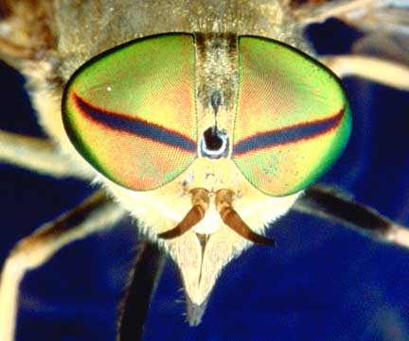 | Tabanus quinquevittatus (personal photo)  “Bare, green, with a narrow transverse dark band” (Teskey, 1990)  Green is quite brilliant, it changes to black when viewed at a very acute angle; the dark purplish stripe is constant at most angles, shifting to a brighter reddish-purple only at extreme angles  T. nigrovittatus has a similar eye pattern; it is called the “greenhead”  I have excellent photos of male eyes.
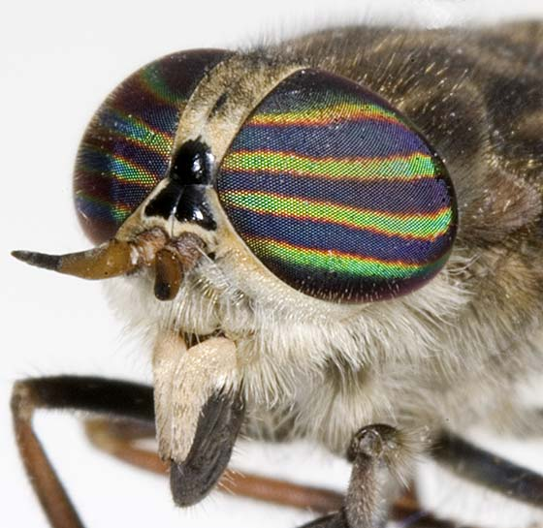 | Hybomitra lasiophthalma (Photo #11436)  Photo by Tony Thomas  http://bugguide.net/node/view/11436  “Eye densely pilose, with 4 narrow greenish blue bands on reddish purple background” (Teskey, 1990)  This is the species where corneal interference filters have been extensively characterized. The eye stripes have a “rainbow” of colours depending on the angle of view, generally quite blue in the middle and green on the edges.  I have excellent photos of male eyes.

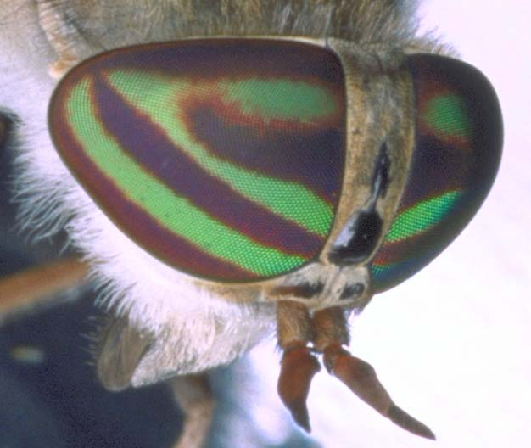 | Tabanus similis (personal photo)  “Bare, reddish purple with a blue [sic] transverse stripe in lower half, and similarly colored V-shaped configuration occupying most of the upper half” (Teskey, 1990)  The colour of the eye stripes is most often a simple GREEN with some blue, but this is dependent on the angle, e.g. it can have blue overtones, especially when viewed at an angle.  At extreme angles the background changes from dark reddish purple to bright reddish-orange.
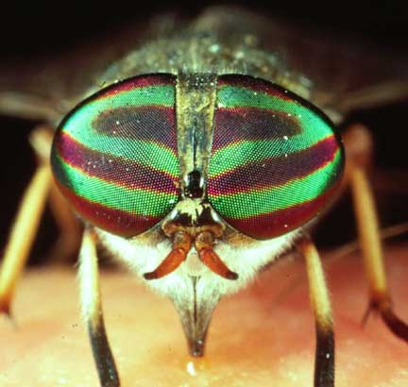 | Tabanus lineola (Photo #1471008)  Photo by Sturgis McKeever  http://www.ipmimages.org/browse/detail.cfm?imgnum=1471008  “Bare, bluish purple with two diagonal green stripes, stripes from near median ventral angle, the upper stripe joined laterally by third stripe from dorsomedial part of eye, forming a V-shaped configuration” (Teskey, 1990)

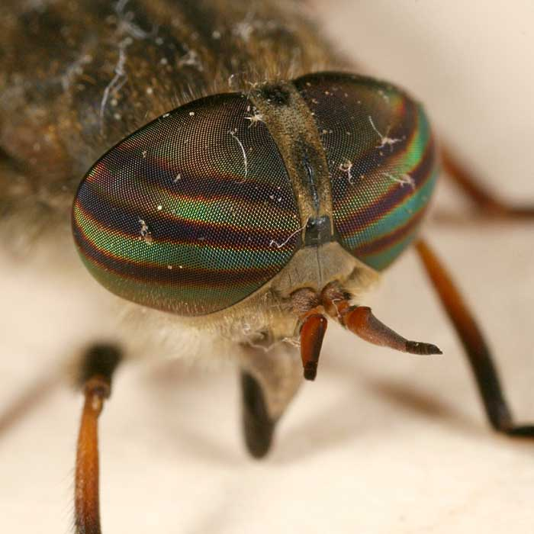 | Hybomitra epistates (no photo ID code)  Photo by Tom Murray  http://www.pbase.com/tmurray74/image/81791107  “Eye densely pilose with 4 transverse green stripes on dark background, the upper stripe faint” (Teskey, 1990)  ID probably OK, but have to be careful with web images as this eye pattern is found in many species
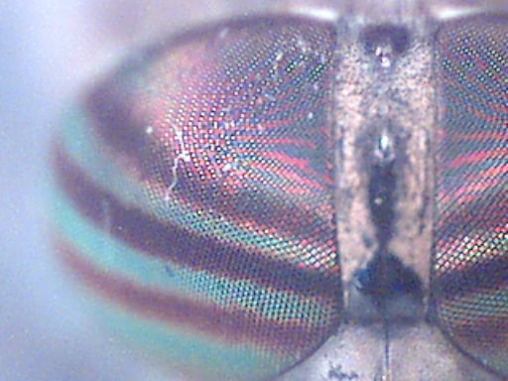 | Hybomitra frontalis (personal photo)  Crude shot with Intel Play Microscope  ”Eye conspicuously pubescent; emerald green with three narrow purplish bands, middle band narrowest, often reduced to a mere line”  McAlpine (1961) Can Ent. 93:894-925.  Teskey (1990) gives incorrect details, In Russell, I see three thin, fairly similar purplish bands on a greenish background
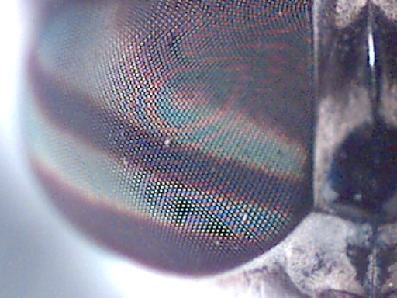 | Tabanus reinwardtii (Personal photo)  Crude shot with Intel Play Microscope  “Bare to very sparsely short pilose, dark purplish, with 2 transverse greenish blue bands” (Teskey, 1990).  Rarely-caught; specimens agree with his description

Site Differences - FAIR WEATHER DAY BASIS

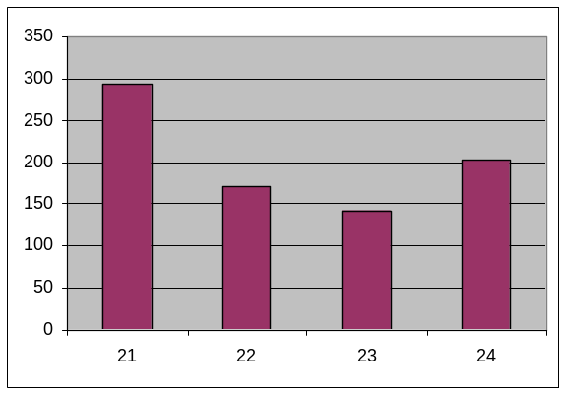 | TABANIDAE  Backtransformed Mean catch  per trap per fair weather day  Sites #22-24 are similar and catch 50-70% as many tabanids as site #21 which is at the horse stable. Site differences are significant in the overall ANOVA, but with only site #21 higher than the other sites.

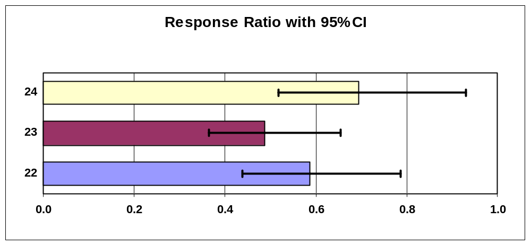

Mean Square Error |  | 0.0147
Calculated LSD |  | 0.127

Farm1 Risk Adjusted
REFRESH TABLES
Average of Tabanidae |  | Backtrans | Index of | Response
SITE | Total | Mean | Increase | Ratio
21 | 2.468 | 293.04 | 1.00 | 1.00
22 | 2.237 | 171.60 | 0.59 | 0.59
23 | 2.157 | 142.58 | 0.49 | 0.49
24 | 2.310 | 203.07 | 0.69 | 0.69
Grand Total | 2.293 | 195.37
Catches Through Time

Tabanus similis (backtransformed mean catch per trap per fair weather day)
(89.0%, 5,832 of 6,554 caught in replicate 1 - females only captured)

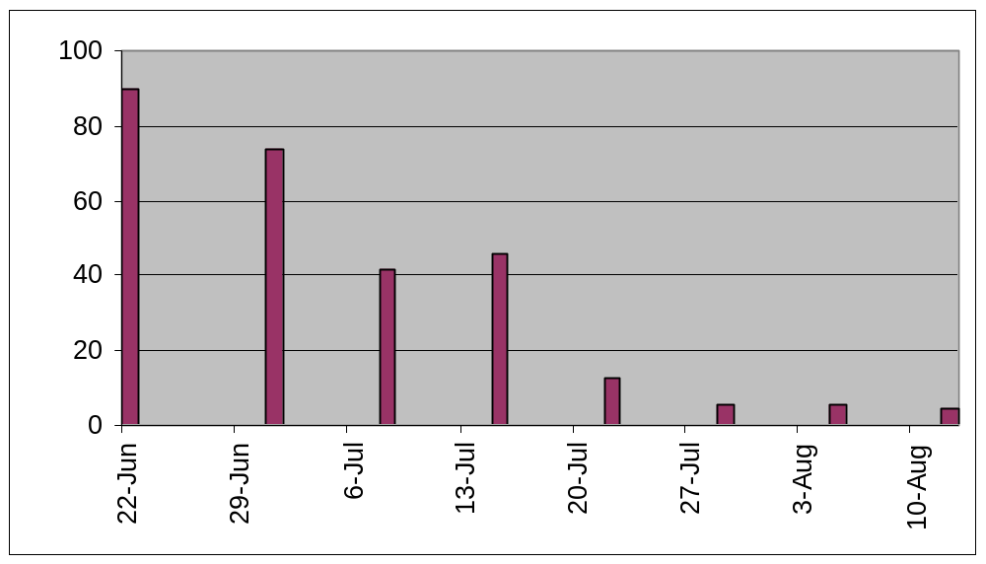

Tabanus quinquevittatus
(80.6%, 26,210 of 32,520 in replicate 2 - female statistics shown, males also caught)

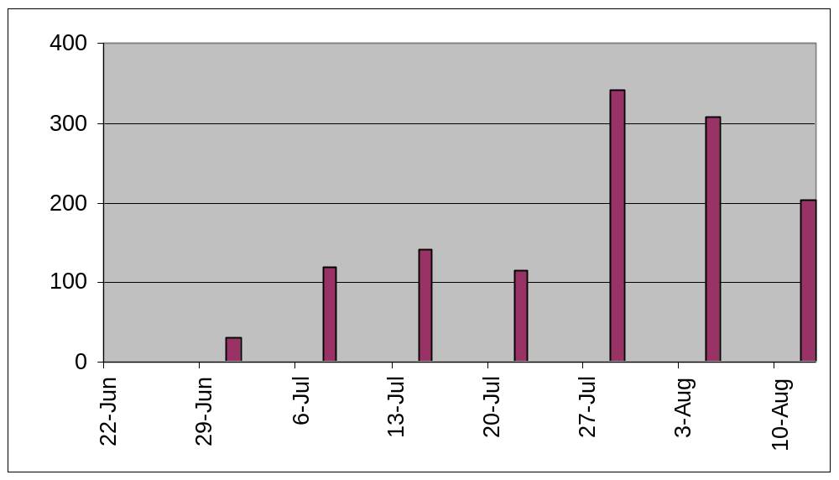
Hybomitra lasiophthalma (99.8%, 1,781 of 1,784 caught in replicate 1)

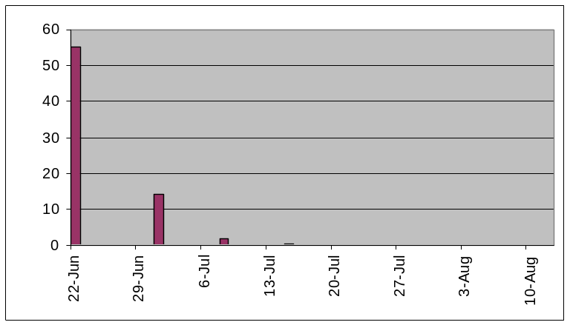

Chrysops (79.6%, 324 of 407 caught in replicate 1)

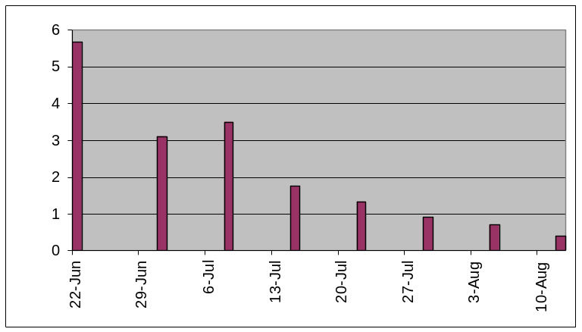

Stomoxys calcitrans (87.8%, 491 of 559 caught in replicate 2)

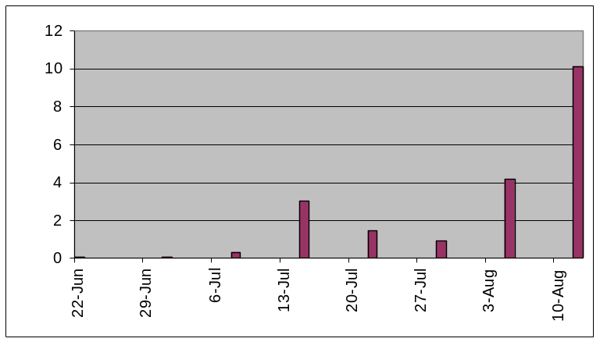
Regional Differences

I had two standard octenol-baited traps (NZI-COT) set continuously at my home in Russell in 2007. These traps were checked daily and rotated among sites close together in my back yard, and in a neighbour’s yard, covering the entire biting fly season.

I calculated average catches over weekly intervals relative to trap checks at the farm and adjusted all the data to a “catch per trap per fair-weather day basis”. The farm data represent 4-7 traps in any particular week, regardless of cloth/netting type. I used this approach to analyze trends in order to smooth out site effects (e.g. site #1 high for tabanids, sites #5-7 very low for stable flies). These site effects would have complicated the weekly patterns, e.g. if only the NZI-COT trap was tallied for the farm.

Catches at the farm were extremely high for all tabanids except for Chrysops. Sustained catches of this magnitude have hardly ever been published. The farm had a lot of wet pasture; it must have been a prime breeding area for T. quinquevittatus (also many males in catches).

Stable fly catches were a few times higher than at Russell early in the season, with a much higher difference in catch towards the end of the season.

FarmRussell.xls contains the pivot table tallies and numerical ratios of trap catches.

Except for Chrysops, the data are graphed on separate Y-axes so that detail is shown for the low catches at Russell. This also makes it clear how dramatically catch ratios changed late in the season for some species.

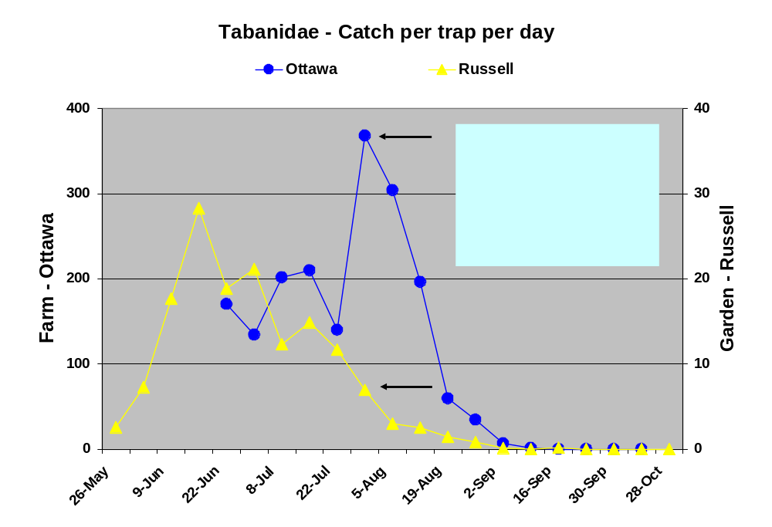

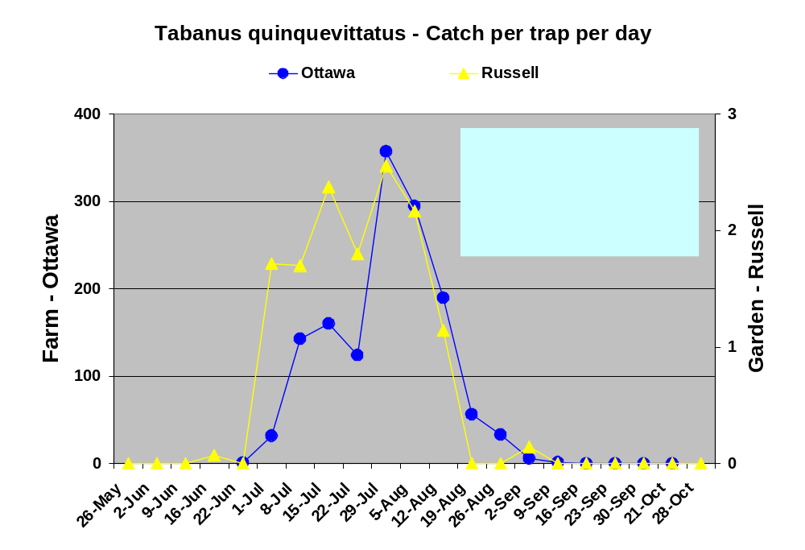
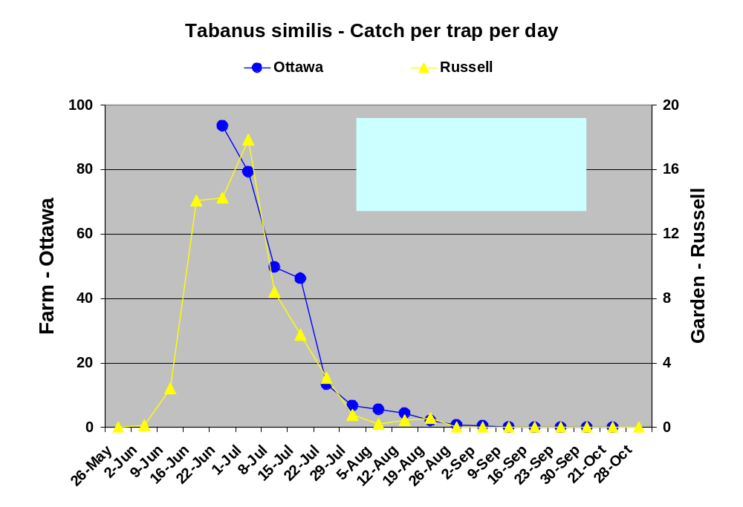

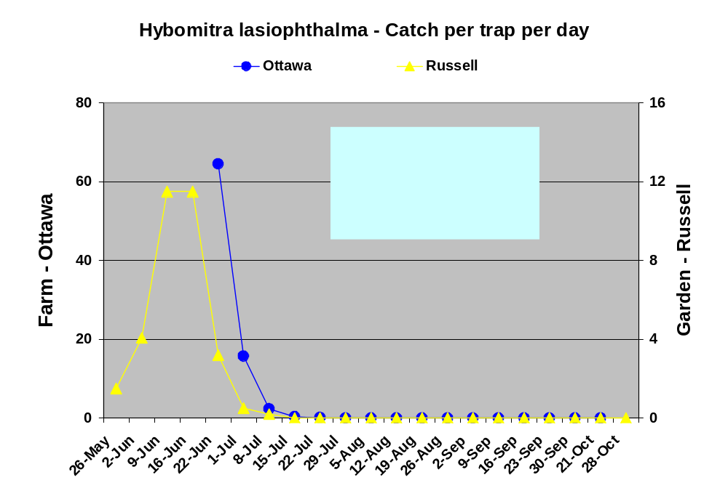
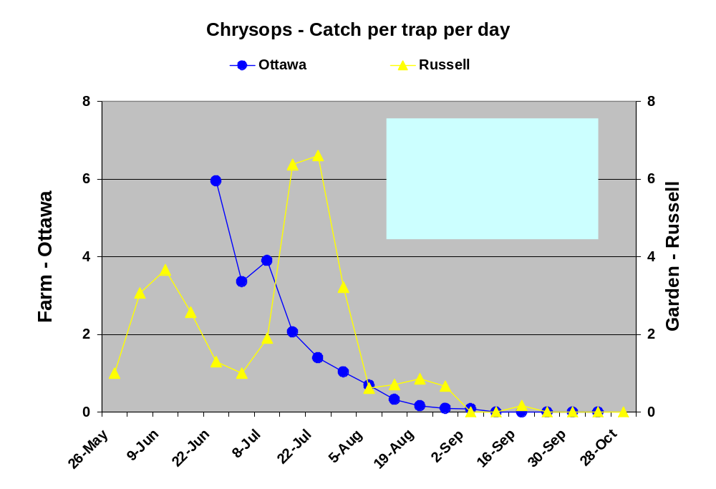

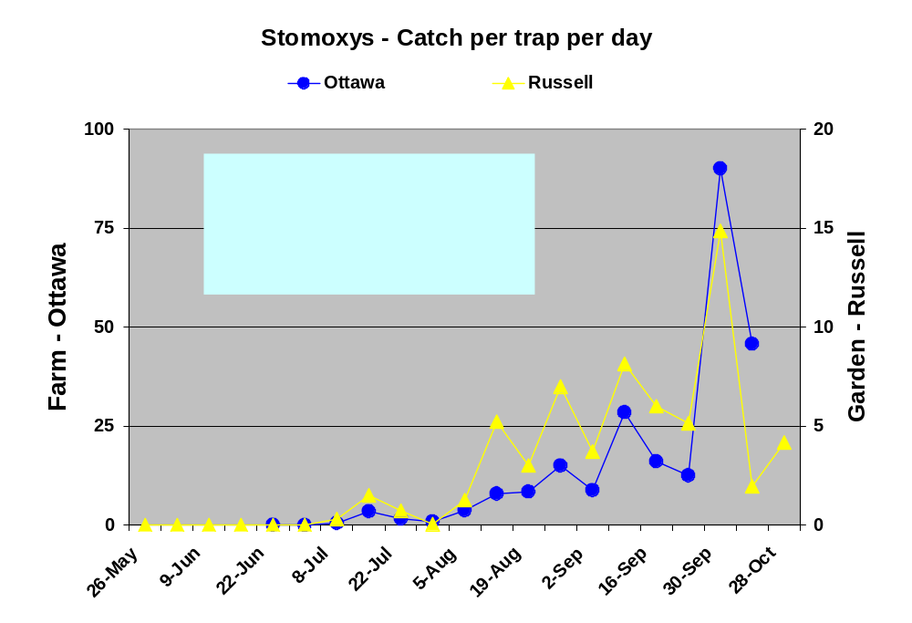
There is one major puzzle in comparisons between the farm and my home. At the end of July, T. quinquevittatus, and to less obvious extent, T. similis, nearly disappeared in traps set at my home in Russell. At the farm, T. quinquevittatus numbers increased greatly at this time. This is a very odd result relative to all previous trapping in Russell (e.g. many Tq were caught in early August in the sticky triangle experiment published in MVE 2007, the typical annual pattern).

The only explanation I can suggest is the possibility of insecticide use right next to where I live. My best guess is that this might have been happened to suppress soybean aphids in July.
http://www.omafra.gov.on.ca/english/crops/facts/04-059.htm. The seasonal summary states:

“Soybean aphid pressure was high in some areas, but economic thresholds were only reached in eastern Ontario, and the region spanning from London to Wingham and east to Guelph, where aphids were found as early as late-May. Unfortunately, a few fields were so infested that multiple foliar insecticide sprays were required.”
http://www.omafra.gov.on.ca/english/crops/field/reports/2007summary-d.htm

There was definitely some spraying in my “eastern” part of Ontario (organophosphates such as Dimethoate?). None of this is tracked in a public record so it is hard to guess what happened.

This summer, there was a major difference in what farmers planted in the two areas where the traps were set - mostly corn by the farm, mostly soybeans by my house.

This Google Photo is from the summer of 2005

Farmers typically alternate between soybeans and corn. It was unusual this year to have the entire area near my house planted in soy.

The Hay fields are near a stable with a few horses. The field near the river at the top of the photo has not been planted in a crop for several years; the area to the south is always just used for Hay.

The dairy barn about 1 km to the west had about 150+ cattle this year; they are kept indoors.

There are large tracts of corn and more soy to the west and south off the image.

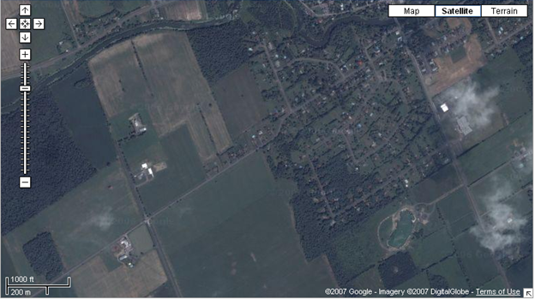
Large Field of Soy
Soy
Soy
Soy
Hay
Hay
Dairy Cattle
Corn to SW
Traps

Below is a government extension news item, unfortunately from southwestern Ontario, which is very far away from where I live in Russell.

Author: | Tracey Baute - Field Crop Entomologist/OMAFRA Ridgetown
Creation Date: | 09 August 2007
Those who have been watching their fields closely every week noticed a big change in the aphid activity early last week. Aphid populations built up in many fields and reached threshold. Other fields that had barely any aphids in them before were found to have at or above threshold numbers within the same week. After some consultation with colleagues in neighbouring states and provinces, we suspect a flush of winged adults were brought from the Midwest via the storm fronts last week, as Ohio, Michigan, Ontario and Quebec all experienced this sudden appearance of more aphids.

Map of high soy aphid populations to the east of Russell at the end of July
(hence, spraying likely to have taken place)

Thresholds have been reached if there are 250 or more aphids per plant on approximately 80% of the field and aphid populations are increasing and the soybean crop is within the reproductive stages (i.e. flowering) of R1 (first bloom) up to and including R5 (beginning seed).
http://www.sbrusa.net/

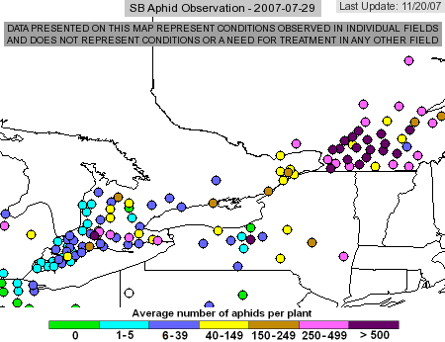
Large-scale setting of the two trapping locations

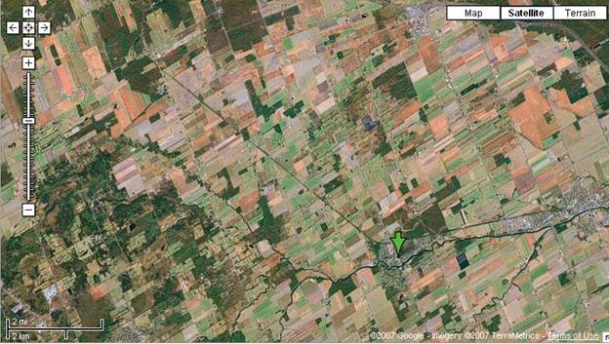
Garden - Russell
Farm - Edwards
Russell Village
Experimental Results

This is the first time I have ever done an experiment with weekly trap rotations, so I have no standard of comparison for what to expect in terms of statistical properties for this design. I therefore looked carefully at the implications of analyzing the data in different ways; there were no surprises. The Least Significant Difference (LSD) was 0.127 for Tabanidae; this equates to a critical Response Ratio (P=0.05 for paired a priori comparisons relative to the standard trap) that is excellent relative to the other work (< 0.75 or > 1.34). This value represents < 10 ^{-0.127} or > 10 ^{+0.127} or a ~30% difference in geometric mean catches (thresholds are not symmetrical due to the log (X+1) transformation). This is an excellent level of discrimination given past experiments, e.g. a 40-80% level of discrimination is more typical of experiments with daily trap checks over a wide range of tabanid numbers with much larger sample sizes.

Trends were similar or identical regardless of whether I adjusted for fair-weather trap days or analyzed the raw data by calendar week. Trends by replicates for the few species that spanned both replicates were consistent.

Site 1 next to the horses had the highest catches, but these were not impressive given the supposed attractiveness of horse urine/etc. The entire woodland area appears to be good for catches of horse flies, but deer flies were not abundant. I have yet to monitor deer flies in any areas where they are known to harass people in large numbers.

The main result is that all traps were “good”; i.e. they all caught very similar numbers of tabanids - and an awful lot of them. Watson et al. (2007) using Horse Pal and Epps traps in North Carolina next to horses (unbaited) caught about 20x fewer tabanids; their main species was also T. quinquevittatus. This paper was just published and is the first publication I am aware of to actually quantify the performance of these commercial traps.

Watson, D.W., Denning, S.S., Calibeo-Hayes, D.I., Stringham, S.M. & Mowrey, R.A. (2007) Comparison of two fly traps for the capture of horse flies (Diptera : Tabanidae). Journal of Entomological Science, 42, 123-132.

There was a hint of lower catches of some species with Sunbrella Pacific Blue acrylic instead of Phthalogen Blue cotton. I have noted this before with Tabanus in Russell. This trend needs to be assessed once a larger data set is available from several experiments.

Effects of Econet-L netting substitutions were difficult to pin down as results were very close, as with the simultaneous substitution of Sunbrella Black for black cotton.

The trend seen in the Sudan with Bionet as the best choice for netting for tabanids seems to be present here. BUT - I think I have bad news from other experiments with stable flies both here and elsewhere. This uv-blocking netting appears to be a terrible choice for catching Stomoxys - more data will follow on this topic along with more comparisons for ECONET-L.

Good news from other experiments is that Top Notch Blue #563 polyester marine canvas may be much better than Sunbrella Pacific Blue - more data to follow.
Tabanidae (Both Replicates)

Dep Var: TABANIDAE N: 32 Multiple R: 0.9144 Squared multiple R: 0.8361

Analysis of Variance
Source Sum-of-Squares df Mean-Square F-ratio P

TYPE$ 0.1985 3 0.0662 4.4889 0.0161
REPLICATE 0.2117 1 0.2117 14.3646 0.0013
SITE 0.4212 3 0.1404 9.5255 0.0005
SEQ(REPLICATE) 0.5219 6 0.0870 5.9009 0.0015

Error 0.2653 18 0.0147

Farm1 Risk Adjusted
REFRESH TABLES
Average of Tabanidae |  | Backtrans | Index of | Response
TYPE$ | Total | Mean | Increase | Ratio
NZI-COT | 2.322 | 209.11 | 1.00 | 1.00
NZI-SUN-ECO | 2.190 | 153.87 | 0.74 | 0.74
NZI-SUN-BIO | 2.403 | 251.79 | 1.20 | 1.20
NZI-COT-SUN-ECO | 2.257 | 179.78 | 0.86 | 0.86
Grand Total | 2.293 | 195.37

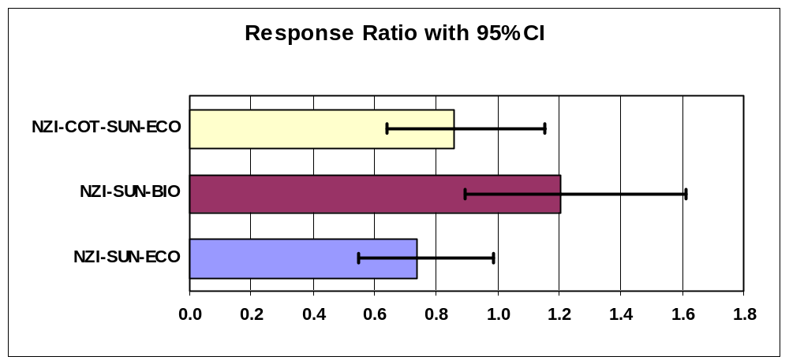

.
Arithmetic Mean WEEKLY |  |  | Maximum WEEKLY
Average of Tabanidae |  |  | Max of Tabanidae
TYPE$ | Total |  | TYPE$ | Total
NZI-COT | 1400.3 |  | NZI-COT | 2783
NZI-SUN-ECO | 984.3 |  | NZI-SUN-ECO | 1725
NZI-SUN-BIO | 1635.1 |  | NZI-SUN-BIO | 3058
NZI-COT-SUN-ECO | 1210.5 |  | NZI-COT-SUN-ECO | 3155
Grand Total | 1307.5 |  | Grand Total | 3155

Tabanidae - Alternative approaches to the ANOVAs

Both Replicates (by raw weekly catch, not divided by fair-weather trapping days)
The pattern is identical to the ANOVA adjusted for risk
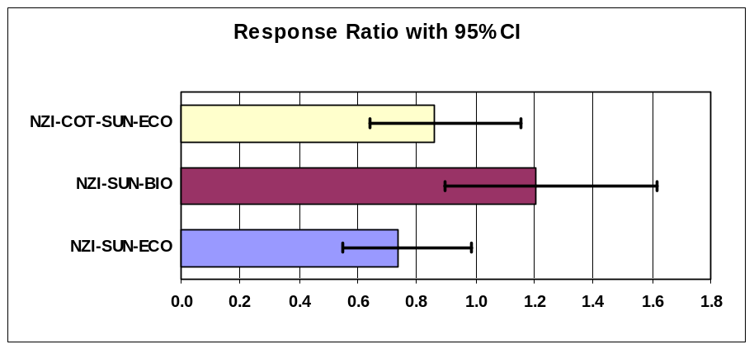

Replicate 1 only (risk-adjusted)
There is a slight change in pattern due to the dominance of H. lasiophthalma, T. similis
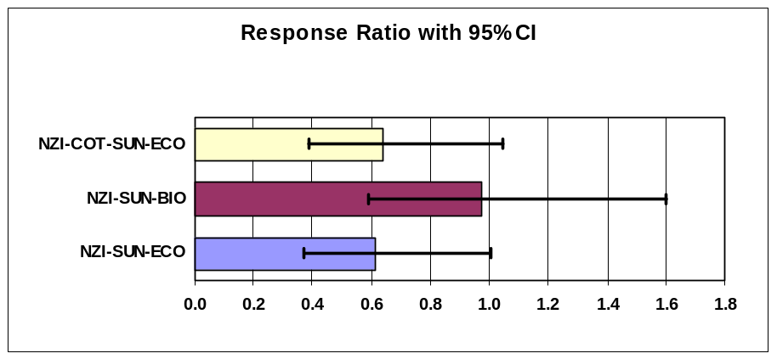

Replicate 2 only (risk adjusted)
There is a slight change in pattern due to the dominance of T. quinquevittatus

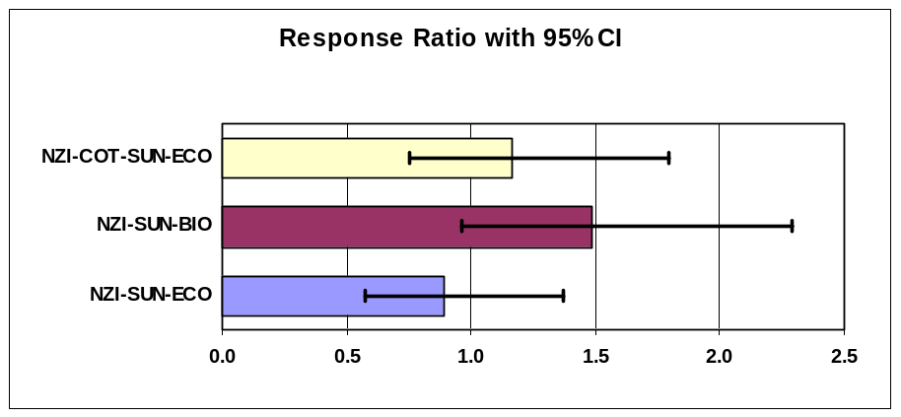
MALE Tabanus quinquevittatus (Both replicates)

Only 156 caught, but data are unique so catch pattern examined.
Highest proportion male Tq in a weekly catch from any one trap was 1.7%

Dep Var: MALETAB N: 32 Multiple R: 0.8959 Squared multiple R: 0.8026

Analysis of Variance
Source Sum-of-Squares df Mean-Square F-ratio P

TYPE$ 0.0206 3 0.0069 0.3835 0.7662
REPLICATE 0.5077 1 0.5077 28.3271 0.0000
SITE 0.3344 3 0.1115 6.2180 0.0044
SEQ(REPLICATE) 0.4487 6 0.0748 4.1721 0.0084

Error 0.3226 18 0.0179

Farm1 Risk Adjusted
REFRESH TABLES
Average of MaleTab |  | Backtrans | Index of | Response
TYPE$ | Total | Mean | Increase | Ratio
NZI-COT | 0.173 | 0.49 | 1.00 | 1.00
NZI-SUN-ECO | 0.126 | 0.34 | 0.69 | 0.90
NZI-SUN-BIO | 0.195 | 0.57 | 1.16 | 1.05
NZI-COT-SUN-ECO | 0.156 | 0.43 | 0.89 | 0.96
Grand Total | 0.163 | 0.45

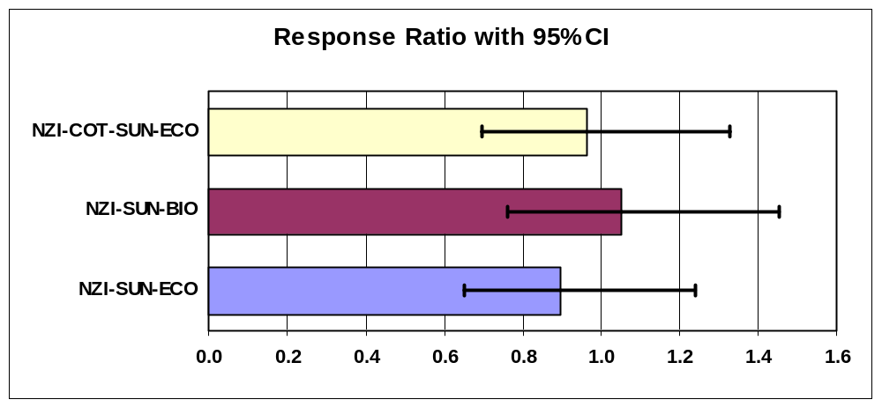

Arithmetic Mean WEEKLY |  |  | Maximum WEEKLY
Average of MaleTab |  |  | Max of MaleTab
TYPE$ | Total |  | TYPE$ | Total
NZI-COT | 4.8 |  | NZI-COT | 18
NZI-SUN-ECO | 3.1 |  | NZI-SUN-ECO | 13
NZI-SUN-BIO | 7.6 |  | NZI-SUN-BIO | 51
NZI-COT-SUN-ECO | 4.0 |  | NZI-COT-SUN-ECO | 18
Grand Total | 4.9 |  | Grand Total | 51

Female Tabanus quinquevittatus (Both replicates)
Interpretation does not change with alternative ANOVAs

Dep Var: TAQUIF N: 32 Multiple R: 0.9925 Squared multiple R: 0.9851

Analysis of Variance
Source Sum-of-Squares df Mean-Square F-ratio P

TYPE$ 0.3365 3 0.1122 8.2011 0.0012
REPLICATE 5.8502 1 5.8502 427.7055 0.0000
SITE 0.4206 3 0.1402 10.2492 0.0004
SEQ(REPLICATE) 9.6991 6 1.6165 118.1819 0.0000

Error 0.2462 18 0.0137

Farm1 Risk Adjusted
REFRESH TABLES
Average of TAQUIF |  | Backtrans | Index of | Response
TYPE$ | Total | Mean | Increase | Ratio
NZI-COT | 1.923 | 82.77 | 1.00 | 1.00
NZI-SUN-ECO | 1.779 | 59.16 | 0.71 | 0.72
NZI-SUN-BIO | 2.069 | 116.25 | 1.40 | 1.40
NZI-COT-SUN-ECO | 1.914 | 81.12 | 0.98 | 0.98
Grand Total | 1.921 | 82.46

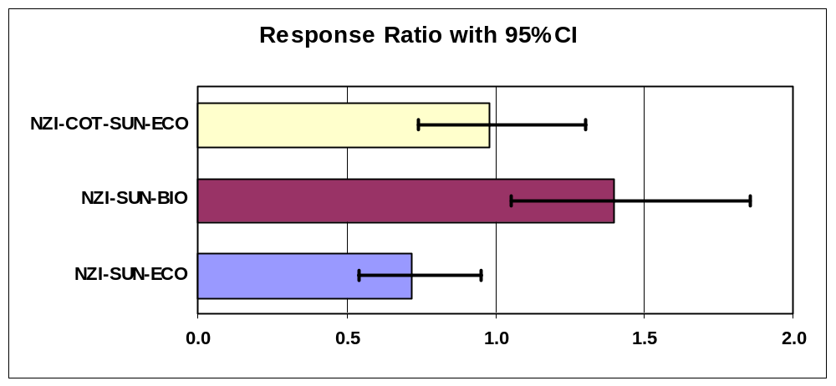

Arithmetic Mean WEEKLY |  |  | Maximum WEEKLY
Average of TAQUIF |  |  | Max of TAQUIF
TYPE$ | Total |  | TYPE$ | Total
NZI-COT | 1062.1 |  | NZI-COT | 2676
NZI-SUN-ECO | 703.5 |  | NZI-SUN-ECO | 1693
NZI-SUN-BIO | 1335.8 |  | NZI-SUN-BIO | 2963
NZI-COT-SUN-ECO | 963.6 |  | NZI-COT-SUN-ECO | 3063
Grand Total | 1016.3 |  | Grand Total | 3063

Tabanus similis (Both replicates)
Interpretation does not change with alternative ANOVAs

Dep Var: TASIMF N: 32 Multiple R: 0.9736 Squared multiple R: 0.9480

Analysis of Variance
Source Sum-of-Squares df Mean-Square F-ratio P

TYPE$ 0.2381 3 0.0794 3.3590 0.0418
REPLICATE 6.5436 1 6.5436 276.9676 0.0000
SITE 0.2990 3 0.0997 4.2190 0.0200
SEQ(REPLICATE) 0.6702 6 0.1117 4.7276 0.0047

Error 0.4253 18 0.0236

Farm1 Risk Adjusted
REFRESH TABLES
Average of TASIMF |  | Backtrans | Index of | Response
TYPE$ | Total | Mean | Increase | Ratio
NZI-COT | 1.450 | 27.20 | 1.00 | 1.00
NZI-SUN-ECO | 1.211 | 15.26 | 0.56 | 0.58
NZI-SUN-BIO | 1.356 | 21.70 | 0.80 | 0.80
NZI-COT-SUN-ECO | 1.308 | 19.32 | 0.71 | 0.72
Grand Total | 1.331 | 20.45

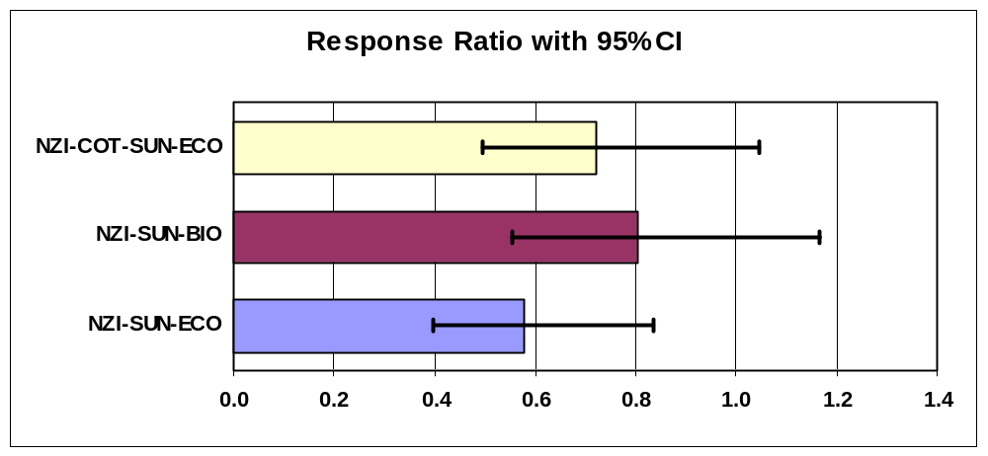

Arithmetic Mean WEEKLY |  |  | Maximum WEEKLY
Average of TASIMF |  |  | Max of TASIMF
TYPE$ | Total |  | TYPE$ | Total
NZI-COT | 246.8 |  | NZI-COT | 734
NZI-SUN-ECO | 171.4 |  | NZI-SUN-ECO | 625
NZI-SUN-BIO | 220.4 |  | NZI-SUN-BIO | 751
NZI-COT-SUN-ECO | 180.8 |  | NZI-COT-SUN-ECO | 550
Grand Total | 204.8 |  | Grand Total | 751

Tabanus lineola (Replicate 2 only - low catches)
Late-flying, rare species but just enough catches for some statistical inference
Interesting species because of its strong response to uv-blocking PVC in other experiments

Dep Var: TALINF N: 16 Multiple R: 0.9690 Squared multiple R: 0.9391

Analysis of Variance
Source Sum-of-Squares df Mean-Square F-ratio P

TYPE$ 0.2670 3 0.0890 12.0288 0.0060
SEQ 0.0794 3 0.0265 3.5767 0.0862
SITE 0.3377 3 0.1126 15.2116 0.0033

Error 0.0444 6 0.0074

Farm1 Risk Rep2
REFRESH TABLES
Average of TALINF |  | Backtrans | Index of | Response
TYPE$ | Total | Mean | Increase | Ratio
NZI-COT | 0.323 | 1.10 | 1.00 | 1.00
NZI-SUN-ECO | 0.095 | 0.24 | 0.22 | 0.59
NZI-SUN-BIO | 0.112 | 0.29 | 0.27 | 0.61
NZI-COT-SUN-ECO | 0.391 | 1.46 | 1.32 | 1.17
Grand Total | 0.230 | 0.70

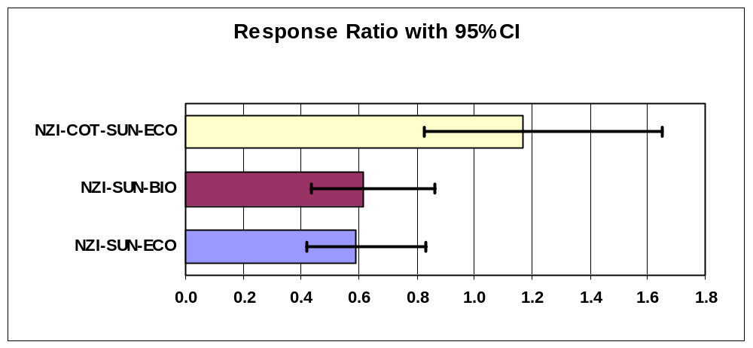

Arithmetic Mean WEEKLY |  |  | Maximum WEEKLY
Average of TALINF |  |  | Max of TALINF
TYPE$ | Total |  | TYPE$ | Total
NZI-COT | 8.0 |  | NZI-COT | 15
NZI-SUN-ECO | 1.5 |  | NZI-SUN-ECO | 4
NZI-SUN-BIO | 2.3 |  | NZI-SUN-BIO | 7
NZI-COT-SUN-ECO | 11.8 |  | NZI-COT-SUN-ECO | 31
Grand Total | 5.9 |  | Grand Total | 31
Hybomitra lasiophthalma (Replicate 1 only)
(spring tabanid - 99.8%, 1,781 of 1,784 caught in replicate 1)
CONFIDENCE INTERVALS are very wide due to the small sample size for just one replicate

Dep Var: HYLASF N: 16 Multiple R: 0.9868 Squared multiple R: 0.9737

Analysis of Variance
Source Sum-of-Squares df Mean-Square F-ratio P

TYPE$ 0.2845 3 0.0948 2.9403 0.1209
SEQ 6.5832 3 2.1944 68.0287 0.0001
SITE 0.3071 3 0.1024 3.1730 0.1064

Error 0.1935 6 0.0323

Farm1 Rep1 Risk
REFRESH TABLES
Average of HYLASF |  | Backtrans | Index of | Response
TYPE$ | Total | Mean | Increase | Ratio
NZI-COT | 1.004 | 9.10 | 1.00 | 1.00
NZI-SUN-ECO | 0.789 | 5.15 | 0.57 | 0.61
NZI-SUN-BIO | 0.986 | 8.68 | 0.95 | 0.96
NZI-COT-SUN-ECO | 0.688 | 3.87 | 0.43 | 0.48
Grand Total | 0.867 | 6.36

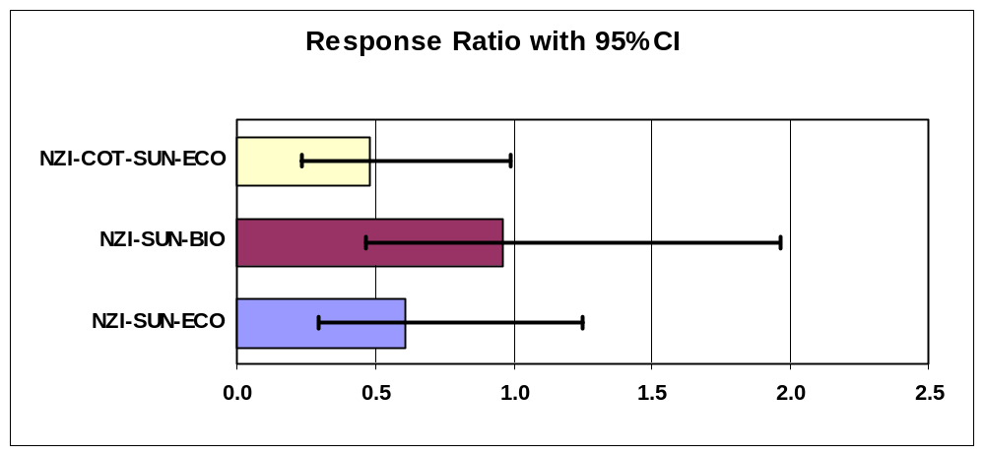

Arithmetic Mean WEEKLY |  |  | Maximum WEEKLY
Average of HYLASF |  |  | Max of HYLASF
TYPE$ | Total |  | TYPE$ | Total
NZI-COT | 111.8 |  | NZI-COT | 261
NZI-SUN-ECO | 173.0 |  | NZI-SUN-ECO | 648
NZI-SUN-BIO | 98.5 |  | NZI-SUN-BIO | 238
NZI-COT-SUN-ECO | 62.0 |  | NZI-COT-SUN-ECO | 142
Grand Total | 111.3 |  | Grand Total | 648

Hybomitra frontalis (Replicate 1 only - low catches)
(spring tabanid - 92.3%, 252 of 273 caught in replicate 1)

Dep Var: HYFROF N: 16 Multiple R: 0.9748 Squared multiple R: 0.9503

Analysis of Variance
Source Sum-of-Squares df Mean-Square F-ratio P

TYPE$ 0.0722 3 0.0241 3.5742 0.0863
SEQ 0.4731 3 0.1577 23.4164 0.0010
SITE 0.2278 3 0.0759 11.2752 0.0070

Error 0.0404 6 0.0067

Farm1 Rep1 Risk
REFRESH TABLES
Average of HYFROF |  | Backtrans | Index of | Response
TYPE$ | Total | Mean | Increase | Ratio
NZI-COT | 0.598 | 2.96 | 1.00 | 1.00
NZI-SUN-ECO | 0.445 | 1.79 | 0.60 | 0.70
NZI-SUN-BIO | 0.601 | 2.99 | 1.01 | 1.01
NZI-COT-SUN-ECO | 0.494 | 2.12 | 0.72 | 0.79
Grand Total | 0.535 | 2.42

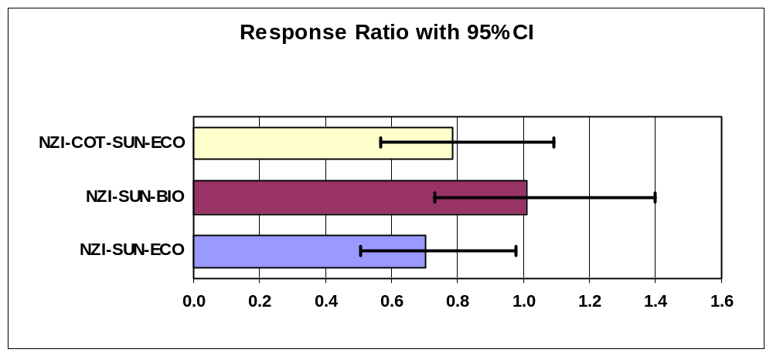

Arithmetic Mean WEEKLY |  |  | Maximum WEEKLY
Average of HYFROF |  |  | Max of HYFROF
TYPE$ | Total |  | TYPE$ | Total
NZI-COT | 18.5 |  | NZI-COT | 32
NZI-SUN-ECO | 12.3 |  | NZI-SUN-ECO | 23
NZI-SUN-BIO | 16.5 |  | NZI-SUN-BIO | 22
NZI-COT-SUN-ECO | 15.8 |  | NZI-COT-SUN-ECO | 33
Grand Total | 15.8 |  | Grand Total | 33

Chrysops [Both replicates, several species, low catches]

Dep Var: CHRYSOPS N: 32 Multiple R: 0.9206 Squared multiple R: 0.8475

Analysis of Variance
Source Sum-of-Squares df Mean-Square F-ratio P

TYPE$ 0.0494 3 0.0165 0.9092 0.4561
REPLICATE 1.1370 1 1.1370 62.8313 0.0000
SITE 0.2175 3 0.0725 4.0065 0.0239
SEQ(REPLICATE) 0.4060 6 0.0677 3.7396 0.0136

Error 0.3257 18 0.0181

Farm1 Risk Adjusted
REFRESH TABLES
Average of Chrysops |  | Backtrans | Index of | Response
TYPE$ | Total | Mean | Increase | Ratio
NZI-COT | 0.486 | 2.06 | 1.00 | 1.00
NZI-SUN-ECO | 0.402 | 1.52 | 0.74 | 0.82
NZI-SUN-BIO | 0.407 | 1.55 | 0.75 | 0.83
NZI-COT-SUN-ECO | 0.480 | 2.02 | 0.98 | 0.99
Grand Total | 0.444 | 1.78

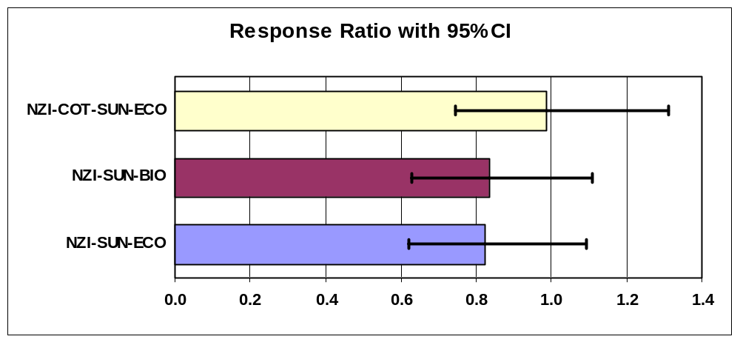

Arithmetic Mean WEEKLY |  |  | Maximum WEEKLY
Average of Chrysops |  |  | Max of Chrysops
TYPE$ | Total |  | TYPE$ | Total
NZI-COT | 14.6 |  | NZI-COT | 46
NZI-SUN-ECO | 11.6 |  | NZI-SUN-ECO | 33
NZI-SUN-BIO | 9.6 |  | NZI-SUN-BIO | 18
NZI-COT-SUN-ECO | 15.0 |  | NZI-COT-SUN-ECO | 34
Grand Total | 12.7 |  | Grand Total | 46

Stomoxys calcitrans [Replicate 2 only]
(87.8%, 491 of 559 caught in replicate 2)

Dep Var: STOMOXYS N: 16 Multiple R: 0.9885 Squared multiple R: 0.9771

Analysis of Variance
Source Sum-of-Squares df Mean-Square F-ratio P

TYPE$ 0.1418 3 0.0473 6.6759 0.0244
SEQ 1.4531 3 0.4844 68.3958 0.0000
SITE 0.2157 3 0.0719 10.1514 0.0091

Error 0.0425 6 0.0071

Farm1 Risk Rep2
REFRESH TABLES
Average of Stomoxys |  | Backtrans | Index of | Response
TYPE$ | Total | Mean | Increase | Ratio
NZI-COT | 0.689 | 3.89 | 1.00 | 1.00
NZI-SUN-ECO | 0.584 | 2.84 | 0.73 | 0.79
NZI-SUN-BIO | 0.687 | 3.87 | 1.00 | 1.00
NZI-COT-SUN-ECO | 0.459 | 1.88 | 0.48 | 0.59
Grand Total | 0.605 | 3.03

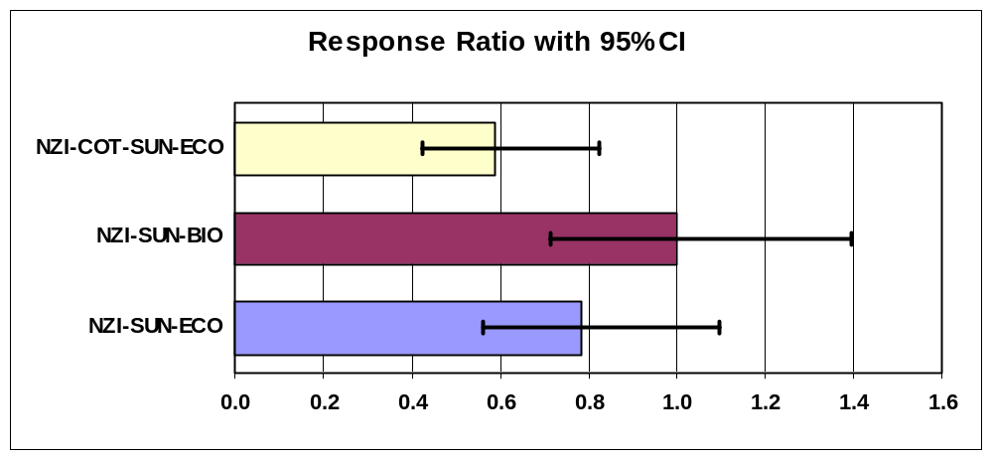

Arithmetic Mean WEEKLY |  |  | Maximum WEEKLY
Average of Stomoxys |  |  | Max of Stomoxys
TYPE$ | Total |  | TYPE$ | Total
NZI-COT | 40.5 |  | NZI-COT | 111
NZI-SUN-ECO | 22.5 |  | NZI-SUN-ECO | 53
NZI-SUN-BIO | 39.5 |  | NZI-SUN-BIO | 114
NZI-COT-SUN-ECO | 20.3 |  | NZI-COT-SUN-ECO | 42
Grand Total | 30.7 |  | Grand Total | 114

