FARM5: Edwards, Ontario, Canada - Jun-Jul 2008

Steve Mihok smihok@rogers.com
Hemendra Mulye hemendra.mulye@alumni.uottawa.ca
Patrick Guerin patrick.guerin@unine.ch

Background: Detailed follow-up to first test of cow urine in Farm4
Other tests of phenols / human urine were published in MVE (2007)
Objective: Comprehensive test of 2-wk old cow urine, phenols/octenol/turpentine
Continue tests of fabric and netting variations of good versions of Nzi traps

Data: Farm5.xls, reference data in Canada nzi.mdb
Design: 12 x 12 Latin square but with one rotation not completed (but with N=12)
Traps rotated a few times to balance trap/site effects as much as possible

Area: Idle Farm ~9.0 km @ 320° (~ NW) from my home in Russell
Edwards is a hamlet incorporated into the city of Ottawa

Habitat: Abandoned pasture, very wet meadows, shrubland with adjacent woodland
Many trees removed in previous winter; woodland image is now out of date
Vigorous vegetation growth during experiment, very wet due to heavy rains

Details: 71 m asl, 45°18.998 N and 75° 75° 26.112 (the barn with a few horses/goats)
Date: Jun 14 - Jul 12, 2008, trap checks every 1-4 fair weather days

Baits: Pooled Cow urine from a ~ 5-yr old Holstein dairy cows, new batch at midpoint
Released at 4 ml/day at INSIDE back corner of trap, outside in Farm4
Details of phenols, etc. described below

Standard: Kenyan Phthalogen Blue IF3GM cotton Nzi trap with fine mesh white polyester, set just off the ground, all traps facing WEST - Fairly strong westerly winds throughout this experiment

Collector: 2-L Coke bottle plastic “funnel” inserted into trap cone (21 mm diameter neck)
Funnel then inserted into a plastic chamber (centre of a cut-off 2-L juice bottle)
Flies collected in a long “no-seeum” netting sleeve attached to the chamber

Catch of nonbiting insects was low, including mosquitoes as in Farm4.

Effort was 276 “fair-weather” trap-days (12 x 23)
Catches standardized as catch per fair weather day for statistical analysis

Weather data stored in EXCEL file with captures

The experiment covered the flight season of Tabanus similis well, and caught the last half of the flight season of Hybomitra lasiophthalma at high numbers; Tabanus quinquevittatus emerged in high numbers only for the last half of the experiment.
27,307 Tabanidae

Backtransformed mean catches varied from.33.8 to 144.8 Tabanidae by trap type
Average across all traps was 72.9 per trap per day

Backtransformed mean catches varied from.44.0 to 112.5 Tabanidae by bait type
Average in an unbaited trap was 60.6 per trap per day

981 Stomoxys calcitrans, 72% male

Male tabanids caught in small numbers except for T. quinquevittatus
Similar to results obtained in 2007 when many male Tq were captured

515 T. quinquevittatus
18 H. lasiophthalma
9 T. similis
1 T. reinwardtii

Female tabanids

H. lasiophthalma | 3871 | 14.2%
H. illota | 45
H. frontalis | 583 | 2.1%
H. epistates | 180
H. lurida | 1
H. nitidifrons nuda | 13
T. similis | 10209 | 37.4%
T. quinquevittatus | 10527 | 38.6%
T. reinwardtii | 1
T. lineola | 78
C. frigidus | 1217 | 4.5%
C. cincticornis | 29
C. aestuans | 2
C. callidus | 2
C. indus | 6
C. aberrans | 4
C. univittatus | 1
C. vittatus | 2

Site Patterns (Satellite image in Farm4)

Fairly even distribution of catches but with Site #27 particularly bad with the trap often in some standing water, Site #26 was also not the best; these sites had good trap-bait combinations for several days with noticeably dismal catches

Site #23 may also not be the best choice for further work; extensive flooding occurred all around the trap and seemed to result in lower catches

Other sites were fairly even with #24 at the pond, and #30 out in the open in the bushes being the two best spots

Should consider more trapping in the open bushland if it is left undisturbed next year; possibly dropping sites 33 and 34 or moving them a bit farther out from the edge of the woodland

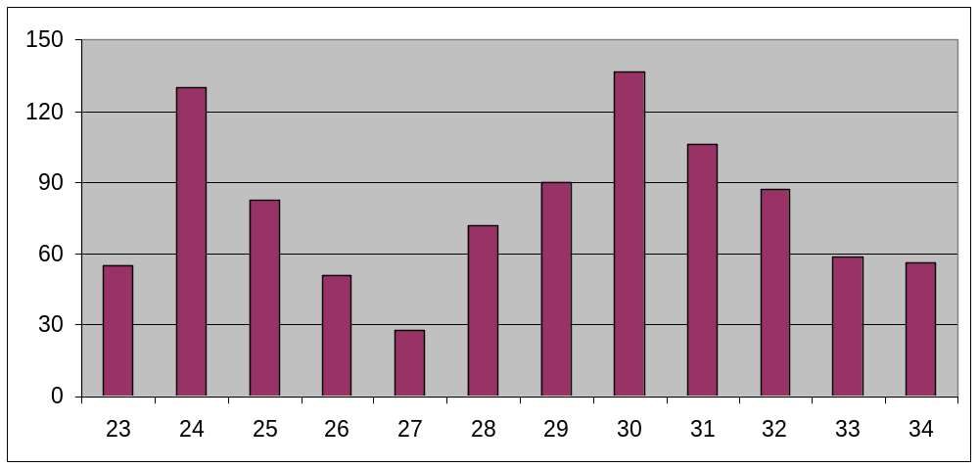

Horse fly and deer fly patterns were about the same

Stomoxys data were not informative with only an average catch of about 1 per trap per day and no particular pattern across the sites
Phenology

Hybomitra catches were low after the first two trap checks but there was a continuing presence of H. frontalis after H. lasiophthalma declined

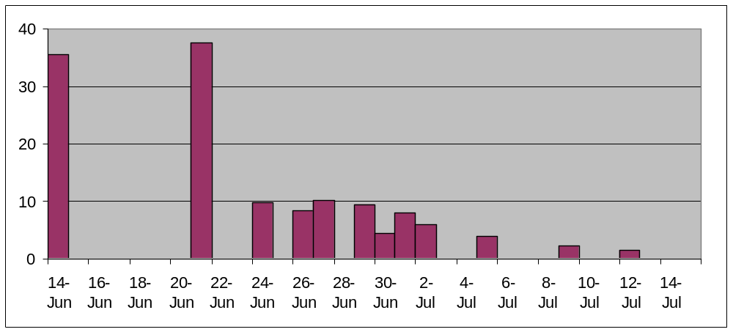

Timing was just about perfect for Tabanus similis with very even catches

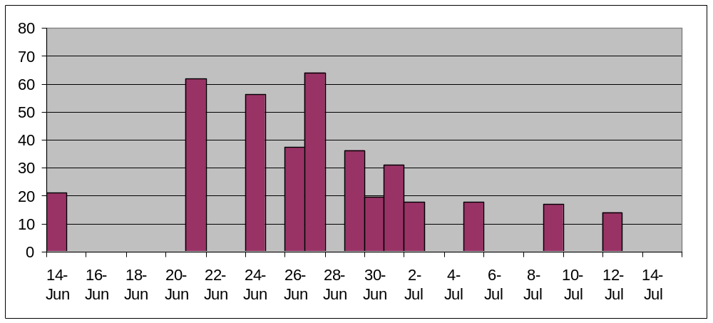
T. quinquevittatus appeared in good numbers in the last half; this species peaked at the end of July in 2007 at perhaps 5x these levels

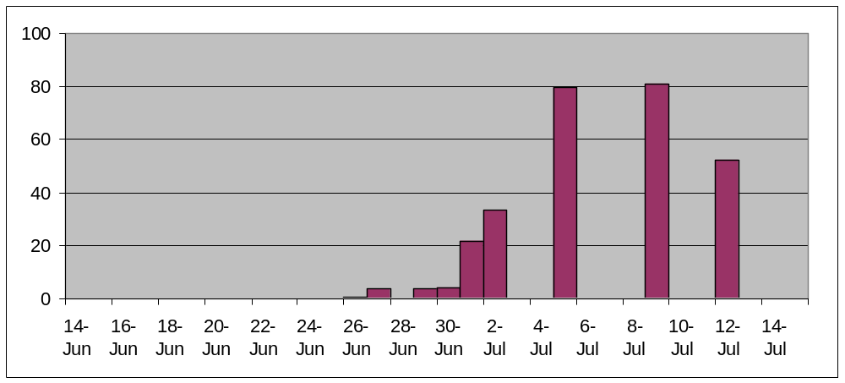

Net effect of above species patterns was for minimal variance in the catch of Total Tabanidae throughout the experiment

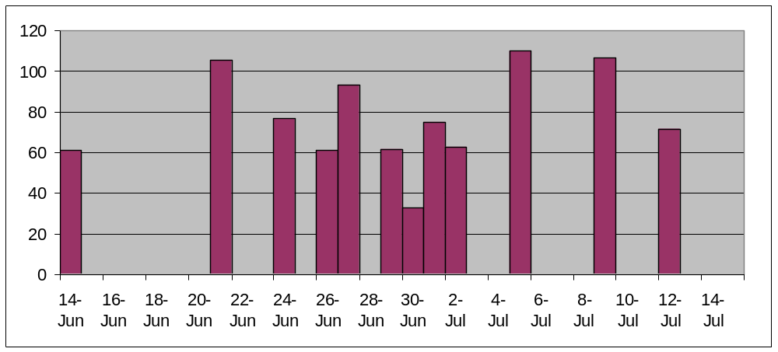

Baits

URINE was easy to smell when walking up to a trap as in June. The release rate was measured over 20 days at 4 ml/d. Samples each represented pooling of urine from several dairy cows. Urine was stored for two weeks at ambient temperatures in my garage in a dark bottle prior to use. There was with minimal headspace (~ anaerobic). Light gas built up after 2 weeks in the bottles (guess at ammonia?)

Average Maximum Daily Temperature was 24.9 °C

Logic of bait choices was to test unbaited, urine, octenol lure, urine+octenol lure relative to phenol + octenol synthetic blends based on the ‘standard” sachet of Torr et al. (1997):

Torr, S.J., Hall, D.R., Phelps, R.J. & Vale, G.A. (1997) Methods for dispensing odour attractants for tsetse flies (Diptera: Glossinidae). Bulletin of Entomological Research, 87, 299-311.

150 micron polyethylene 5 x 5 cm sachets with 3.9 ml of solution were prepared at the University of Neuchatel by Patrick Guerin based on Page 301 of Torr et al. (1997).

Dioctylphthalate was used as a diluent to maintain a fixed total volume of 3.9 ml so that each compound in the different blends would be released at similar rates (amounts in microlitres shown in the table below). From Fig. 4 of Torr et al. (1997) release rates are not exactly linear with different proportions so this would only have been partly true.

 | 4mp | 3pp | octenol
Sachets
STANDARD 8:1:4 | 2400 | 300 | 1200
4MP | 2400
3PP |  | 300
OCTENOL |  |  | 1200
4MP+3PP | 2400 | 300
4MP+OCTENOL | 2400 |  | 1200
3PP+OCTENOL |  | 300 | 1200

Expected release rates at 27 °C for the full 1:4:8 blend from Torr et al. (2007)

1 | parts | 3-n-propylphenol | 0.022 | mg/h
4 |  | 1-octen--3-ol | 0.13
8 |  | 4-methylphenol | 0.38

The release rates tested previously and reported in MVE(2007) were MUCH HIGHER AND ARE SHOWN BELOW (some tests of with acetone were also conducted in that work)...

Code | Octenol | 4-methylphenol | 3-propy phenol
O+LowPhe | 1.5 | 0.83 | 0.55
O+MedPhe | 1.5 | 1.65 | 0.17
O+HighPhe | 1.5 | 1.65 | 0.55

Note that there are two Octenol treatments, the one labeled “OCT” is octenol in a sachet with a release rate of about 0.13 mg/h, and the one labeled “OCTENOL” is the commercial octenol lure from Biosensory with a release rate of about 1.5 mg/h (old manufacturer’s web brochure).

One speculative treatment was included based on plant volatiles: L-turpentine (3 ml + 0.9 ml diocytylphthalate) in three nested sachets to reduce evaporation rate. In the lab the release rate was 91.9 mg/d but the compound evaporated much faster in the field (which was windy, exposed to the sun, etc.). Approximate field evaporation rate was 6.9 mg/h or 166.5 mg/d (two sachets were used up to complete this one experiment over about a month).

[I tested essential oil of Pinus sylvestris + octenol a few years ago as an attractant for tabanids in a robust experiment and found no effect on the catch relative to octenol alone - unpublished]

All synthetic compounds could be smelled at the trap, or from a short distance. Phenols were definitely as noticeable as the urine. Sachets were suspended in the air at the top back corner of the trap and hence were exposed to the sun most of the day. Except for the turpentine, all of the sachets still had compound left at the end of the experiment.

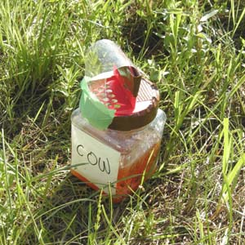 | Large Plastic Urine Container used in this experiment (~ 500 ml).  This is a “Smart-Cote” fertilizer container from a gardening store. It just happened to provide the same release rate as two small bottles with 3 cm apertures that were used in the earlier experiment to get 4 ml/d.  I moved the urine container to inside the trap in this experiment as there were a few Hybomitra drowned in the urine in the previous experiment, so I wanted to check if they were being that specific in their behaviour. This was probably pure coincidence; there was no difference in catch index between the two experiments with urine in different positions.

During warmer weather, the two urine treatments always attracted very large numbers of very small black Diptera - Sepsidae. These were caught in the many hundreds to thousands. I’ve never seen this phenomenon before using other baits. It was always clear which traps were baited with cow urine because of the presence of large numbers of these flies in the baits. There were relatively few in the various phenol treatments. Sepsidae flies might go unnoticed in other people’s work as they are very small. I used fine no-seeum mesh for collecting bags in this experiment so I retained almost everything that made it to the top of the trap cone. These flies would have gone through typical mosquito netting used in most traps but would be retained by the horticultural netting I was using in this experiment.

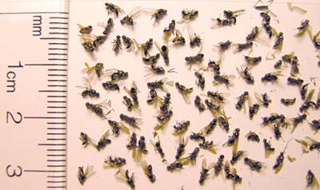

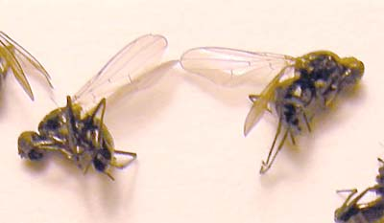
Tabanidae

Gross results for all Tabanidae were close to the patterns by genus / species, with the exception of a positive response to cow urine by Hybomitra, and other minor idiosyncrasies.

The most consistent result was a fairly universal attraction to octenol regardless of the release rate (OCTENOL was ten times OCT), and regardless of the presence of other phenols.

The phenols showed no hint of attraction in any context; there may have been some evidence for a lower catch with 3-n-propylphenol in a few species, but nothing particularly definitive.

Flies either did not react to the turpentine or there was some minor repellency. Detailed results by species with good sample sizes follow this general set of results for all Tabanidae.

Dep Var: TABANIDAE N: 144 Multiple R: 0.8755 Squared multiple R: 0.7665

Source Sum-of-Squares df Mean-Square F-ratio P

TYPE$ 1.7313 11 0.1574 4.2228 0.0000
ODOURS$ 2.4801 11 0.2255 6.0490 0.0000
SITE 2.9792 11 0.2708 7.2662 0.0000
SEQ 2.7675 11 0.2516 6.7500 0.0000
Error 3.6900 99 0.0373

Average of Tabanidae |  | Backtrans | Index of | Response
ODOURS$ | Total | Mean | Increase | Ratio
UNBAIT | 1.790 | 60.62 | 1.00 | 1.00
3PP | 1.653 | 44.00 | 0.73 | 0.73
4MP | 1.870 | 73.19 | 1.21 | 1.20
4MP+3PP | 1.731 | 52.89 | 0.87 | 0.87
COW2 | 1.794 | 61.21 | 1.01 | 1.01
OCT+3PP | 1.966 | 91.45 | 1.51 | 1.50
OCT+4MP | 1.990 | 96.81 | 1.60 | 1.59
OCT+4MP+3PP | 1.963 | 90.84 | 1.50 | 1.49
OCTENOL | 1.977 | 93.83 | 1.55 | 1.54
OCT | 2.001 | 99.12 | 1.64 | 1.62
TURPENTINE | 1.636 | 42.24 | 0.70 | 0.70
COW2+OCTENOL | 2.055 | 112.53 | 1.86 | 1.84
Grand Total | 1.869 | 72.94

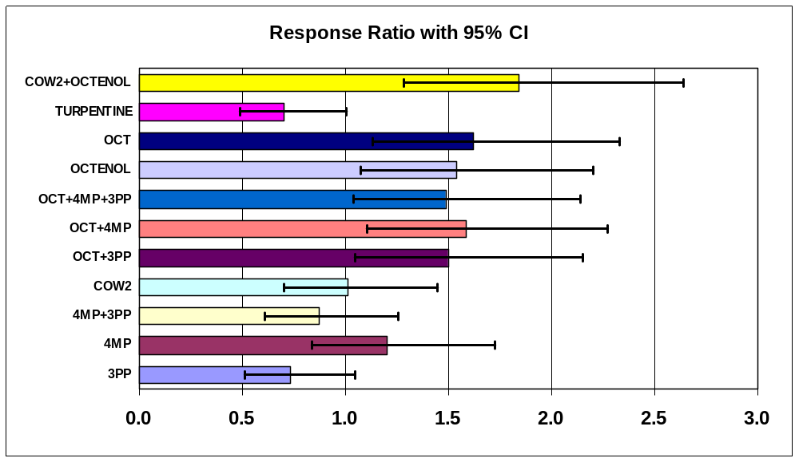

CATCHES by TRAP CHECK - NOT risk adjusted in these two pivot tables
Arithmetic Mean |  |  | Maximum
Average of Tabanidae |  |  | Max of Tabanidae
ODOURS$ | Total |  | ODOURS$ | Total
UNBAIT | 153.5 |  | UNBAIT | 423
3PP | 157.5 |  | 3PP | 940
4MP | 206.0 |  | 4MP | 911
4MP+3PP | 141.8 |  | 4MP+3PP | 396
COW2 | 156.0 |  | COW2 | 478
OCT+3PP | 198.7 |  | OCT+3PP | 511
OCT+4MP | 231.3 |  | OCT+4MP | 613
OCT+4MP+3PP | 238.3 |  | OCT+4MP+3PP | 777
OCTENOL | 211.5 |  | OCTENOL | 639
OCT | 233.9 |  | OCT | 813
TURPENTINE | 112.3 |  | TURPENTINE | 328
COW2+OCTENOL | 234.9 |  | COW2+OCTENOL | 635
Grand Total | 189.6 |  | Grand Total | 940

Hybomitra lasiophthalma

Exactly as in experiment Farm4, there was a clear response to cow urine with a doubling of the catch. There was a strong response to the OCTENOL lure, consistent with the only other test I have done for this species [Fig. 5 of MVE (2007)]. However, the release rate of octenol in the sachets appeared to be too low for eliciting a “significant” increase in catch.

There was an additive effect of cow urine plus octenol, providing a decent increase in catch of 3.2 x.. Phenols and turpentine did not affect catches.

The cow urine result could be attraction to ammonia given attraction of fresh urine in the first half of experiment Farm4. This was found by Hribar several years ago with only a little bit of follow up by other researchers, but only for other species.

Hribar, L.J., LePrince, D.J. & Foil, L.D. (1992) Ammonia as an attractant for adult Hybomitra lasiophthalma (Diptera: Tabanidae). Journal of Medical Entomology, 29, 346-348.

My only other data on this topic is a test of human urine mentioned in MVE (2007). I got a significant octenol response in that experiment for Hl, but no indication of anything for aged human urine. That experiment was done at very low numbers.

Dep Var: HYLASF N: 144 Multiple R: 0.9563 Squared multiple R: 0.9145

Source Sum-of-Squares df Mean-Square F-ratio P
TYPE$ 3.6561 11 0.3324 7.9833 0.0000
ODOURS$ 4.1412 11 0.3765 9.0425 0.0000
SITE 1.3172 11 0.1197 2.8761 0.0026
SEQ 33.9273 11 3.0843 74.0811 0.0000
Error 4.1218 99 0.0416

Average of HYLASF |  | Backtrans | Index of | Response
ODOURS$ | Total | Mean | Increase | Ratio
UNBAIT | 0.576 | 2.76 | 1.00 | 1.00
3PP | 0.492 | 2.11 | 0.76 | 0.83
4MP | 0.568 | 2.70 | 0.98 | 0.98
4MP+3PP | 0.613 | 3.10 | 1.12 | 1.09
COW2 | 0.882 | 6.63 | 2.40 | 2.03
OCT+3PP | 0.711 | 4.13 | 1.50 | 1.36
OCT+4MP | 0.703 | 4.05 | 1.46 | 1.34
OCT+4MP+3PP | 0.671 | 3.69 | 1.33 | 1.25
OCTENOL | 0.886 | 6.69 | 2.42 | 2.04
OCT | 0.716 | 4.20 | 1.52 | 1.38
TURPENTINE | 0.526 | 2.36 | 0.85 | 0.89
COW2+OCTENOL | 1.078 | 10.96 | 3.97 | 3.18
Grand Total | 0.702 | 4.03

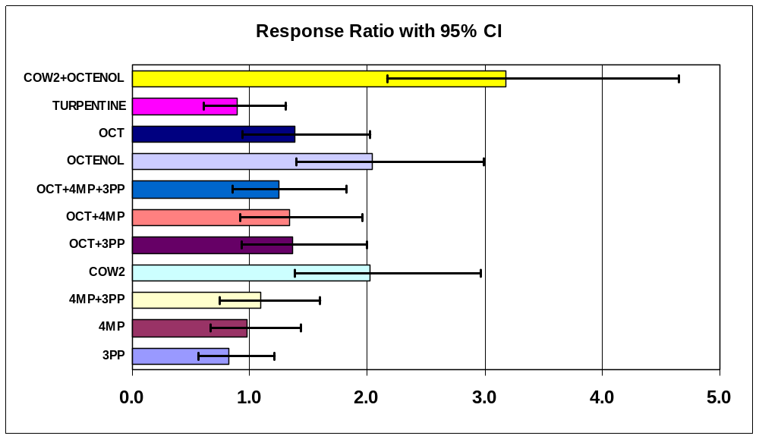

CATCHES by TRAP CHECK - NOT risk adjusted in these two pivot tables
Arithmetic Mean |  |  | Maximum
Average of HYLASF |  |  | Max of HYLASF
ODOURS$ | Total |  | ODOURS$ | Total
UNBAIT | 33.8 |  | UNBAIT | 304
3PP | 6.8 |  | 3PP | 34
4MP | 20.5 |  | 4MP | 112
4MP+3PP | 14.1 |  | 4MP+3PP | 70
COW2 | 28.0 |  | COW2 | 169
OCT+3PP | 19.5 |  | OCT+3PP | 66
OCT+4MP | 26.4 |  | OCT+4MP | 165
OCT+4MP+3PP | 35.2 |  | OCT+4MP+3PP | 347
OCTENOL | 30.4 |  | OCTENOL | 180
OCT | 21.3 |  | OCT | 131
TURPENTINE | 16.7 |  | TURPENTINE | 145
COW2+OCTENOL | 69.9 |  | COW2+OCTENOL | 375
Grand Total | 26.9 |  | Grand Total | 375

Hybomitra frontalis

Catches of this species were just high enough for potential statistical inference. The trends are not perfect because of the large confidence intervals. There appears to an increase in catch with octenol, but no evidence for a response to cow urine; there might be a lower catch when octenol is combined with phenols.

Dep Var: HYFROF N: 144 Multiple R: 0.8540 Squared multiple R: 0.7293

Source Sum-of-Squares df Mean-Square F-ratio P
TYPE$ 1.6765 11 0.1524 3.6162 0.0003
ODOURS$ 1.6397 11 0.1491 3.5367 0.0003
SITE 2.8467 11 0.2588 6.1401 0.0000
SEQ 2.0272 11 0.1843 4.3726 0.0000
Error 4.1725 99 0.0421

Average of HYFROF |  | Backtrans | Index of | Response
ODOURS$ | Total | Mean | Increase | Ratio
UNBAIT | 0.303 | 1.01 | 1.00 | 1.00
3PP | 0.269 | 0.86 | 0.85 | 0.92
4MP | 0.270 | 0.86 | 0.86 | 0.93
4MP+3PP | 0.295 | 0.97 | 0.97 | 0.98
COW2 | 0.256 | 0.80 | 0.79 | 0.90
OCT+3PP | 0.542 | 2.48 | 2.46 | 1.73
OCT+4MP | 0.537 | 2.44 | 2.42 | 1.72
OCT+4MP+3PP | 0.439 | 1.75 | 1.73 | 1.37
OCTENOL | 0.643 | 3.39 | 3.36 | 2.19
OCT | 0.603 | 3.01 | 2.98 | 2.00
TURPENTINE | 0.332 | 1.15 | 1.14 | 1.07
COW2+OCTENOL | 0.470 | 1.95 | 1.94 | 1.47
Grand Total | 0.413 | 1.59

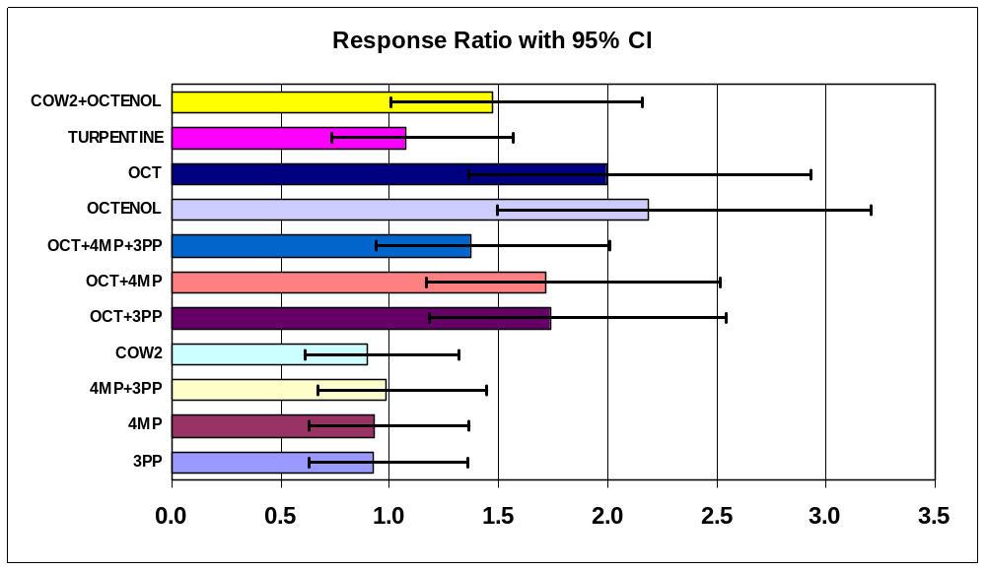
Hybomitra epistates

Catches of this species were too low for statistical inferences. Trends are shown below without any statistical interpretation. They mainly suggest the usual response to octenol, whenever it is present, regardless of the circumstances.

Dep Var: HYEPIF N: 144 Multiple R: 0.8299 Squared multiple R: 0.6887

Source Sum-of-Squares df Mean-Square F-ratio P
TYPE$ 1.5547 11 0.1413 4.8275 0.0000
ODOURS$ 1.0340 11 0.0940 3.2107 0.0009
SITE 0.5966 11 0.0542 1.8526 0.0551
SEQ 2.3932 11 0.2176 7.4313 0.0000
Error 2.8984 99 0.0293

Average of HYEPIF |  | Backtrans | Index of | Response
ODOURS$ | Total | Mean | Increase | Ratio
UNBAIT | 0.119 | 0.31 | 1.00 | 1.00
3PP | 0.048 | 0.12 | 0.37 | 0.85
4MP | 0.044 | 0.11 | 0.34 | 0.84
4MP+3PP | 0.035 | 0.09 | 0.27 | 0.83
COW2 | 0.155 | 0.43 | 1.36 | 1.09
OCT+3PP | 0.245 | 0.76 | 2.40 | 1.34
OCT+4MP | 0.253 | 0.79 | 2.51 | 1.36
OCT+4MP+3PP | 0.223 | 0.67 | 2.13 | 1.27
OCTENOL | 0.269 | 0.86 | 2.72 | 1.41
OCT | 0.328 | 1.13 | 3.59 | 1.62
TURPENTINE | 0.100 | 0.26 | 0.82 | 0.96
COW2+OCTENOL | 0.279 | 0.90 | 2.86 | 1.44
Grand Total | 0.175 | 0.50

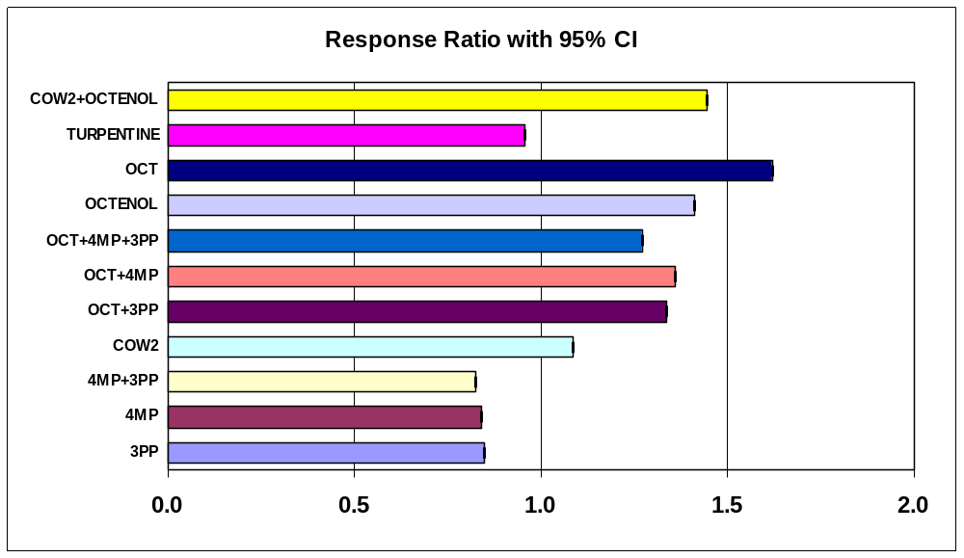
Tabanus similis

This is likely the most reliable result for any one species because of the high and even catches of this tabanid throughout the experiment, and the ability to compare to previous experiments (e.g. I have tested octenol in different formulations before as an attractant for T. similis; it was also the main species caught in previous tests with phenols, acetone, humane urine, etc.).

Attraction to octenol on its own was almost identical to previous tests [1.63, 1.63 here versus 1.50, 1.54 in Fig. 4 of MVE (2007)]; surprisingly with no indication of a dose response over a range of about 0.1 to 1.5 to 5.4 mg/h.. It’s interesting to see consistency relative to previous tests done at sample sizes 5-10 x lower than here at the farm.

With the exception of a hint of repellency for 3PP, higher catches were consistently obtained with octenol in all formulations.

There was essentially no evidence for attraction to urine or phenols.

Turpentine appears to be repellent for T. similis.

Dep Var: TASIMF N: 144 Multiple R: 0.8888 Squared multiple R: 0.7900

Source Sum-of-Squares df Mean-Square F-ratio P

TYPE$ 1.6173 11 0.1470 2.8792 0.0025
ODOURS$ 3.3919 11 0.3084 6.0385 0.0000
SITE 4.2293 11 0.3845 7.5292 0.0000
SEQ 6.9813 11 0.6347 12.4284 0.0000
Error 5.0555 99 0.0511

Average of TASIMF |  | Backtrans | Index of | Response
ODOURS$ | Total | Mean | Increase | Ratio
UNBAIT | 1.391 | 23.60 | 1.00 | 1.00
3PP | 1.268 | 17.52 | 0.74 | 0.75
4MP | 1.510 | 31.34 | 1.33 | 1.31
4MP+3PP | 1.381 | 23.03 | 0.98 | 0.98
COW2 | 1.339 | 20.81 | 0.88 | 0.89
OCT+3PP | 1.539 | 33.58 | 1.42 | 1.41
OCT+4MP | 1.611 | 39.80 | 1.69 | 1.66
OCT+4MP+3PP | 1.584 | 37.41 | 1.59 | 1.56
OCTENOL | 1.604 | 39.15 | 1.66 | 1.63
OCT | 1.604 | 39.21 | 1.66 | 1.63
TURPENTINE | 1.139 | 12.77 | 0.54 | 0.56
COW2+OCTENOL | 1.700 | 49.10 | 2.08 | 2.04
Grand Total | 1.472 | 28.67

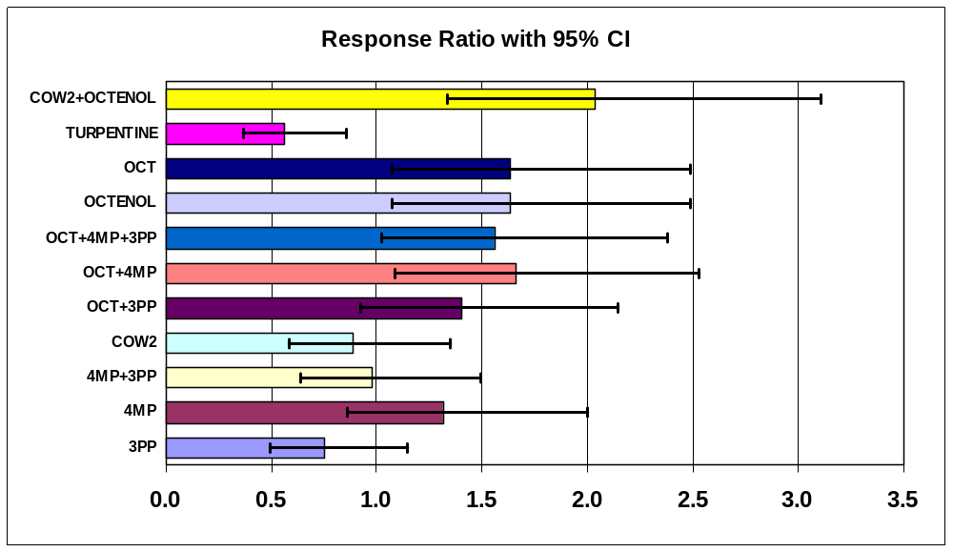

CATCHES by TRAP CHECK - NOT risk adjusted in these two pivot tables
Arithmetic Mean |  |  | Maximum
Average of TASIMF |  |  | Max of TASIMF
ODOURS$ | Total |  | ODOURS$ | Total
UNBAIT | 57.5 |  | UNBAIT | 170
3PP | 40.3 |  | 3PP | 102
4MP | 66.1 |  | 4MP | 127
4MP+3PP | 69.4 |  | 4MP+3PP | 254
COW2 | 55.7 |  | COW2 | 144
OCT+3PP | 76.4 |  | OCT+3PP | 172
OCT+4MP | 85.5 |  | OCT+4MP | 160
OCT+4MP+3PP | 80.1 |  | OCT+4MP+3PP | 202
OCTENOL | 79.3 |  | OCTENOL | 166
OCT | 83.9 |  | OCT | 179
TURPENTINE | 47.6 |  | TURPENTINE | 170
COW2+OCTENOL | 109.0 |  | COW2+OCTENOL | 275
Grand Total | 70.9 |  | Grand Total | 275

Tabanus quinquevittatus [FEMALES]

As with T. similis, these results should be robust, but are affected by higher variance due to the /low catches of this species in the first half of the experiment. If I had not broken my ankle, I would have been able to generate better data for this species in a follow-up experiment.

Trends were similar to those found for T. similis with consistent increases in catch whenever octenol was present in the formulation; the one exception being OCTENOL+URINE with a confidence interval that just overlaps with 1.0. This treatment happened to be at the two worst trap locations at the end of the experiment when numbers were very high. The octenol treatments produced increases in catch of 1.54, 1.93 versus 2.14 in the previous test in Fig. 4 of MVE (2007). Confidence intervals are large for all of these data. As for T. similis there is no evidence for a dose response relationship with octenol.

One difference between the two Tabanus species was that there was no evidence for repellency by turpentine for T. quinquevittatus.

Dep Var: TAQUIF N: 144 Multiple R: 0.9797 Squared multiple R: 0.9598

Source Sum-of-Squares df Mean-Square F-ratio P

TYPE$ 1.5166 11 0.1379 3.9495 0.0001
ODOURS$ 1.4392 11 0.1308 3.7479 0.0002
SITE 1.3143 11 0.1195 3.4228 0.0005
SEQ 76.0769 11 6.9161 198.1196 0.0000
Error 3.4560 99 0.0349

Average of TAQUIF |  | Backtrans | Index of | Response
ODOURS$ | Total | Mean | Increase | Ratio
UNBAIT | 0.780 | 5.03 | 1.00 | 1.00
3PP | 0.874 | 6.48 | 1.29 | 1.24
4MP | 0.894 | 6.83 | 1.36 | 1.30
4MP+3PP | 0.734 | 4.42 | 0.88 | 0.90
COW2 | 0.722 | 4.27 | 0.85 | 0.87
OCT+3PP | 1.020 | 9.47 | 1.88 | 1.74
OCT+4MP | 1.007 | 9.16 | 1.82 | 1.69
OCT+4MP+3PP | 0.984 | 8.63 | 1.72 | 1.60
OCTENOL | 0.967 | 8.28 | 1.64 | 1.54
OCT | 1.066 | 10.63 | 2.11 | 1.93
TURPENTINE | 0.767 | 4.85 | 0.96 | 0.97
COW2+OCTENOL | 0.913 | 7.19 | 1.43 | 1.36
Grand Total | 0.894 | 6.83

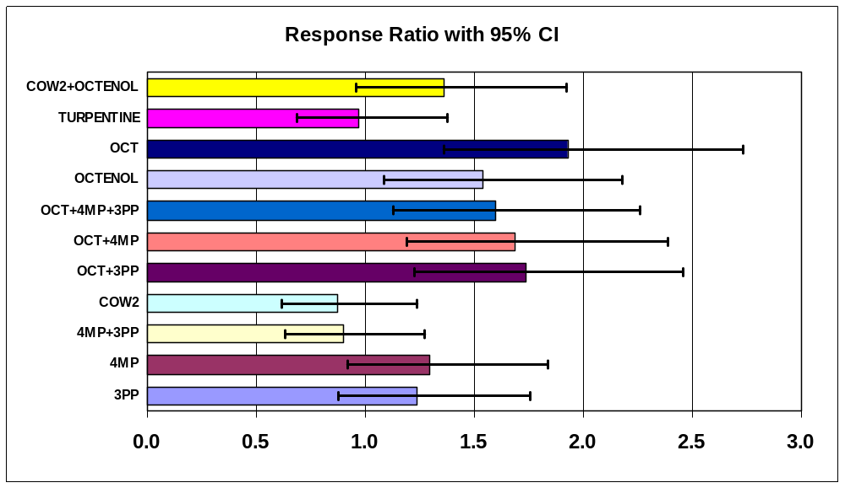

CATCHES by TRAP CHECK - NOT risk adjusted in these two pivot tables
Arithmetic Mean |  |  | Maximum
Average of TAQUIF |  |  | Max of TAQUIF
ODOURS$ | Total |  | ODOURS$ | Total
UNBAIT | 48.7 |  | UNBAIT | 200
3PP | 97.4 |  | 3PP | 772
4MP | 98.1 |  | 4MP | 670
4MP+3PP | 50.2 |  | 4MP+3PP | 289
COW2 | 58.9 |  | COW2 | 392
OCT+3PP | 84.0 |  | OCT+3PP | 381
OCT+4MP | 94.0 |  | OCT+4MP | 389
OCT+4MP+3PP | 100.8 |  | OCT+4MP+3PP | 588
OCTENOL | 78.8 |  | OCTENOL | 528
OCT | 97.8 |  | OCT | 482
TURPENTINE | 34.8 |  | TURPENTINE | 153
COW2+OCTENOL | 33.8 |  | COW2+OCTENOL | 135
Grand Total | 73.1 |  | Grand Total | 772

Tabanus quinquevittatus [MALES]

There were enough males caught of this species to get some insights, even if the average catch was < 1 per trap per day. The highest catch was 90 males plus 670 females in the TNB-IN6 trap on 9 July for 4 days at risk. It might be worthwhile to do a study of males some day coinciding with the Tq peak in July. Besides using traps, an experiment with baits and blue plexiglass sticky panels laid on the ground might be interesting. I have obtained excellent catches of male H. lasiophthalma with this technique, but have yet to test it out on Tabanus.

Tends below don’t show any clear response to any bait.

Average of TAQUIM |  | Backtrans | Index of | Response
ODOURS$ | Total | Mean | Increase | Ratio
UNBAIT | 0.136 | 0.37 | 1.00 | 1.00
3PP | 0.189 | 0.54 | 1.48 | 1.13
4MP | 0.188 | 0.54 | 1.47 | 1.13
4MP+3PP | 0.025 | 0.06 | 0.16 | 0.77
COW2 | 0.085 | 0.22 | 0.59 | 0.89
OCT+3PP | 0.108 | 0.28 | 0.77 | 0.94
OCT+4MP | 0.328 | 1.13 | 3.07 | 1.56
OCT+4MP+3PP | 0.254 | 0.80 | 2.17 | 1.31
OCTENOL | 0.143 | 0.39 | 1.06 | 1.02
OCT | 0.231 | 0.70 | 1.91 | 1.25
TURPENTINE | 0.069 | 0.17 | 0.47 | 0.86
COW2+OCTENOL | 0.018 | 0.04 | 0.12 | 0.76
Grand Total | 0.148 | 0.41

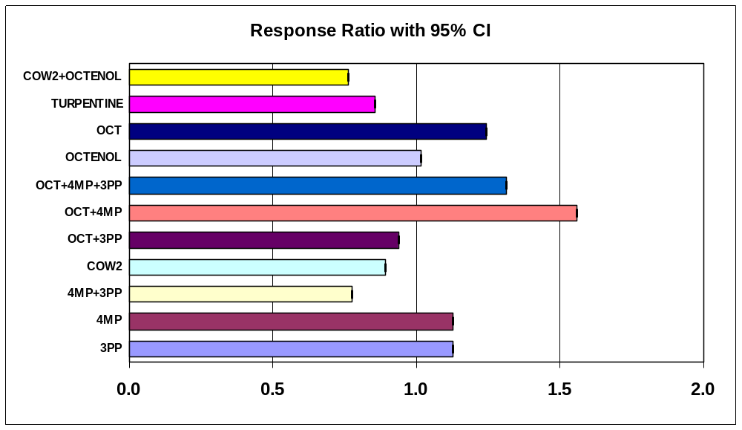
Chrysops frigidus

This species accounted for 96% of the deer fly catch. There was hardly any indication of bait effects, although two of the treatments were significantly different from an unbaited trap, but only just barely so. I don’t think there is anything biologically meaningful in these results. In MVE (2007), I got a similar weak response to octenol for three other deer fly species.

Yet another species, Chrysops aberrans was represented in Fig. 6 of MVE (2007) when I tested phenols, but with no reaction to any of the combinations tested.

Dep Var: CHFRIF N: 144 Multiple R: 0.8849 Squared multiple R: 0.7830

Source Sum-of-Squares df Mean-Square F-ratio P

TYPE$ 1.9301 11 0.1755 3.6044 0.0003
ODOURS$ 1.9367 11 0.1761 3.6166 0.0003
SITE 1.6897 11 0.1536 3.1555 0.0011
SEQ 9.9778 11 0.9071 18.6328 0.0000
Error 4.8194 99 0.0487

Average of CHFRIF |  | Backtrans | Index of | Response
ODOURS$ | Total | Mean | Increase | Ratio
UNBAIT | 0.653 | 3.50 | 1.00 | 1.00
3PP | 0.520 | 2.31 | 0.66 | 0.74
4MP | 0.599 | 2.98 | 0.85 | 0.88
4MP+3PP | 0.418 | 1.62 | 0.46 | 0.58
COW2 | 0.619 | 3.16 | 0.90 | 0.92
OCT+3PP | 0.641 | 3.38 | 0.97 | 0.97
OCT+4MP | 0.560 | 2.63 | 0.75 | 0.81
OCT+4MP+3PP | 0.654 | 3.51 | 1.00 | 1.00
OCTENOL | 0.711 | 4.14 | 1.18 | 1.14
OCT | 0.766 | 4.83 | 1.38 | 1.29
TURPENTINE | 0.578 | 2.79 | 0.80 | 0.84
COW2+OCTENOL | 0.866 | 6.34 | 1.81 | 1.63
Grand Total | 0.632 | 3.29

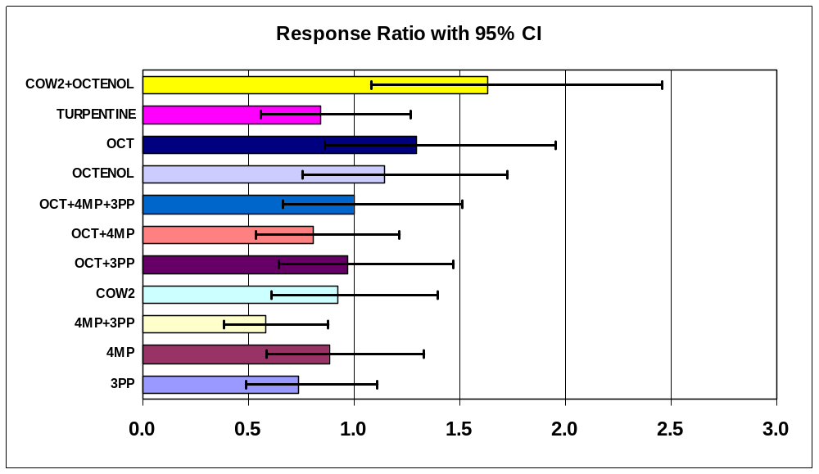

CATCHES by TRAP CHECK - NOT risk adjusted in these two pivot tables
Arithmetic Mean |  |  | Maximum
Average of CHFRIF |  |  | Max of CHFRIF
ODOURS$ | Total |  | ODOURS$ | Total
UNBAIT | 7.3 |  | UNBAIT | 17
3PP | 4.9 |  | 3PP | 15
4MP | 6.8 |  | 4MP | 21
4MP+3PP | 5.4 |  | 4MP+3PP | 38
COW2 | 8.0 |  | COW2 | 24
OCT+3PP | 9.1 |  | OCT+3PP | 34
OCT+4MP | 7.0 |  | OCT+4MP | 22
OCT+4MP+3PP | 8.0 |  | OCT+4MP+3PP | 25
OCTENOL | 10.5 |  | OCTENOL | 42
OCT | 10.6 |  | OCT | 22
TURPENTINE | 8.8 |  | TURPENTINE | 45
COW2+OCTENOL | 15.2 |  | COW2+OCTENOL | 45
Grand Total | 8.5 |  | Grand Total | 45

Stomoxys calcitrans

Catches were only about one fly per trap per day so statistical tests may not be worthwhile. Nevertheless, I have added the confidence intervals to the graph below.

One treatment (octenol sachet alone) just managed to be significantly different from the unbaited trap, likely only a random result.

Average of Stomoxys |  | Backtrans | Index of | Response
ODOURS$ | Total | Mean | Increase | Ratio
UNBAIT | 0.229 | 0.70 | 1.00 | 1.00
3PP | 0.209 | 0.62 | 0.89 | 0.95
4MP | 0.272 | 0.87 | 1.25 | 1.10
4MP+3PP | 0.183 | 0.52 | 0.75 | 0.90
COW2 | 0.189 | 0.55 | 0.78 | 0.91
OCT+3PP | 0.138 | 0.38 | 0.54 | 0.81
OCT+4MP | 0.343 | 1.20 | 1.72 | 1.30
OCT+4MP+3PP | 0.317 | 1.08 | 1.54 | 1.22
OCTENOL | 0.249 | 0.78 | 1.11 | 1.05
OCT | 0.417 | 1.61 | 2.31 | 1.54
TURPENTINE | 0.098 | 0.25 | 0.36 | 0.74
COW2+OCTENOL | 0.194 | 0.56 | 0.81 | 0.92
Grand Total | 0.237 | 0.72

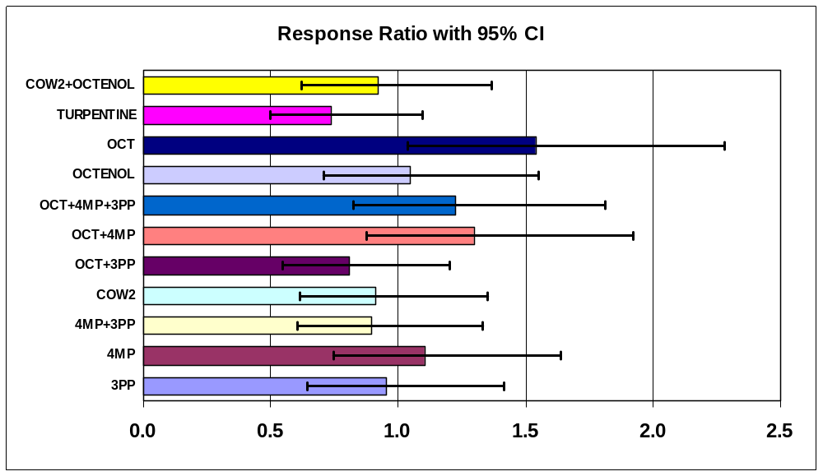
Trap Results (Farm4+Farm5 combined)

Five traps were replaced during the last two days of Farm4 for a consistent set of traps through Farm4 and Farm5 with N=14 per trap. This subset of data is probably the best use of the trap comparisons done in both experiments in 2008 as it was only during the last few trap checks of Farm4 that high catches were obtained.

The distribution of baits among sites was very even for this comparison so only trap-site idiosyncrasies might have affected catches.

Count of TYPE$ | SITE
ODOURS$ | 23 | 24 | 25 | 26 | 27 | 28 | 29 | 30 | 31 | 32 | 33 | 34 | Grand Total
OCT | 1 | 1 | 1 | 2 |  | 1 | 1 | 1 | 1 | 1 | 1 | 1 | 12
3PP |  | 1 | 1 | 1 | 1 | 1 | 1 | 1 | 1 | 1 | 1 | 2 | 12
4MP | 1 | 1 | 1 | 1 | 1 | 1 | 2 |  | 1 | 1 | 1 | 1 | 12
4MP+3PP | 1 | 1 | 1 | 1 | 1 | 1 | 1 | 1 | 1 | 2 |  | 1 | 12
COW1 | 1 | 1 | 1 | 1 | 1 | 1 | 1 | 1 | 1 | 1 | 1 | 1 | 12
COW2 | 2 |  | 1 | 1 | 1 | 1 | 1 | 1 | 1 | 1 | 1 | 1 | 12
OCT+3PP | 1 | 1 | 1 | 1 | 1 | 1 | 1 | 1 | 1 | 1 | 2 |  | 12
OCT+4MP | 1 | 1 | 1 | 1 | 2 |  | 1 | 1 | 1 | 1 | 1 | 1 | 12
OCT+4MP+3PP | 1 | 1 | 1 | 1 | 1 | 2 |  | 1 | 1 | 1 | 1 | 1 | 12
OCTENOL | 1 | 1 | 2 |  | 1 | 1 | 1 | 1 | 1 | 1 | 1 | 1 | 12
TURPENTINE | 1 | 1 | 1 | 1 | 1 | 1 | 1 | 1 | 2 |  | 1 | 1 | 12
UNBAIT | 2 | 2 | 2 | 2 | 2 | 2 | 2 | 3 | 1 | 2 | 2 | 2 | 24
COW2+OCTENOL | 1 | 2 |  | 1 | 1 | 1 | 1 | 1 | 1 | 1 | 1 | 1 | 12
Grand Total | 14 | 14 | 14 | 14 | 14 | 14 | 14 | 14 | 14 | 14 | 14 | 14 | 168

The distribution of traps x sites was not perfect. Traps were rotated on 5 occasions. I had planned to do more but ran out of daylight in the evenings, and then everything went haywire when I broke my ankle. The pattern across sites is below with some of the idiosyncrasies highlighted.

Count of TYPE$ | SITE
TYPE$ | 23 | 24 | 25 | 26 | 27 | 28 | 29 | 30 | 31 | 32 | 33 | 34 | Grand Total
NZI-COT |  |  | 3 | 1 | 3 | 3 | 4 |  |  |  |  |  | 14
NZI-SUN-ECO | 3 | 4 |  |  |  |  |  |  |  | 3 | 1 | 3 | 14
NZI-SUN-BIO |  |  |  |  |  |  | 3 | 1 | 3 | 3 | 4 |  | 14
NZI-TURQ-CIBA2 |  |  |  |  |  |  |  | 3 | 1 | 3 | 3 | 4 | 14
NZI-TNB-STAGGER | 4 |  |  |  |  |  |  |  | 3 | 1 | 3 | 3 | 14
NZI-TNB-NAVY | 3 | 3 | 4 |  |  |  |  |  |  |  | 3 | 1 | 14
NZI-TNB-FOREST | 1 | 3 | 3 | 4 |  |  |  |  |  |  |  | 3 | 14
NZI-TURQ4MG | 3 | 1 | 3 | 3 | 4 |  |  |  |  |  |  |  | 14
NZI-NYL-TURQ |  | 3 | 1 | 3 | 3 | 4 |  |  |  |  |  |  | 14
NZI-AZU-PC |  |  |  | 3 | 1 | 3 | 3 | 4 |  |  |  |  | 14
NZI-TNB-BIO-ECO |  |  |  |  | 3 | 1 | 3 | 3 | 4 |  |  |  | 14
NZI-TNB-IN6 |  |  |  |  |  | 3 | 1 | 3 | 3 | 4 |  |  | 14
Grand Total | 14 | 14 | 14 | 14 | 14 | 14 | 14 | 14 | 14 | 14 | 14 | 14 | 168

From the pattern above, low catches in STAGGER, FOREST, TURQ4MG, and NYL-TURQ are likely related to the fact that these traps got stuck at some of the worst locations for either 4 or 7 trap checks; this period coincided with some of the highest catches of tabanids towards the end of the experiment when I broke my ankle.

Also, the catch in the “best trap” TNB-IN6 was likely higher than it should have been as this trap only moved through the best locations throughout the experiment.

The details and logic of original trap choices are explained in Farm 4. The five traps added for this sequence to replace duds from the previous experiment were:

NZI-TNB-IN6 Used Top Notch Blue with white polyester mosquito netting to provide a contrast with the new trap made with Bionet & Econet L [fabric firsts]
All other Top Notch traps were made with fabric seconds

NZI-SUN-BIO Used Sunbrella trap with Bionet tested in 2006, repeating to confirm performance and get results versus Top Notch Blue [fabric seconds]

NZI-SUN-ECO Used Sunbrella trap with Econet L tested in 2006, repeating to confirm performance and get results versus Top Notch Blue [fabric seconds]

NZI-AZU-PC New TDV Industries “Azure” polyester/cotton trap with white polyester mosquito netting, essentially an alternate control as the azure colour is also produced with Phthalogen Blue IF3GM - first ever test of this fabric, equivalent Ivory Coast “Santiago” did reasonably well in MVE (2007)

NZI-NYL-TURQ New SolarMax Nylon trap in “Turquoise” - dark bluish green as opposed to the bright greenish blue of Reactive Blue 140; fabric is shiny and translucent, equipped with white polyester mosquito netting - first ever test of a synthetic fabric in blue-green for comparison with home dyeing efforts. I tested Royal Blue and Peacock SolarMax nylon in MVE (2007); tabanid catches were only slightly lower than the standard.

By the start of this experiment, the TURQ4MG trap had faded a bit (the dyeing was not good due to a bad batch of dye). The CIBA2 trap stayed in good shape throughout both experiments.

The total catch of Tabanidae in this N=14 subset was 30,301. The mains species were...

H. lasiophthalma | 6451 | 21.3%
T. similis | 10484 | 34.6%
T. quinquevittatus | 10527 | 34.7%

The main benefit of using these 14 data points as opposed to just the 12 data points from Farm5 is the doubling of catches of Hybomitra, along with more balance in sites x traps.
Tabanidae

For total catches, the differences among traps were minor with only three significant differences with confidence intervals not quite overlapping with 1.0. These could all have been a function of certain traps being at “good” or “bad” locations for longer periods than other traps, as mentioned previously. The catch ratios were amazingly close to 1.00 for several traps with minor variations in fabric or netting. The AZU-PC trap and the TNB-BIO-ECO traps were almost identical to the NZI-COT standard. Substitution of Navy Blue for Black in the TNB trap also produced identical results. There may have been a depression in catch when Forest Green was substituted [I chose Forest Green because of its unbelievably low price and to provide yet another contrast on the blue versus green question]. Slightly lower catches with the rearrangements of the black panels in the TNB STAGGER trap may be real from looking at the patterns across days, but the effect was not large.

The used Sunbrella traps in fabric seconds with horticultural netting both did fine, as was found in 2007 during a robust test over most of the tabanid season. This 2008 result rounded things out for Hybomitra, which was sampled a bit too late in 2007.

This was the first comprehensive test of the Top Notch Blue fabric with various options for various species. Similar excellent results were nevertheless obtained in 2007 just at the end of the season when T. quinquevittatus was still present in good numbers.

Buried within these totals are some interesting reactions of certain species, explained later.

Dep Var: TABANIDAE N: 168 Multiple R: 0.7420 Squared multiple R: 0.5505

Source Sum-of-Squares df Mean-Square F-ratio P

TYPE$ 2.2027 11 0.2002 3.1466 0.0008
SITE 3.9498 11 0.3591 5.6423 0.0000
SEQ 2.8124 11 0.2557 4.0175 0.0000
Error 8.5276 134 0.0636

Average of Tabanidae |  | Backtrans | Index of | Response | Difference
TYPE$ | Total | Mean | Increase | Ratio | log means | Signif
NZI-COT | 1.906 | 79.54 | 1.00 | 1.00
NZI-SUN-ECO | 1.831 | 66.82 | 0.84 | 0.84 | -0.075
NZI-SUN-BIO | 1.875 | 73.96 | 0.93 | 0.93 | -0.031
NZI-TURQ-CIBA2 | 1.970 | 92.28 | 1.16 | 1.16 | 0.064
NZI-TNB-STAGGER | 1.618 | 40.54 | 0.51 | 0.52 | -0.288 | P<0.05
NZI-TNB-NAVY | 1.938 | 85.69 | 1.08 | 1.08 | 0.032
NZI-TNB-FOREST | 1.720 | 51.43 | 0.65 | 0.65 | -0.186
NZI-TURQ4MG | 1.567 | 35.91 | 0.45 | 0.46 | -0.339 | P<0.05
NZI-NYL-TURQ | 1.756 | 56.05 | 0.70 | 0.71 | -0.150
NZI-AZU-PC | 1.897 | 77.80 | 0.98 | 0.98 | -0.009
NZI-TNB-BIO-ECO | 1.901 | 78.60 | 0.99 | 0.99 | -0.005
NZI-TNB-IN6 | 2.121 | 131.19 | 1.65 | 1.64 | 0.215 | P<0.05
Grand Total | 1.842 | 68.45

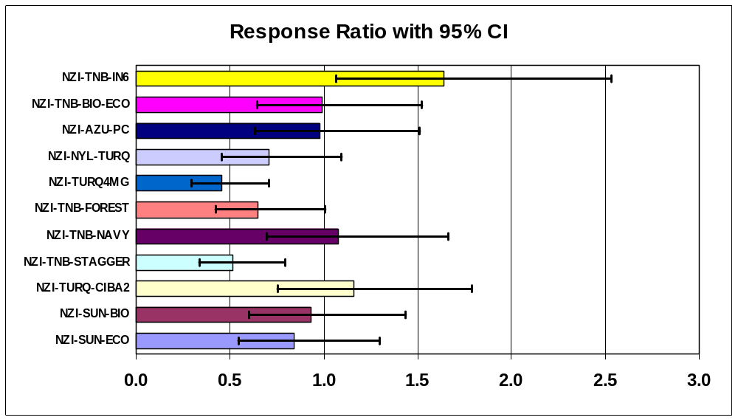

CATCHES by TRAP CHECK - NOT risk adjusted in these two pivot tables
Arithmetic Mean |  |  | Maximum
Average of Tabanidae |  |  | Max of Tabanidae
TYPE$ | Total |  | TYPE$ | Total
NZI-COT | 218.6 |  | NZI-COT | 813
NZI-SUN-ECO | 175.6 |  | NZI-SUN-ECO | 511
NZI-SUN-BIO | 146.2 |  | NZI-SUN-BIO | 266
NZI-TURQ-CIBA2 | 201.9 |  | NZI-TURQ-CIBA2 | 488
NZI-TNB-STAGGER | 89.1 |  | NZI-TNB-STAGGER | 242
NZI-TNB-NAVY | 230.0 |  | NZI-TNB-NAVY | 940
NZI-TNB-FOREST | 124.6 |  | NZI-TNB-FOREST | 341
NZI-TURQ4MG | 119.9 |  | NZI-TURQ4MG | 635
NZI-NYL-TURQ | 179.2 |  | NZI-NYL-TURQ | 639
NZI-AZU-PC | 185.9 |  | NZI-AZU-PC | 613
NZI-TNB-BIO-ECO | 207.8 |  | NZI-TNB-BIO-ECO | 777
NZI-TNB-IN6 | 285.5 |  | NZI-TNB-IN6 | 911
Grand Total | 180.4 |  | Grand Total | 940

Hybomitra lasiophthalma

The TURQ-CIBA2 and TNB-IN6 traps caught significantly more H. lasiophthalma. This result was unfortunately affected by these two traps also being at the best locations just when this species hit its annual peak, which is very brief. In a previous test, I found a doubling of the catch of Hl in a deep turquoise trap (unpublished), to compliment the mainly Tabanus results in Fig. 3 of BER (2006). I am sure the result for TURQ-CIBA2 is valid. I and others have now tested this turquoise effect for various species and it comes up over and over again; the hard part is to understand the pattern of why some species react to turquoise and some do not.

The TNB-IN6 result is the only test done so far for this group as I got this TNB trap out too late in 2007 for any insights. The equivalent TNB trap with Bionet/Econet did not show any increase in catch of Hybomitra. Note the large confidence intervals and the possible site-trap interactions.

There was an interesting trend in catches in the CIBA2 trap with “rare” Hybomitra appearing in modest numbers in this trap or in its near equivalent (TURQ4MG) during the brief period when these horse flies were abundant. This is the first summer I have ever caught lots of “rare” Hybomitra and it corresponds to the first summer that I have put out turquoise traps at the exact right place at the exact right time. Combined with the increases in catch with octenol and cow urine, the use of a turquoise trap produced some amazing catches relative to a standard unbaited phthalogen blue trap (e.g. 10x the catch in traps not very far apart).

Dep Var: HYLASF N: 168 Multiple R: 0.8185 Squared multiple R: 0.6700

Source Sum-of-Squares df Mean-Square F-ratio P

TYPE$ 4.4595 11 0.4054 2.4426 0.0083
SITE 1.7194 11 0.1563 0.9418 0.5028
SEQ 37.6245 11 3.4204 20.6080 0.0000
Error 22.2406 134 0.1660

Average of HYLASF |  | Backtrans | Index of | Response | Difference
TYPE$ | Total | Mean | Increase | Ratio | log means | Signif
NZI-COT | 0.722 | 4.27 | 1.00 | 1.00
NZI-SUN-ECO | 0.733 | 4.41 | 1.03 | 1.03 | 0.011
NZI-SUN-BIO | 0.864 | 6.31 | 1.48 | 1.39 | 0.142
NZI-TURQ-CIBA2 | 1.144 | 12.92 | 3.02 | 2.64 | 0.422 | P<0.05
NZI-TNB-STAGGER | 0.615 | 3.12 | 0.73 | 0.78 | -0.107
NZI-TNB-NAVY | 0.705 | 4.08 | 0.95 | 0.96 | -0.017
NZI-TNB-FOREST | 0.564 | 2.67 | 0.62 | 0.70 | -0.158
NZI-TURQ4MG | 0.893 | 6.82 | 1.60 | 1.48 | 0.171
NZI-NYL-TURQ | 0.911 | 7.14 | 1.67 | 1.54 | 0.189
NZI-AZU-PC | 0.883 | 6.63 | 1.55 | 1.45 | 0.161
NZI-TNB-BIO-ECO | 0.706 | 4.08 | 0.95 | 0.96 | -0.016
NZI-TNB-IN6 | 1.195 | 14.67 | 3.43 | 2.97 | 0.473 | P<0.05
Grand Total | 0.828 | 5.73

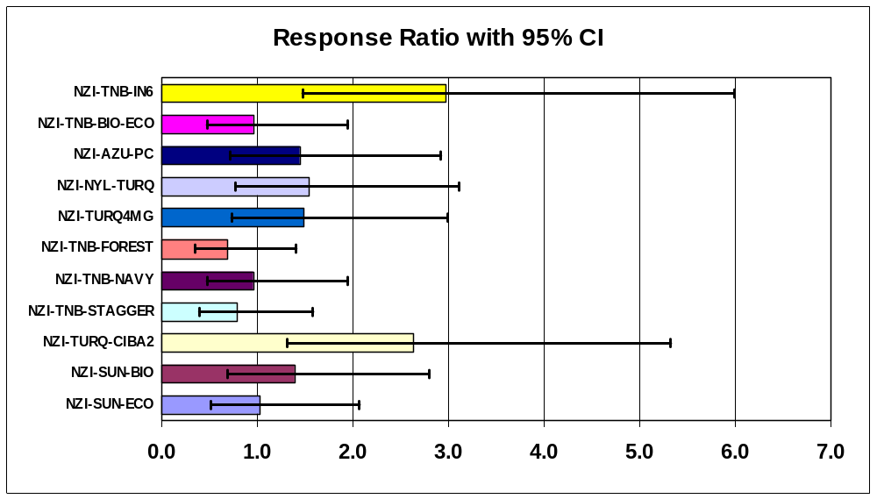

Average of HYLASF |  |  | Max of HYLASF
TYPE$ | Total |  | TYPE$ | Total
NZI-COT | 36.9 |  | NZI-COT | 220
NZI-SUN-ECO | 26.6 |  | NZI-SUN-ECO | 72
NZI-SUN-BIO | 35.1 |  | NZI-SUN-BIO | 200
NZI-TURQ-CIBA2 | 99.4 |  | NZI-TURQ-CIBA2 | 450
NZI-TNB-STAGGER | 13.9 |  | NZI-TNB-STAGGER | 94
NZI-TNB-NAVY | 20.2 |  | NZI-TNB-NAVY | 88
NZI-TNB-FOREST | 11.4 |  | NZI-TNB-FOREST | 56
NZI-TURQ4MG | 57.7 |  | NZI-TURQ4MG | 375
NZI-NYL-TURQ | 45.0 |  | NZI-NYL-TURQ | 283
NZI-AZU-PC | 31.1 |  | NZI-AZU-PC | 131
NZI-TNB-BIO-ECO | 21.6 |  | NZI-TNB-BIO-ECO | 165
NZI-TNB-IN6 | 61.9 |  | NZI-TNB-IN6 | 347
Grand Total | 38.4 |  | Grand Total | 450

Tabanus similis

For the most common tabanid with the best distribution of catches through time, the overall ANOVA was just significant at P=0.04.

I suspect that any “significant” trends were simply related to the catch patterns among good and bad sites, but can’t be absolutely sure.

The most basic Top Notch blue trap just happened to be the best of the entire series; with the exception of the STAGGER trap, all other TNB variations also did very well.

Dep Var: TASIMF N: 168 Multiple R: 0.7665 Squared multiple R: 0.5875

Source Sum-of-Squares df Mean-Square F-ratio P

TYPE$ 2.4475 11 0.2225 1.9742 0.0356
SITE 4.8277 11 0.4389 3.8941 0.0001
SEQ 13.1114 11 1.1919 10.5758 0.0000
Error 15.1024 134 0.1127

Average of TASIMF |  | Backtrans | Index of | Response | Difference
TYPE$ | Total | Mean | Increase | Ratio | log means | Signif
NZI-COT | 1.491 | 30.00 | 1.00 | 1.00
NZI-SUN-ECO | 1.392 | 23.64 | 0.79 | 0.79 | -0.100
NZI-SUN-BIO | 1.358 | 21.79 | 0.73 | 0.74 | -0.134
NZI-TURQ-CIBA2 | 1.425 | 25.63 | 0.85 | 0.86 | -0.066
NZI-TNB-STAGGER | 1.041 | 9.99 | 0.33 | 0.35 | -0.450 | P<0.05
NZI-TNB-NAVY | 1.478 | 29.09 | 0.97 | 0.97 | -0.013
NZI-TNB-FOREST | 1.336 | 20.67 | 0.69 | 0.70 | -0.156
NZI-TURQ4MG | 1.171 | 13.83 | 0.46 | 0.48 | -0.320 | P<0.05
NZI-NYL-TURQ | 1.238 | 16.29 | 0.54 | 0.56 | -0.253 | P<0.05
NZI-AZU-PC | 1.441 | 26.58 | 0.89 | 0.89 | -0.051
NZI-TNB-BIO-ECO | 1.497 | 30.40 | 1.01 | 1.01 | 0.006
NZI-TNB-IN6 | 1.564 | 35.67 | 1.19 | 1.18 | 0.073
Grand Total | 1.369 | 22.41

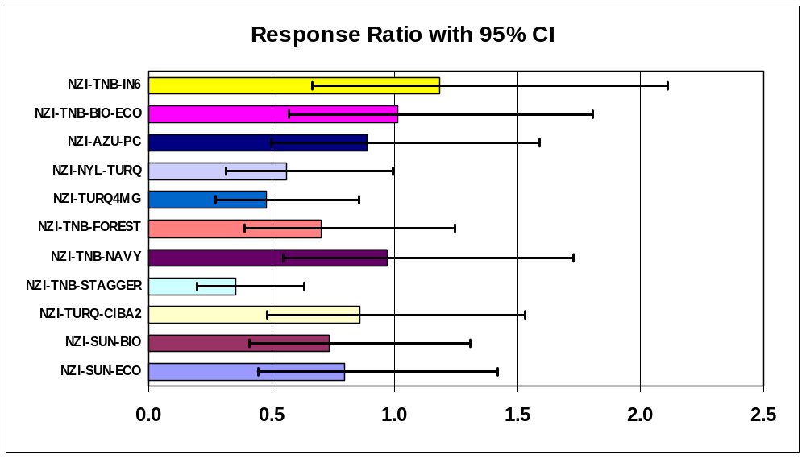

CATCHES by TRAP CHECK - NOT risk adjusted in these two pivot tables
Arithmetic Mean |  |  | Maximum
Average of TASIMF |  |  | Max of TASIMF
TYPE$ | Total |  | TYPE$ | Total
NZI-COT | 71.0 |  | NZI-COT | 179
NZI-SUN-ECO | 65.8 |  | NZI-SUN-ECO | 190
NZI-SUN-BIO | 61.2 |  | NZI-SUN-BIO | 170
NZI-TURQ-CIBA2 | 55.9 |  | NZI-TURQ-CIBA2 | 170
NZI-TNB-STAGGER | 28.7 |  | NZI-TNB-STAGGER | 99
NZI-TNB-NAVY | 72.0 |  | NZI-TNB-NAVY | 275
NZI-TNB-FOREST | 62.7 |  | NZI-TNB-FOREST | 175
NZI-TURQ4MG | 47.1 |  | NZI-TURQ4MG | 248
NZI-NYL-TURQ | 54.8 |  | NZI-NYL-TURQ | 125
NZI-AZU-PC | 62.4 |  | NZI-AZU-PC | 160
NZI-TNB-BIO-ECO | 66.9 |  | NZI-TNB-BIO-ECO | 125
NZI-TNB-IN6 | 100.4 |  | NZI-TNB-IN6 | 254
Grand Total | 62.4 |  | Grand Total | 275

Tabanus quinquevittatus

Trap differences were not significant in the ANOVA.

Note that confidence intervals are rather large as this species was not present for the first few trap checks and then numbers rose considerably towards the end of the experiment.

The low catch in the TURQ4MG is an artifact. This trap was stuck at the two worst trap sites exactly at the time when T. quinquevittatus was present in high numbers.

Dep Var: TAQUIF N: 168 Multiple R: 0.8997 Squared multiple R: 0.8094

Source Sum-of-Squares df Mean-Square F-ratio P

TYPE$ 1.8652 11 0.1696 1.1628 0.3188
SITE 1.6168 11 0.1470 1.0079 0.4428
SEQ 78.3874 11 7.1261 48.8681 0.0000
Error 19.5404 134 0.1458

Average of TAQUIF |  | Backtrans | Index of | Response
TYPE$ | Total | Mean | Increase | Ratio
NZI-COT | 0.784 | 5.08 | 1.00 | 1.00
NZI-SUN-ECO | 0.808 | 5.43 | 1.07 | 1.06
NZI-SUN-BIO | 0.837 | 5.87 | 1.16 | 1.13
NZI-TURQ-CIBA2 | 0.714 | 4.18 | 0.82 | 0.85
NZI-TNB-STAGGER | 0.787 | 5.12 | 1.01 | 1.01
NZI-TNB-NAVY | 0.947 | 7.85 | 1.55 | 1.46
NZI-TNB-FOREST | 0.735 | 4.44 | 0.87 | 0.89
NZI-TURQ4MG | 0.400 | 1.51 | 0.30 | 0.41
NZI-NYL-TURQ | 0.647 | 3.43 | 0.68 | 0.73
NZI-AZU-PC | 0.836 | 5.86 | 1.15 | 1.13
NZI-TNB-BIO-ECO | 0.860 | 6.25 | 1.23 | 1.19
NZI-TNB-IN6 | 0.841 | 5.94 | 1.17 | 1.14
Grand Total | 0.766 | 4.84

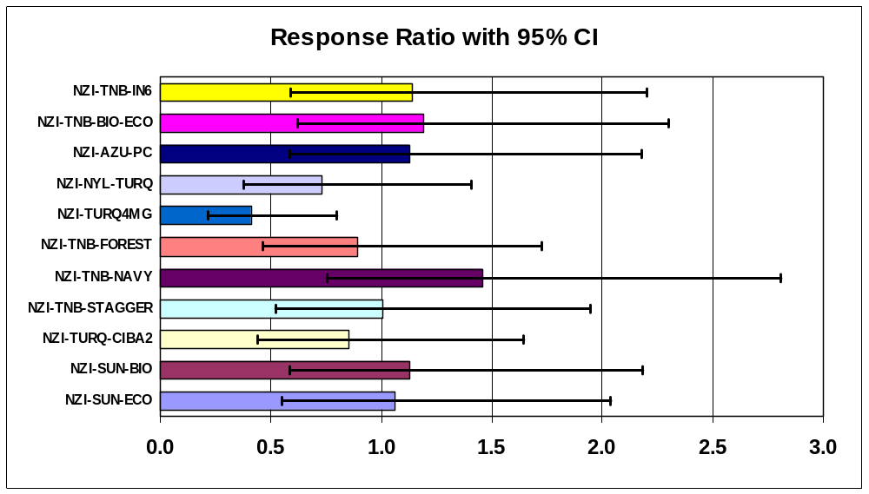

CATCHES by TRAP CHECK - NOT risk adjusted in these two pivot tables
Arithmetic Mean |  |  | Maximum
Average of TAQUIF |  |  | Max of TAQUIF
TYPE$ | Total |  | TYPE$ | Total
NZI-COT | 78.6 |  | NZI-COT | 482
NZI-SUN-ECO | 69.9 |  | NZI-SUN-ECO | 380
NZI-SUN-BIO | 37.9 |  | NZI-SUN-BIO | 200
NZI-TURQ-CIBA2 | 30.5 |  | NZI-TURQ-CIBA2 | 153
NZI-TNB-STAGGER | 39.1 |  | NZI-TNB-STAGGER | 222
NZI-TNB-NAVY | 118.4 |  | NZI-TNB-NAVY | 772
NZI-TNB-FOREST | 43.2 |  | NZI-TNB-FOREST | 264
NZI-TURQ4MG | 8.1 |  | NZI-TURQ4MG | 61
NZI-NYL-TURQ | 69.3 |  | NZI-NYL-TURQ | 528
NZI-AZU-PC | 71.3 |  | NZI-AZU-PC | 389
NZI-TNB-BIO-ECO | 98.6 |  | NZI-TNB-BIO-ECO | 588
NZI-TNB-IN6 | 87.1 |  | NZI-TNB-IN6 | 670
Grand Total | 62.7 |  | Grand Total | 772

T. quinquevittatus at high numbers

Results are similar if we only look at data for the last 6 trap checks when numbers of this species were very high. The statistics above include many zero catches during the first several trap checks and highlight what happens when a trap like TURQ4MG gets stuck at a bad site just at the time when a species is peaking in numbers. This subset includes 10,397 of the 10,527 Tq caught over the 14 trap checks. If I had not broken my ankle, I would have been able to test traps/baits again for this species before the season ended to get better statistics.

Results for the NAVY trap are intriguing for Tq, but it was in good locations at this exact time.

Average of TAQUIF |  | Backtrans | Index of | Response
TYPE$ | Total | Mean | Increase | Ratio
NZI-COT | 1.640 | 42.66 | 1.00 | 1.00
NZI-SUN-ECO | 1.552 | 34.64 | 0.81 | 0.82
NZI-SUN-BIO | 1.566 | 35.78 | 0.84 | 0.84
NZI-TURQ-CIBA2 | 1.486 | 29.62 | 0.69 | 0.70
NZI-TNB-STAGGER | 1.516 | 31.78 | 0.74 | 0.75
NZI-TNB-NAVY | 1.855 | 70.60 | 1.65 | 1.64
NZI-TNB-FOREST | 1.469 | 28.47 | 0.67 | 0.67
NZI-TURQ4MG | 0.803 | 5.35 | 0.13 | 0.15
NZI-NYL-TURQ | 1.379 | 22.93 | 0.54 | 0.55
NZI-AZU-PC | 1.649 | 43.56 | 1.02 | 1.02
NZI-TNB-BIO-ECO | 1.670 | 45.80 | 1.07 | 1.07
NZI-TNB-IN6 | 1.733 | 53.06 | 1.24 | 1.24
Grand Total | 1.526 | 32.61

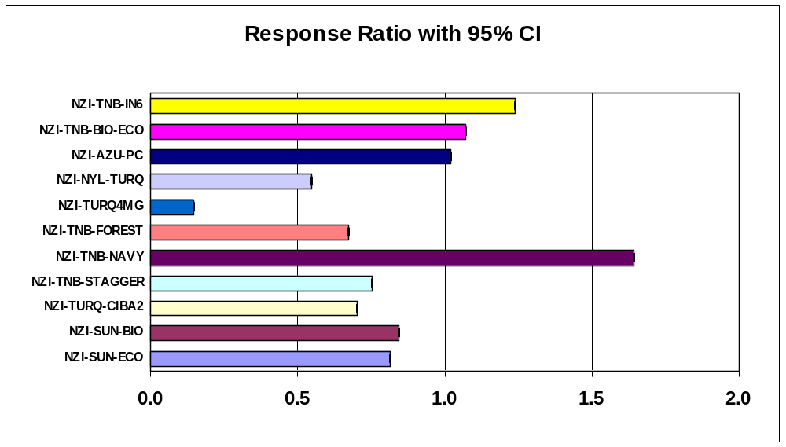
Chrysops frigidus

Trap differences were not significant in the ANOVA below, but statistical power was not particularly good with very low catches.

Trends that I expect from previous work were nevertheless present. Over the years, deer fly catches have always been best in the standard NZI-COT trap; deviations from this standard format always results in lower catches.

The use of white netting appears to be important for deer flies as substitutions are never quite as good. Note here the identical catches in the AZU-PC trap and TNB-IN6 trap - both with white netting and both with exactly the right colour blue.

Dep Var: CHFRIF N: 168 Multiple R: 0.7171 Squared multiple R: 0.5143

Source Sum-of-Squares df Mean-Square F-ratio P

TYPE$ 1.3839 11 0.1258 1.3639 0.1971
SITE 2.1318 11 0.1938 2.1010 0.0242
SEQ 7.9778 11 0.7253 7.8626 0.0000
Error 12.3602 134 0.0922

Average of CHFRIF |  | Backtrans | Index of | Response | Difference
TYPE$ | Total | Mean | Increase | Ratio | log means
NZI-COT | 0.758 | 4.72 | 1.00 | 1.00
NZI-SUN-ECO | 0.592 | 2.90 | 0.62 | 0.68 | -0.166
NZI-SUN-BIO | 0.576 | 2.76 | 0.59 | 0.66 | -0.182
NZI-TURQ-CIBA2 | 0.691 | 3.91 | 0.83 | 0.86 | -0.066
NZI-TNB-STAGGER | 0.549 | 2.54 | 0.54 | 0.62 | -0.209
NZI-TNB-NAVY | 0.609 | 3.07 | 0.65 | 0.71 | -0.148
NZI-TNB-FOREST | 0.325 | 1.11 | 0.24 | 0.37 | -0.433
NZI-TURQ4MG | 0.420 | 1.63 | 0.35 | 0.46 | -0.338
NZI-NYL-TURQ | 0.464 | 1.91 | 0.40 | 0.51 | -0.294
NZI-AZU-PC | 0.747 | 4.58 | 0.97 | 0.98 | -0.011
NZI-TNB-BIO-ECO | 0.555 | 2.59 | 0.55 | 0.63 | -0.203
NZI-TNB-IN6 | 0.767 | 4.84 | 1.03 | 1.02 | 0.009
Grand Total | 0.588 | 2.87

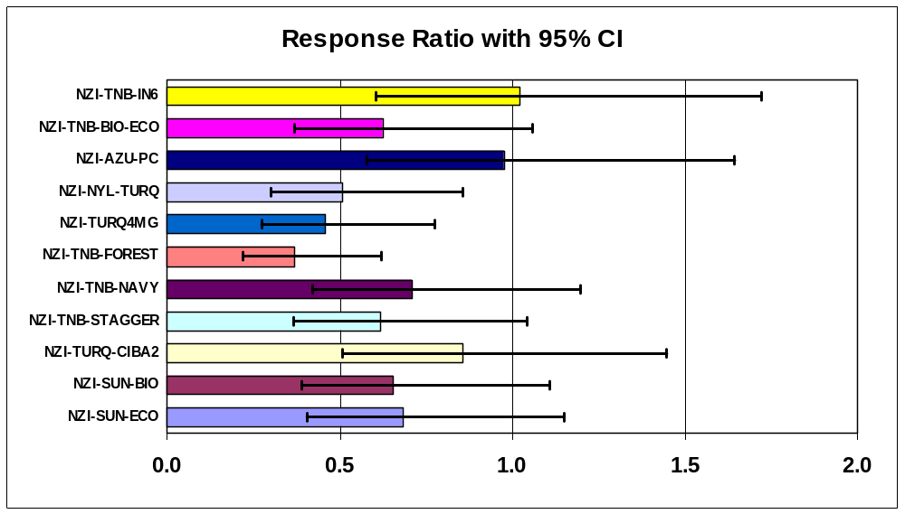

CATCHES by TRAP CHECK - NOT risk adjusted in these two pivot tables
Arithmetic Mean |  |  | Maximum
Average of CHFRIF |  |  | Max of CHFRIF
TYPE$ | Total |  | TYPE$ | Total
NZI-COT | 12.4 |  | NZI-COT | 42
NZI-SUN-ECO | 8.1 |  | NZI-SUN-ECO | 38
NZI-SUN-BIO | 5.6 |  | NZI-SUN-BIO | 13
NZI-TURQ-CIBA2 | 7.7 |  | NZI-TURQ-CIBA2 | 20
NZI-TNB-STAGGER | 5.3 |  | NZI-TNB-STAGGER | 19
NZI-TNB-NAVY | 9.2 |  | NZI-TNB-NAVY | 45
NZI-TNB-FOREST | 2.1 |  | NZI-TNB-FOREST | 4
NZI-TURQ4MG | 4.7 |  | NZI-TURQ4MG | 22
NZI-NYL-TURQ | 4.5 |  | NZI-NYL-TURQ | 14
NZI-AZU-PC | 10.4 |  | NZI-AZU-PC | 23
NZI-TNB-BIO-ECO | 7.4 |  | NZI-TNB-BIO-ECO | 29
NZI-TNB-IN6 | 14.4 |  | NZI-TNB-IN6 | 45
Grand Total | 7.6 |  | Grand Total | 45
Photos of the new traps when first set on 8 June, from about 11 am to noon.
Only low resolution images below, originals stored elsewhere are 12 Mega pixels.

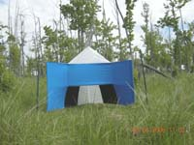 | 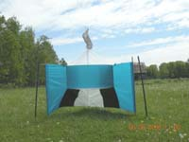
NZI-AZU-PC Site #26  (Azure Poly/Cotton alternative standard) | NZI-NYL-TURQ Site #24  (SolarMax Nylon - turquoise)
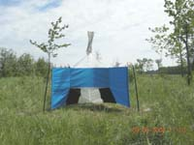 | 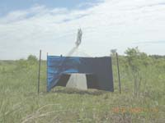
NZI-TNB-IN6 Site #28  (Top Notch Blue, white polyester net) | NZI-SUN-BIO Site #29  (Sunbrella and Bionet)
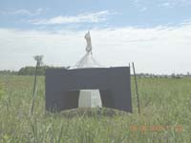
NZI-SUN-ECO Site #32
(Sunbrella and Econet -L)

June 30 in the middle of the experiment showing vegetation growth

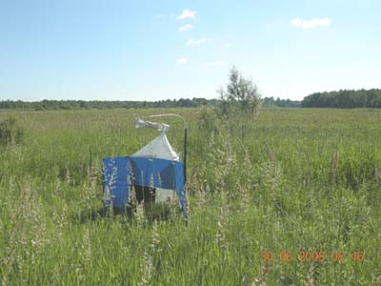
Grass approaching chest height at site #31, TNB-IN6

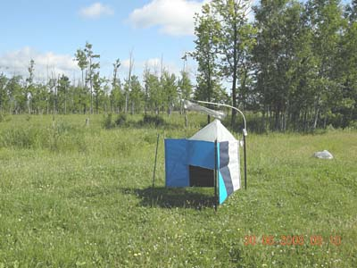
Good site #24 near the pond and edge of woodland , TNB-NAVY

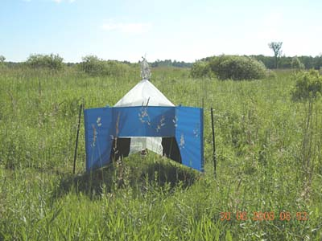
Best Site #30 in open bushland, tall grass, TNB-BIO-ECO
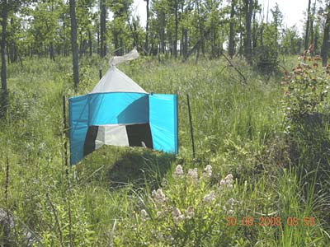
Worst Site #27 showing translucent SolarMax nylon, NYL-TURQ

