Michigan: Mears, USA July - September 2007

Dr. David A. Carlson dacarls@gmail.com
Objective: Compare alternative transparent materials for Nzi traps, test turquoise trap
Compliment tests of similar traps sent to Sudan/Philippines

Data: MEARS1.xls, query linked to reference data in Canada nzi.mdb
Design: One 4 x 4 Latin square
Area: Silver Lake Campground (East shore of state park, nearest town is Mears)

Habitat: Cottage country, small lake near extensive sand dunes on Lake Michigan
Details: 237 m asl, 43°68.2 N latitude and 86° 41.7 W longitude (web data)
Date: August 31 - September 7, 2007, traps checked every two days

Baits: Unbaited
Standard: TDV Phthalogen Blue IF3GM cotton Nzi trap with Econet L netting
all traps set facing WEST
Collector: 2-L Coke bottle plastic “funnel” inserted into trap cone (21 mm diameter neck)
Funnel then inserted into 2-L angled plastic Coke bottle pointing forward
Second bottle inserted into similar vertical bottle for collection of flies
Flies were killed with paint remover vapour (after collection, not when set)

Too late for the tabanid season, stable flies just starting to appear; no livestock within 2-3 km
The catch of nonbiting insects was very low

Two data points were lost due to wind/people interfering with traps, these two traps were rerun on September 9/10 (unfortunately with zero catch due to poor weather)

Weather was mediocre with some high winds/rain - only two relatively good trap sets of four

Best 2-day catch in a single trap was 32 Stomoxys calcitrans

113 | Stomoxys calcitrans (54 %)
1 | Tabanus similis

ANOVAs conducted on a risk adjusted basis, catch per trap per day
Setting
Silver Lake and the sand dunes in the state park are in the background
Traps were set roughly 20 m apart in a square configuration, not well-stretched

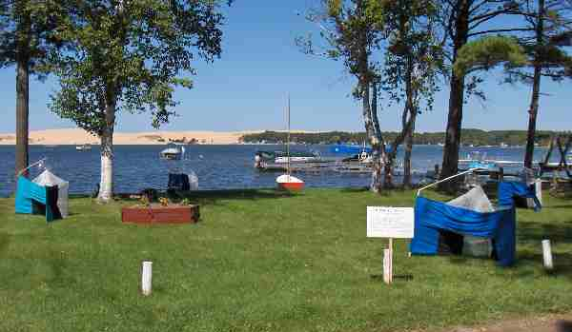

Satellite image has poor resolution so close-up image is not informative
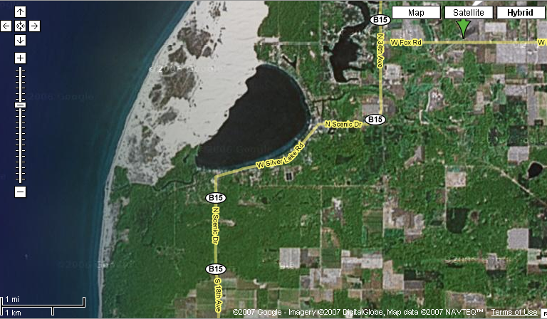
Carlson

Trap Codes

The TDV and the turquoise trap had been used earlier in the summer; the others were new
The turquoise trap would have faded by the time it was used in this experiment (6-weeks old)

The generic black cotton twill I purchased in 2007 faded badly in Russell; it’s hard to know exactly which traps in which countries got pieces of this bad lot of fabric

The turquoise trap fades gradually outdoors, but maintains its attractiveness for several months for both tabanids and stable flies. Other fabrics are all stable.

Standard (Response ratios are calculated relative to this trap)

1. NZI-TDV-ECO TDV Phthalogen Blue IF3GM cotton, generic black cotton twill
All ECONET L netting for cone, back, and inner shelf

This opaque cotton twill is slightly brighter than the cotton dyed by Mountex in Kenya used as a previous standard (e.g. maybe 4% dye vs 5%). The TDV fabric is identical to the 1990’s Bonar fabric from Zimbabwe and is genuine phthalogen blue type IF3GM (Dystar). See Spectra.xls for raw wavelength profiles and the Fabric Guide.doc for comparative graphs.

ECONET L is a robust horticultural netting that is an excellent match in ultraviolet and visible light transmittance (86%, 62% respectively) to Vestergaard Frandsen wide mesh white polyester mosquito netting from the 1990’s and beyond, used in previous standard traps.

Experimental

2. NZI-SUN-BIO Pacific Blue and Black Sunbrella acrylic awning fabric
All BIONET netting (90% vis, 40% uv transmittance)

3. NZI-SUN-CRY-ECO Pacific Blue and Black Sunbrella acrylic awning fabric
Crystal 20/20 clear PVC 30 mil cone from Strataglass (uv block)
ECONET L netting for back, and inner shelf

These were made with seconds of Sunbrella as in the traps used in the FARM experiments in Russell in 2007. Firsts of Sunbrella were used for traps in the Sudan/Philippines. Crystal Clear 20/20 PVC is stable and blocks all ultraviolet light.

Alternative Standard/Experimental

4. NZI-TURQ3MG Procion Turquoise M-G bleached, light-weight, plain cotton
Generic black cotton twill, IN6 white polyester mosquito netting
Based on previous work (BER 2006 Nzi paper), this trap should be equivalent to a Kenyan phthalogen blue cotton + white polyester mosquito netting trap and therefore can provide insights into the consequences of using ECONET L netting in the TDV standard used here.
This turquoise trap was made out of the same light, plain weave cotton sent to all researchers. It is the same colour as in the 2006 BER Nzi paper. The turquoise fabric tested in Russell in 2007 differed in terms of being a heavier weight twill; hence it had better colour saturation.

Fabric Codes (full details are in Fabrics.mdb or FabricMaster.xls)

301 Phthalogen Blue IF3GM CV47 2-ply cotton twill from TDV Industries, France
315 Procion Turquoise M-G bleached, light-weight, plain cotton
214f SECONDS of Sunbrella Pacific Blue acrylic awning fabric, USA

215b SECONDS of Sunbrella Black acrylic awning fabric, USA
236 Black “Galaxy” 100% cotton twill, Fabricland, Canada [poor lot that fades?]

357 Econet L from Ludvig Svensson, Sweden via Gintec Shade Technologies, Canada
360 Bionet from Klayman Meteor, Israel (polyethylene, patented uv blocking treatment)
323c Army Navy Type IN6 fine mesh white polyester netting, lot from 2007

313 Crystal 20/20 clear PVC 30 mil from Strataglass, USA

Weather: Daily Statistics: http://www.wundergound.com

Not sure of how traps were checked (am/pm) - grouping below assumed to represent days 1-4 of Latin square with Sep 9/10 representing the re-setting of two traps to complete design

 | Temp (°F) |  |  | Humidity (%) |  |  | Wind (mph) |  | Precip (in) | Events
Sep | high | avg | low | high | avg | low | high | avg | sum
1 | 73 | 62 | 50 | 100 | 86 | 61 | 12 | 0 | 0.00
2 | 77 | 66 | 55 | 94 | 77 | 50 | 22 | 0 | 0.00
3 | 80 | 71 | 62 | 94 | 67 | 36 | 9 | 7 | 0.00 | Fog
4 | 80 | 68 | 57 | 88 | 73 | 54 | 14 | 0 | 0.00
5 | 89 | 76 | 62 | 88 | 60 | 33 | 16 | 2 | 0.00
6 | 82 | 75 | 68 | 83 | 76 | 58 | 22 | 0 | 0.00 | Rain
7 | 77 | 73 | 69 | 94 | 88 | 78 | 29 | 19 | 0.26 | Rain
8 | 77 | 64 | 50 | 100 | 72 | 47 | 8 | 0 | 0.00
9 | 73 | 62 | 50 | 94 | 83 | 53 | 17 | 1 | 0.00
10 | 60 | 56 | 51 | 94 | 87 | 63 | 10 | 4 | 0.04 | Rain

Results

With only N=4 per trap; there was not much discriminatory power in this experiment, hence all results were not significant. Confidence intervals were gigantic.

All traps were good except for the trap with the PVC cone (38% of the control) - BUT results might have been better for this trap if one data point would not have been lost on a fair-weather day, and replaced with a bad-weather day when it was reset.

This pattern agrees with experiment Farm3 in Russell at much higher numbers where a NZI-SUN-CRY-BIO trap caught 30% as many stable flies as a NZI-COT trap (this experimental trap had a lot of uv blocking at both the top and the back). Here the comparison was between a NZI-SUN-CRY-ECO trap and a NZI-TDV-ECO trap with ultraviolet block mainly from the top.

I also got significantly lower catches of stable flies with an ultraviolet blocking PVC cone late this summer in experiment UV8 (you don’t have these results) where I tested this in more detail with different transparent materials (55% of the catch using a cloth trap with a PVC cone, 62% using a painted plywood trap with a PVC cone versus a NZI-COT standard control with a regular white polyester netting cone).

Unfortunately, stable fly catches are significantly lower with an ultraviolet-blocking cone, whereas tabanid catches either increase or are equal. Similar problems occur with stable flies with the use of ultraviolet-blocking materials at the back of the trap. This is now clear after several experiments with the definitive work completed this autumn in Russell in a last good experiment (UV8) with multiple material contrasts at reasonable stable fly numbers.

The stable fly catches in Michigan were similar to what I found in my back yard in Russell at the same time (octenol-baited traps) - e.g. a few to several per trap per day with just a few higher catches. My maximum catch during this period was 26, 36 in two traps on the evening of September 8th. Stable flies did not reach a seasonal peak in Russell until early October.

Stomoxys calcitrans (Risk adjusted ANOVA)

Dep Var: STOMOXYS N: 16 Multiple R: 0.9290 Squared multiple R: 0.8630

Analysis of Variance
Source Sum-of-Squares df Mean-Square F-ratio P

TYPE$ 0.6682 3 0.2227 3.8119 0.0767
SEQ 1.1521 3 0.3840 6.5728 0.0252
SITE 0.3885 3 0.1295 2.2162 0.1870

Error 0.3506 6 0.0584

Mears1Risk
REFRESH TABLES
Average of Stomoxys |  | Backtrans | Index of | Response
TYPE$ | Total | Mean | Increase | Ratio
NZI-TDV-ECO | 0.535 | 2.43 | 1.00 | 1.00
NZI-SUN-BIO | 0.605 | 3.03 | 1.25 | 1.17
NZI-TURQ3MG | 0.617 | 3.14 | 1.29 | 1.21
NZI-SUN-CRY-ECO | 0.119 | 0.32 | 0.13 | 0.38
Grand Total | 0.469 | 1.94

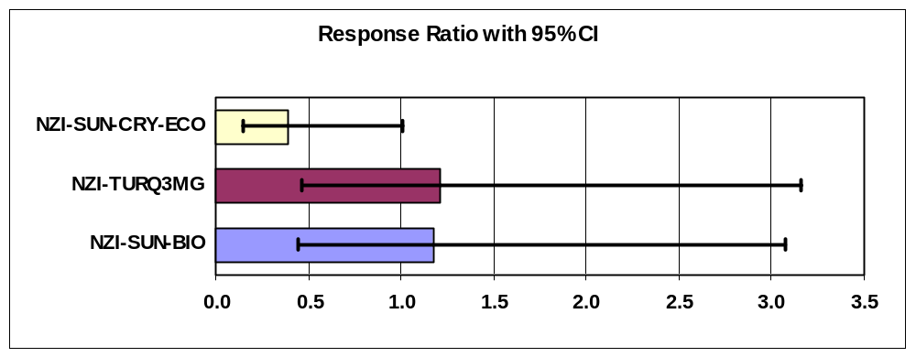

Arithmetic 2-d Catches |  |  | Max 2-day Catches
Average of Stomoxys |  |  | Max of Stomoxys
TYPE$ | Total |  | TYPE$ | Total
NZI-TDV-ECO | 7.3 |  | NZI-TDV-ECO | 15
NZI-SUN-BIO | 6.8 |  | NZI-SUN-BIO | 11
NZI-TURQ3MG | 13.5 |  | NZI-TURQ3MG | 32
NZI-SUN-CRY-ECO | 0.8 |  | NZI-SUN-CRY-ECO | 2
Grand Total | 7.1 |  | Grand Total | 32

Male and Female patterns about the same - sample sizes too small for much inference
Other Trapping

Two traps were set about 200 m from Lake Michigan, 100 m apart, unbaited. This work was conducted at a farm about 1-2 km away from the campground.

The traps were set in July-August for about 6 weeks with two collections; trapping ended on August 26th. The farm is on Scenic Drive with 4 paddocks, 5 horses, and a new Amish-built barn. It has a frequently-used dumpster that is used daily for manure disposal.

The distance from the traps to the dumpster and/or the horses is not clear.

NZI-TDV-ECO, NZI-TURQ3MG

The data for the TDV-ECO trap were not useful as flies were not present in the first check (something went wrong with the collector?); in the second check flies were almost all wet and rotted and could not be counted. (14 male, 12 female S. calcitrans were recovered). The catch of nonbiting insects was very low in all trapping at this farm.

Turquoise trap | First 3 wk | Second 3 wk | Total
Tabanus sackeni | 9 | 3 | 12
Tabanus lineola | 5 | 1 | 6
Chrysops cincticornis | 1 | 0 | 1
S. calcitrans male | 85 | 75 | 160
S. calcitrans female | 75 | 40 | 115
Sc % Male | 53% | 65% | 58%
Sc approx catch per day | 7.6 | 5.5 | 6.5

The two Tabanus are what might be expected from late-season trapping given a table of Malaise and hand net trapping results in Strickler & Walker (1993) below. Tabanus sackeni is unusual in that it is very active just before sunset (Taylor, 1989). It is mentioned in trap catches in a few publications from different states, but is hardly present in Canada. Taylor’s paper and the keys to Michigan tabanids (Hays, 1956) are both available on the internet. There are surprisingly few papers on the ecology of Michigan tabanids for interpretation of these results.

Hays, K.L. (1956) A synopsis of the Tabanidae (Diptera) of Michigan. Miscellaneous Publications of the Museum of Zoology, University of Michigan, 98, 1-79.

Strickler, J.D. & Walker, E.D. (1993) Seasonal abundance and species diversity of adult Tabanidae (Diptera) at Lake Lansing Park-North, Michigan. Great Lakes Entomologist, 26, 107-112.

Taylor, P.D. & Smith, S.M. (1989) Activities and physiological states of male and female Tabanus sackeni. Medical and Veterinary Entomology, 3, 203-212.

Female Eye Patterns

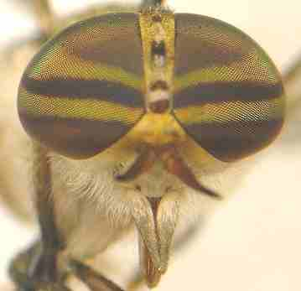 | Tabanus sackeni (Photo #126952)  Photo by Brad Barnd, 2007 (Indiana)  http://bugguide.net/node/view/127119  “Eye bare, dark purplish blue with two greenish transverse bands” (Teskey, 1990)  No description of eyes in Hays (1956)  Good photos of museum specimens are also available from Harvard.edu

